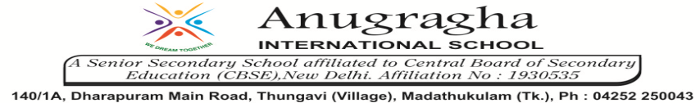

ANNUAL EXAMINATION-JAN-2020

KBQ - 02
NAME | «NAME_OF_THE_STUDENT» |  |  | AD.NO | «ADMNO»
CLASS | VII-«SECTION» |  |  | EX.NO | «EXNO»
G.D | 21/01/2020 | S.D | 23/01/2020 | SUB | SST
TOPIC: CH:8 DEVOTIONAL PATHS TO THE DIVINE

Short Answer Type Questions:
1.Why do you think many teachers rejected prevalent religious beliefs and practices?
2.For either Virashaivas or the sants of Maharashtra, discuss their attitude towards caste.
3.What were the evils prevalent in the Hindu religion?
4.How did Shiva, Vishnu and Durga emerge as supreme deities?
5.What was the contribution of Chola and Pandya kings in this period?
6.Who was Guru Nanak? What did he start?

Long Answer Type questions:
1.What were the major ideas expressed by Kabir? How did he express these?
2.What were the major beliefs and practices of the Sufis?
3.Give five principles of Bhakti tradition.
4.What was the attitude of Alvars and Nayanars towards various cults in India?
5.What were the main pillars of Islam?

