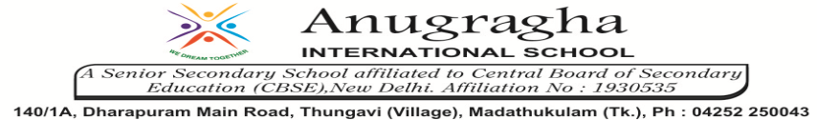

ANNUAL EXAMINATION-FEB-2020

KBQ - 05
NAME | «NAME_OF_THE_STUDENT» |  |  | AD.NO | «ADMNO»
CLASS | VI-«SECTION» |  |  | EX.NO | «EXNO»
G.D | 14.02.2020 | S.D | 17.02.2020 | SUB | SST
TOPIC: CH:8 INDIA: CLIMATE, VEGETATION AND WILDLIFE
Short Answer Type Questions:
1.Name the major season in India and their duration.
2.What is monsoon? Give example from India.
3.How is weather different from climate?
4.What are the various types of vegetation found in India?
5.Describe the type of wildlife found in India.
6.Why is wildlife depleting?
7.How can we conserve wildlife?
Long Answer Type questions:
1.Describe India’s hot weather season.
2.What is Retreating Monsoon?
3.Examine the importance of forests.
4.Give characteristics of Tropical Rain forests.
5.How do we promote wildlife conservation in India?

