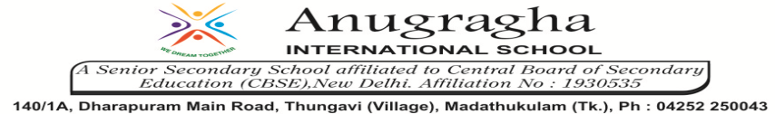

ANNUAL EXAMINATION-FEB-2020

KBQ - 04
NAME | «NAME_OF_THE_STUDENT» |  |  | AD.NO | «ADMNO»
CLASS | VII-«SECTION» |  |  | EX.NO | «EXNO»
G.D | 05.02.2020 | S.D | 08.02.2020 | SUB | SST
TOPIC: CH:10.LIFE IN THE DESERTS
Short Answer Type Questions:
1.Give physical landscape of Sahara desert.
2.Examine the climate of Sahara desert.
3.Describe the flora and fauna of Sahara desert.
4.How are depressions and oasis formed?
5.Describe the physical landscape of Ladakh.
Long Answer Type questions:
1.Descrie the life of people in Ladakh.
2.Write a note on inhabitation of Sahara.
3.Examine the altitude and climate of Ladakh.

