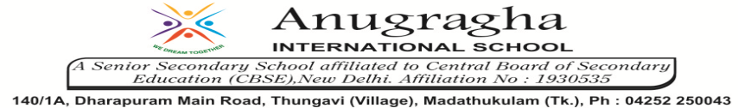

ANNUAL EXAMINATION-FEB-2020

KBQ - 04
NAME | «NAME_OF_THE_STUDENT» |  |  | AD.NO | «ADMNO»
CLASS | VI-«SECTION» |  |  | EX.NO | «EXNO»
G.D | 07.02.2020 | S.D | 10.02.2020 | SUB | SST
TOPIC: CH:11 NEW EMPIRES AND KINGDOMS
Short Answer Type Questions:
1.What changes do you find in the army at this time?
2.What were the new administrative arrangements during this period?
3.How did the Gupta empire emerge?
4.What was the contribution of Aryabhatta?
5.How was medical science developed under the Gupta age?
6.How were painting developed under Gupta Age?
7.How did Guptas decline?
8. Write a note on Chalukyas.
9. Who were the Pallavas?

Long Answer Type questions:
1.Describe the sources of knowing about the Guptas.
2.Write a short note on Samudragupta.
3.Give an account of slavery in India under Gupta Age.
4.Give an account of rise of Harshavardhan.
5.Describe an account of life of ordinary people of this age.

