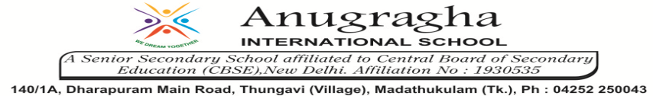

ANNUAL EXAMINATION-JAN-2020

KBQ - 03
NAME | «NAME_OF_THE_STUDENT» |  |  | AD.NO | «ADMNO»
CLASS | VI-«SECTION» |  |  | EX.NO | «EXNO»
G.D | 31.01.2020 | S.D | 03.02.2020 | SUB | SST
TOPIC: CH:8 RURAL LIVELIHOODS

Short Answer Type Questions:
1.List the different types of people you read about in Kalpattu who depend on farming. Who is the poorest among them and why?
2.How is life in rural areas a tough task?
3.How are rural livelihoods a battle for survival?

Long Answer Type questions:

1.How do people lead life in Kalpattu?
2.Write a note of Mangamma’s life as a casual labour. How does she lead a tough life?
3.How does Mangamma face economic problems?
4.How do villagers lead a tough life?
5.How do small farmers lead a life of indebtedness in India?
6.Examine the type of farming in Nagaland.
HOTS:
1.Poor rural laborers like Thulasi often do not have access to good medical facilities, good schools, and other resources. You have read about inequality in the first unit of this text. The differences between her and Ramalingam is one of inequalities. Do you think this is a fair situation? What do you think can be done?

