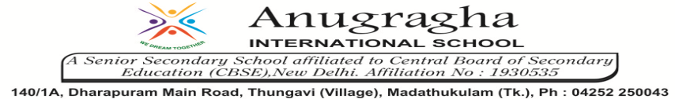

ANNUAL EXAMINATION-JAN-2020

KBQ - 03
NAME | «NAME_OF_THE_STUDENT» |  |  | AD.NO | «ADMNO»
CLASS | VII-«SECTION» |  |  | EX.NO | «EXNO»
G.D | 28.01.2020 | S.D | 31.01.2020 | SUB | SST
TOPIC: CH:9 A SHIRT IN THE MARKET

Short Answer Type Questions:

1.What made Swapana sell the cotton to the trader instead of selling at the Kurnool cotton market?

Long Answer Type questions:

1.Describe the conditions of employment as well as the wages of workers in the garment exporting factory. Do you think the workers get a fair deal?
2.Examine the activities involved in garments export centre in Delhi.
3.Write a note on the cloth market in Erode.
4.How are shirts exported to USA? How does US make profit in the chain of market?

HOTS:
1.Think of something common that we use. It could be sugar, tea, milk, pen, paper, pencil, etc., Discuss through what chain of markets this reaches you. Can you think of the people that help in the production or trade?
2. “The relationship between market and equality is intricate”. Explain.

