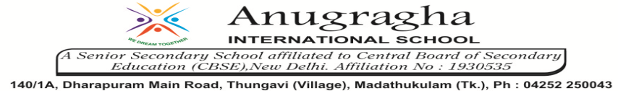

ANNUAL EXAMINATION-MAR-2020

KBQ - 07
NAME | «NAME_OF_THE_STUDENT» |  |  | AD.NO | «ADMNO»
CLASS | VII-«SECTION» |  |  | EX.NO | «EXNO»
G.D | 03.03.2020 | S.D | 05.03.2020 | SUB | SST
TOPIC: CH:10 STRUGGLES FOR EQUALITY

Short Answer Type Questions:
1.Which communities face discrimination in India?
2.Why do people struggle ? In what forms do they struggle?
3.How does the building of dam affect people?
4.Why was the Tawa Matsya Sangh formed?
5.How is the Indian Constitution a living document?
Long Answer Type questions:
1.How did TMS organize and support people?

