GRADE I
ENGLISH
DAILY PRACTICE PAPER
2019-2020

PRE-MID TERM
S.NO | DATE | CONTENT | REMARKS | TEACHER  SIGNATURE
1
2
3
4
5
6
7
8
9
10
11
12

CONCEPT BASED WORKSHEET
Objective: Identify the sounds:

Q1.Complete the following words:

- r__d 6. d___y
- p__ay 7. P___n
- c__y 8. gr__ __n
- tr__ __ 9. ha__ __y
- s__ n 10.S___t

Q2.Now read and spell out the words loud:

PLAY | DANCE | WRITE | SING | SWIM | CLIMB | EAT | READ
PLAY | DANCE | WRITE | SING | SWIM | CLIMB | EAT | READ
PLAY | DANCE | WRITE | SING | SWIM | CLIMB | EAT | READ
PLAY | DANCE | WRITE | SING | SWIM | CLIMB | EAT | READ

DATE: TEACHER’S SIGN:
CREATE AND INNOVATE
Objective: To improve the vocabulary

Q1.Make small words using the letters of given word ‘caterpillar’
E.g., : cat
1.
................................ ................................

2.
................................ ................................

3.
................................................................
4.
................................................................
5.
................................................................

Q2.Rearrange the letters in correct order to make a word:

1.der __________
2.nsu __________
3.yrc___________
4.yad___________
5.eert___________

DATE: TEACHER’S SIGN:

HEARING AND LISTENING

Objective: Identify the sounds and the reaction

Rhyming words with the same end sound.
Eg.cat and bat

Q1.Underline the word on the right that rhymes with the word on the left:

 | red | bed | bad | mat
 | Sun | ten | men | gun
 | Cry | bay | dry | Toy
 | tree | free | ghee | flee
 | sit | ten | bit | tin

Q2. Make a faces for the following questions:

For example: I buy a bicycle -

1.My mom bake me a cake -
2.Ram fell down in the park -
3.I won the game-
4.Ragu scold Banu -

DATE: TEACHER’S SIGN:

VISUAL STIMULUS BASED
Objective: To improve the visual and reading vocabulary

Q1. See the pictures and read the names:

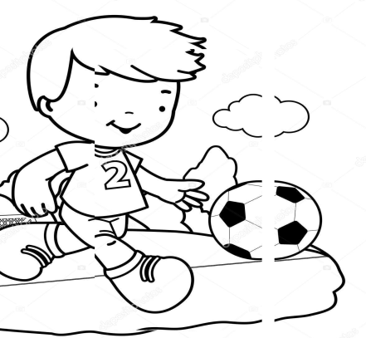

TREE HOUSE PLAY

CHILD LAUGH

Q2. Now read and spell out of these words loud:

Cry | happy | red | green | house

DATE: TEACHER’S SIGN:

CONCEPT BASED WORKSHEET
Objective: To improve visual skill and writing skill

I. MATHCH THE OPPOSITES:
- Day × cry
- Laugh × short
- Happy × night
- Long × stand
- Sit × sad
II. CHOOSE IT:
- I have a tree__________ (green/ red).
- My house is__________(blue/red).
- A _______ child am I (sad/happy).
- I hardly ever______(laugh/cry).
- When all my_______ is done (sleep/play).
III.MATCH THE FOLLOWING:
- Happy

- 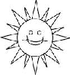 Cry
- Tree

- Sun

DATE: TEACHER’S SIGN:

CREATIVE BASED WORKSHEET
Objective: To improve small hand development

COLOUR THE PICTURE DAY TIME:
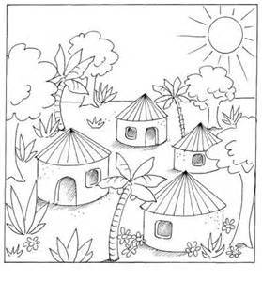
House - Red
Sun - Yellow
Tree - green

DATE: TEACHER’S SIGN:

CONCEPT BASED WORKSHEET
Objective: To improve the witting skill

I.WRITE THE ANSWER:
- Name the three little pigs?
Ans: ______________________________________________
- Who lived in a straw house?
Ans:______________________________________________
- Who lived in a sticks house?
Ans: ______________________________________________
- Who lived in a bricks house?
Ans: ______________________________________________
- Which animal blow the pigs house?
Ans: ______________________________________________
- Whose house was very strong?
Ans: ______________________________________________

DATE: TEACHER’S SIGN:
VISUAL BASED WORKSHEET
Objective: Thinking skill
I.MATCH THE ANIMALS:
- Dog - 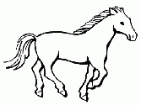
- Rabbit - 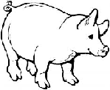
- Monkey - 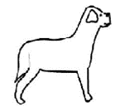
- Cow - 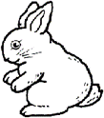
- Pig - 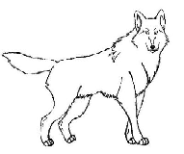
- Horse - 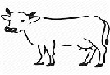
7) Wolf - 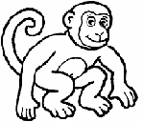
DATE: TEACHER’S SIGN:

VISUAL STIMULUS BASED
Objective: To improve the thinking skill by way of matching animals and their babies
MATCH THE FOLLOWING:
1] 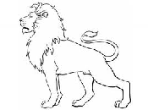 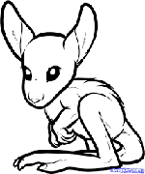
2] 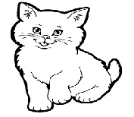 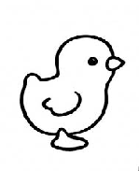
3] 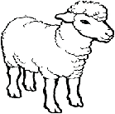
4] 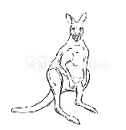 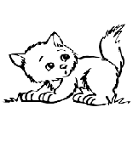
5] 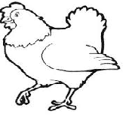 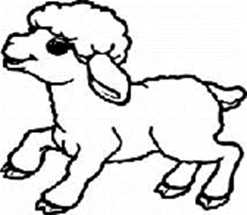

DATE: TEACHER’S SIGN:

NOUN FINDER
Objective: To know about noun
Circle each noun:-

the big Tom bus door
cat stick ate win this
on child apple mom pen
rug go is one how
dog bike sun desk room
find are it red me
goat eat boy lamp parrot
lion tree moon star was
girl monkey box up at
make fast water pencil sky
dance snow bottle John Ram

DATE: TEACHER’S SIGN:

APPLICATION BASED WORKSHEET
Objective:To improve the grammar skill

A.Circle the noun(s) in each sentence.

Nouns are a person, a place or a thing.

1. An apple a day keeps the doctor away.
2. Nick plays with his little brother.
3. The sun rises in the east.
4. Billy went to the store to buy candy.
5. Drinking milk is good for you.
B.Complete the word grids given below. Take help from the pictures.
1. Across Down
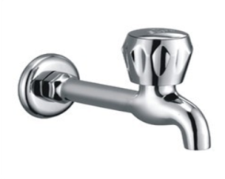
B |  | S
T |  | P

2.Across
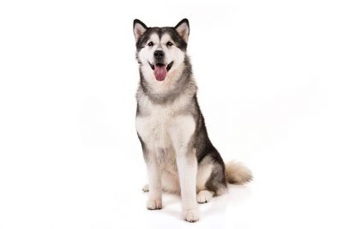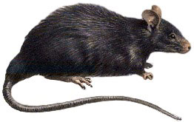

D |  | G
R |  | T

Down
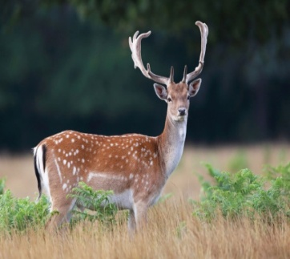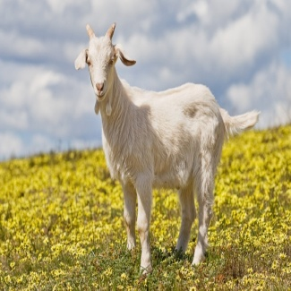

DATE: TEACHER’S SIGN:

APPLICATION BASED WORKSHEET
Objective: To improve the communication skill

I.Think and write - Write the naming words.

Things mango _______________________________
Places river _______________________________
Persons beggar _______________________________
Animals tiger ________________________________
Birds pigeon ________________________________

II. Circle the correct answers.

1. banana – fruit/animal
2. actor – thing/person
3. cow – thing/animal
4. school – place/person
5. pen – thing/place
III. Circle the animals and birds with blue. Circle the things with red.

Goat parrot pencil bed
Bear soap board duck
Shirt doll fan fish
Lion monkey lamp toy

DATE: TEACHER’S SIGN:
CREATIVE BASED WORKSHEET
Objective: Free-hand Drawing

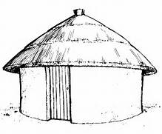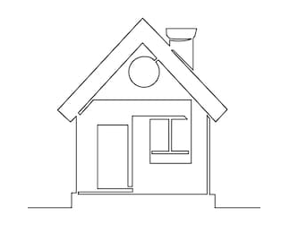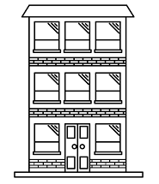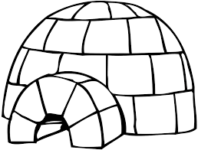

DATE: TEACHER’S SIGN:

