GRADE I
ENGLISH
DAILY PRACTICE PAPER
[DPP]
2019-2020

POST MID TERM
UNIT -5 MERRY- GO-ROUND
CREATIVE AND INNOVATIVE
Objectives: To improve the vocabulary
Rearrange the letters in correct order to make a word :

- uot - ____________ 6. obwnr - ____________
- rfai - ____________ 7. arod - ____________
- osrhe - ____________ 8.orse - ____________
- gib - ____________ 9. lcmib - ___________
- odnw - ____________ 10. ermry - ___________

Match the rhyming words :

- Merry - Down
- Round - Bye
- High - Cup
- Brown - Around
- Up - Jerry
- Big - Won
- Horse - Pin
- In - Dig
- Out - Rose
- On - Spout

DATE TEACHER’S SIGN

CIRCLE
CONCEPT BASED WORKSHEET
Objectives: To identify the sounds
Draw the following things using a circle :
Wheel | Moon | Ball
Balloon | Face | Cat

Now read and spell out the words loud :
CIRCLE | BLUE | LINE | MOON
RABBIT | WHEEL | SUN | YELLOW
FACE | BALLOON | DREW | SMALL
LOOK | SIT | CLAP | JOY

DATE TEACHER’S SIGN

CONCEPT BASED WORKSHEET
Objectives:To identify the sound
Complete the names of the colours:
1.Y ___ L L ___ W 6.W H ____ T E
2.G R ___ ___ N 7. B ____ O ___ N
3. B L ____ ____ 8. O ___ AN ___ E
4.R ____ D 9. P ____R P____ E
5.P ____ N K 10. G ____EY
Now read and spell out the words loud

MANGO | NUT | PEACH
ORANGE | BALLOON | ZIG-ZAG
CLAP | DOOR | TRAIN
APPLE | THREW | PEOPLE
FEW | GROW | FRUIT

Find and circle the differences between the two pictures.

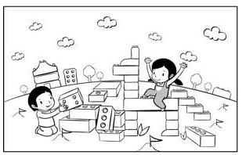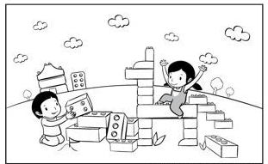

DATE TEACHER’S SIGN

PEN PAPER TEST
Objectives:To apply the concept
Have you ever been on a merry – go – round? How do you feel? Colour the right face

AFRAID CONFIDENT SAD HAPPY

Write true or false ( reading the story ‘circle’ )
- Mohini was sitting with her grandfather _______________
- Grandmother drew a circle _______________
- Mohini drew five lines on the circle _______________
- Grandmother drew a balloon _______________
- Mohini drew her own face also _______________

Fill in the blanks:
( ride , draw , moon, brown, zig-zag )
- I can ____________ a circle.
- The ___________ is round.
- I ______________ on a horse.
- Grandmother added a_____________ line to the circle.
- I climbed up on a big ________________ horse.

DATE TEACHER’S SIGN

APPLICATION BASED WORKSHEET
Objectives: To develop the grammar skill

Fill in the blanks, use ( A, AN )

1.______ engine 2._____ pencil 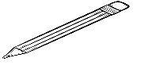
3._____ insect 4._____ mask 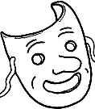
5._____ ink pot 6._____ table 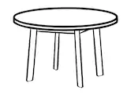
7._____ egg 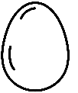 8._____ apple 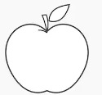
9._____ car 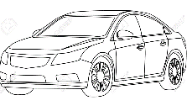 10._____ umbrella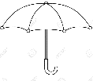

Singular and plural

Eg: Mango – mangoes

- Potato _ _________________ 4.Tomato _ _________________
- Box _ _________________ 5.Wish _ _________________
- Brush _ _________________

DATE TEACHER’S SIGN

UNIT-6 IF I WERE AN APPLE
CONCEPT BASED WORKSHEET

Objective: To develop the writing skill
Match the rhyming words.
1.Boy - a) Ball
2. Tree - b) Beat
3. Down - c) Me
4. Fall - d) Joy
5. Eat - e) Town

Put the following things under the correct heading:
Chair Car Bird Table Cat Duck Boy Bag Goat Pencil

Living things | Non- living things

DATE TEACHER’S SIGN

OUR TREE
VISUAL STIMULUS BASED WORKSHEET

Objective: To develop the thinking skill
Match the fruits with their names

Grapes Orange Apple Pomegranate Mango

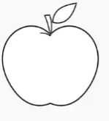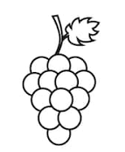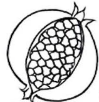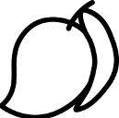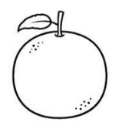

Answer the following:
1. What does the little bird see on the tree?
Ans: _________________________________________________________
2. How does the berry seed fall?
Ans: _________________________________________________________
3. Name the animals and birds found the tree.
Ans: _________________________________________________________
4. Have you seen any other animals on the tree?
Ans: _________________________________________________________
5.Name any two trees .
Ans : _________________________________________________________

DATE TEACHER’S SIGN

PEN PAPER TEST
Objectives: To improve their knowledge skill
Based on the poem “ If I were an apple” write the correct answer
( Tree , Eat , Apple , Once )
1.The boy wishes to be an ________________
2.Apples grow on a _______________________
3.The boy would fall down at ________________
4.The boy would say,”____________________ me, my boy!”

Label the parts of the tree :
Root Leaf Branch Trunk Fruit

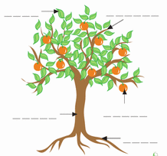

DATE TEACHER’S SIGN

APPLICATION BASED WORKSHEET
Objectives : To develop the communication skill
Fill in the missing vowels to complete the words:
R___ N 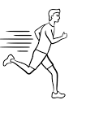 F____ T 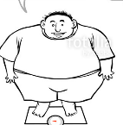 D_____ G
T_____ P 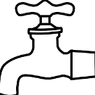 M ____ P 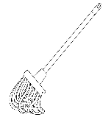 L _____ P 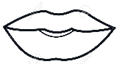
B _____ D B _____ X N ______ T 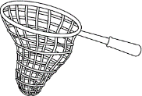
C _____ T 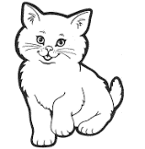 C ______ T Z _______ P 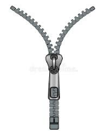
L ______ G 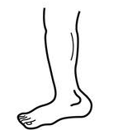 M ______ T 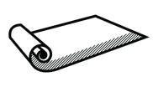 P ______ N

H ______ T 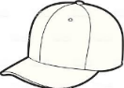 L ______ G 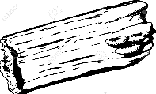 R ______ T 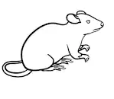

Write the correct position word. Choose the word given below:
On Inside Under Between Behind

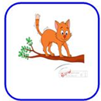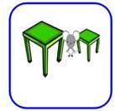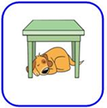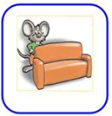
_______________ ________________ _______________ ____________ ______________
DATE TEACHER’S SIGN

CHECK POINT
Look at the picture and write the correct pronoun
1.__________ is kicking the ball.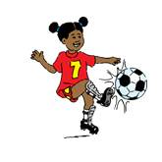2. This is _______________ hat.
3.__________ is dancing. 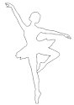 4.______________ is a blue bag.
5.___________ is standing. 6._________ is eating grass.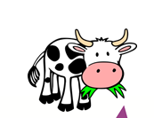

Circle the sentence with the correct preposition.
Jam is in the bottle.
Jam is on the bottle. Jam is under the bottle.

- 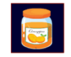
2.
A pen is under a pillow.

A pen is on a pillow. A pen is in a pillow.

3.
A TV is in the wall.

A TV is on the wall. A TV is under the wall.

4.
A man in on the rug.

A man is under the rug. A man is in the rug.

5.
A cake is in the oven.

A A cake is on the oven. A cake is under the oven.

DATE TEACHER’S SIGN

UNIT-7 A KITE
KNOWLEDGE BASED WORKSHEET
Objectives: To improve their reading skill
READING COMPREHENTION
Football
Ravi plays football.
He loves football.
Ravi can run fast and throw far.
He will ask John to play with him.
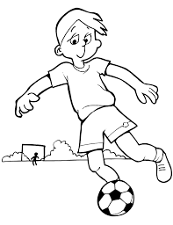
Choose the correct answer:
1. What does Ravi play?
A) games B) football C) cricket

2. What can Ravi do?
A) run fast B) jump high C) score

3. What will he do?
A) wear a hat B) run fast C) ask john to play

4. What is the title of this passage?
A) football B) cricket C) throw ball

5. Who played with Ravi?
A) Babu B) John C) Ramu
Now read and spell out the words loud:
Bride | Kite | Ride | Side | Sky
Cart | Chance | Dance | Fast | Part
Breeze | Blow | Ride | Chance | Fly
Wing | Rainbow | Moon | Cloud | Sun

SUNDARI
DATE TEACHER’S SIGN

APPLICATION BASED WORKSHEET
Objectives: To improve the thinking skill
Circle the odd one out
- Cat Dog Parrot Cow Frog
- Aeroplane Helicopter Bird Kite Lion
- Apple Banana Pink Orange Pear
- Red Green White Boy Black
- Mother Tree Father Brother Sister
Match the opposites:
- Small x Close
- Beautiful x Short
- Open x Big
- Give x Ugly
- Long x Take
- Like x Last
- Tough x Down
- Up x Dislike
- Lock x Easy
- First x Unlock

DATE TEACHER’S SIGN

PEN PAPER TEST
Objectives: To apply the concept
Write the things related to night:

Match the rhyming words:
1.Sit - Tide
2.Blow - White
3.Ride - Shy
4.Kite - Hit
5.Sky - Flow

Based on the poem “ a kite “ choose the correct answer
SKY KITE BREEZE BAND DIZZY

1.The child wants to be a ________________________
2.The child wants to fly up in the _______________
3. Child wants to ride upon the ______________
4.The ____________ was playing a tune
5. I feel ________________ on a merry – go – round

DATE TEACHER’S SIGN

CREATIVITY BASED WORKSHEET
Objectives : Free hand drawing
DRAW A KITE AND COLOUR IT WITH MULTIPLE COLOUR

Imagine you are a kite and you can fly high in sky. How do you feel? Write three lines on it:

1.______________________________________________________________

2._____________________________________________________________

3._____________________________________________________________

DATE TEACHER’S SIGN

CONCEPT BASED WORKSHEET
Objectives: To improve the grammar skill
Match the following
A | B
- Blue  - Grass  - Cold  - Sweet  - Sharp  - Hot  - Fast | Hopper  Ice- cream  Sky  Tea  Train  Knife  Mango

Choose the correct answer:
- The mouse is a ____________ (small/ big) animal.
- The _______________ (hungry / thirsty) dog ate the food.
- Nobody likes _________________ (honest / dishonest) people.
- The fox is a _______________ (clever / foolish) animal.
- The cow is ___________ (black / blue).

DATE TEACHER’S SIGN

