GRADE I
MATHEMATICS
DAILY PRACTICE PAPER
[DPP]
2019-2020

MID TERM
S.NO | DATE | CONTENT | REMARKS | TEACHER  SIGNATURE
1 |  | Concept Based Worksheet
2 |  | Application Based Worksheet
3 |  | Mathematical Ability
4 |  | Check Point
5 |  | Application Based Worksheet
6 |  | Concept Based Worksheet
7 |  | Numerical Ability
8 |  | Check Point
9 |  | Application Based Worksheet
10 |  | Pen Paper Test
11 |  | Application Based Worksheet
12 |  | Think And Write
13 |  | Mathematical Ability
14 |  | Concept Based Worksheet
15 |  | Pen Paper Test
16 |  | Check point
17 |  | Application Based Worksheet
18 |  | Pen Paper Test
19 |  | Think And Write
20 |  | Mathematical Ability

CONCEPT BASED WORKSHEET
ADDITION
Objective: To apply the numerics.
- Count and circle the correct answer.
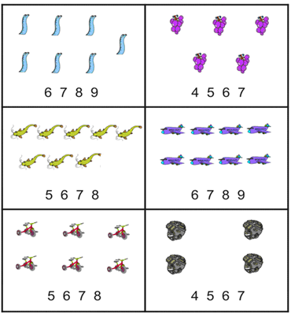

- Count and write.
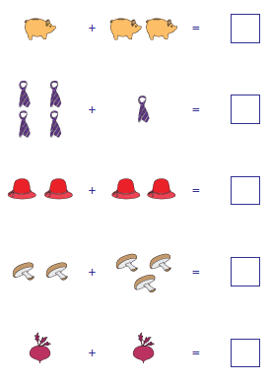
DATE TEACHER’S SIGN

APPLICATION BASED WORKSHEET
Objective: To check their Numerical ability.
- Count and write the numbers.

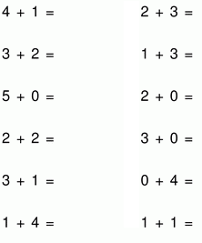
- Count and write.
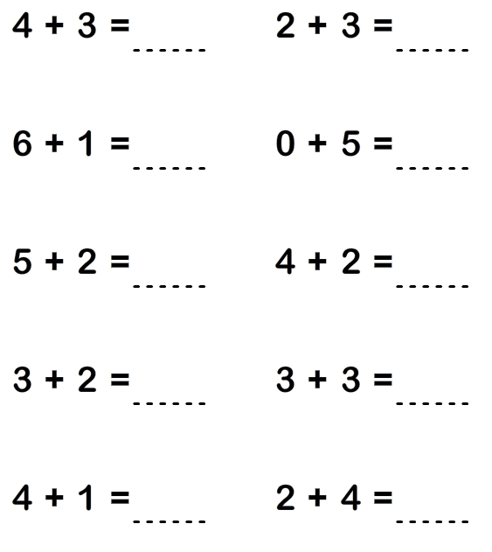
DATE TEACHER’S SIGN

MATHEMATICAL ABILITY
Objective:To check their Numerical ability.
- Add the numbers and write down the correct answer.
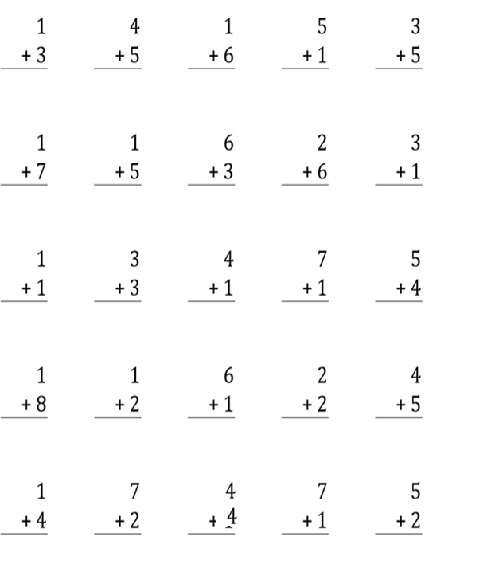

DATE TEACHER’S SIGN

CHECK POINT
Objective: To apply the numerics.
- Count and write the numbers.

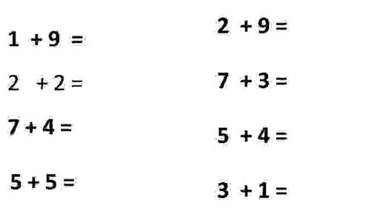
- Add the two numbers.

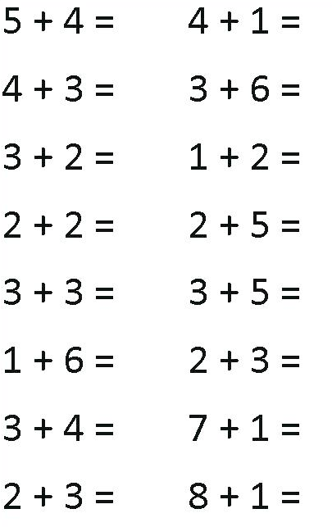

DATE TEACHER’S SIGN

APPLICATION BASED WORKSHEET
Objective: To think and solve the word problem.
1.Sam has 5 pens.
Dan has 3 pens.
How many pens in all ?

2.Jen has 3 cats.
Max has 2 cats.
How many cats in all ?

3.He saw 2 bugs.
We saw 4 more.
How many bugs in all ?

4.I have 4 hats.
Mom has 1 hat.
How many hats in all ?

DATE TEACHER’S SIGN

SUBTRACTION
CONCEPT BASED WORKSHEET
Objective: To solve simple equations involving subtraction.
- Subtract the following and find the remainder using vertical method. Cross out the objects taken away.
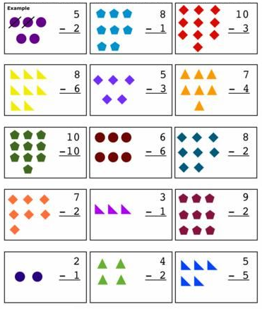
DATE TEACHER’S SIGN

NUMERICAL ABILITY
Objective: To apply the numerics.
- With the help of subtraction facts given for each object, cross out the flowers and write the remaining number of things.

- Count the pieces of food, then cross out the number of pieces you need to subtract. How many do you have left ?
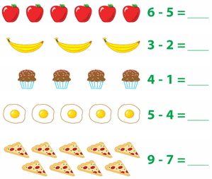
DATE TEACHER’S SIGN

DATE TEACHER’S SIGN

CHECK POINT
Objective: To check their Numerical ability.
- Subtract the numbers and write down the correct answer.

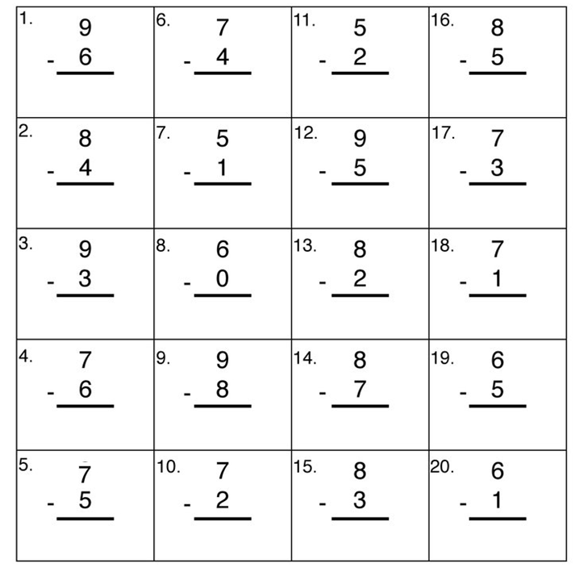

DATE TEACHER’S SIGN

APPLICATION BASED WORKSHEET
Objective: To develop their numerical ability.
- Subtract the numbers and write down the correct answer.

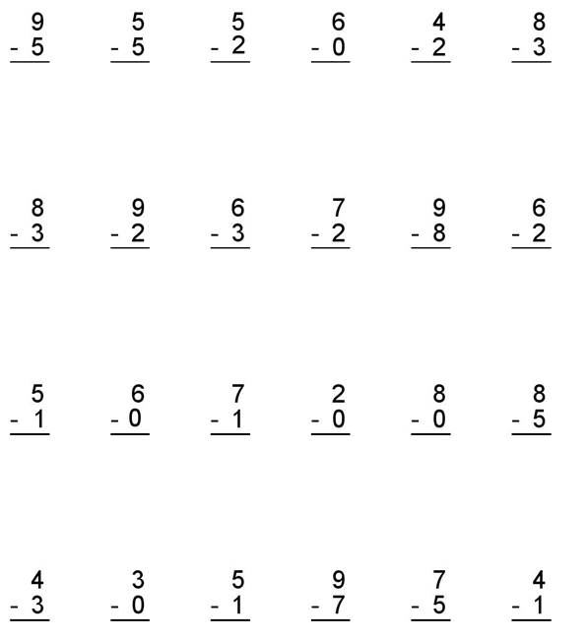

DATE TEACHER’S SIGN

PEN PAPER TEST
By this they can develop their Numerical ability.
- Subtract the numbers and write down the correct answer.
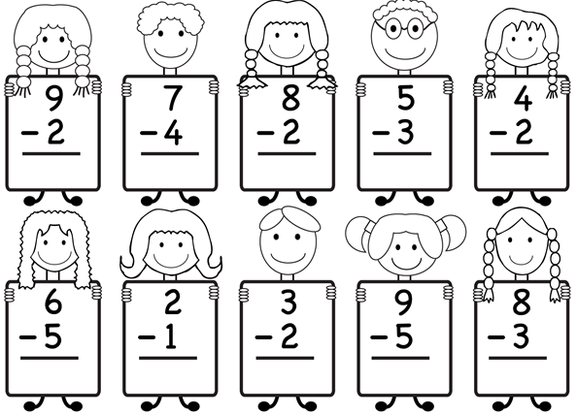

- Subtract the two numbers.
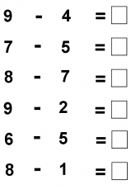
DATE TEACHER’S SIGN

6. FOOTPRINTS
APPLICATION BASED WORKSHEET
Objective: To know how to do story based sums.

- I see 6 rabbits.
3 rabbits hop away.
How many rabbit are left?

- I pick 9 carrots.
I ate 2 of them.
How many carrots are left?

- I see 7 birds.
5 birds fly away.
How many birds are left?

- I have 9 bananas.
I eat 6 bananas.
How many bananas are left?

DATE TEACHER’S SIGN

5.NUMBERS FROM TEN TO TWENTY
THINK AND WRITE
Objective: By this they can develop their Numerical ability.
- Fill in the numbers that are missing in the table.
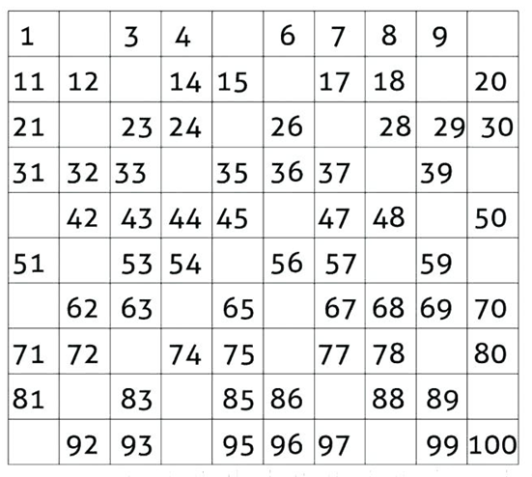
DATE TEACHER’S SIGN

MATHEMATICAL ABILITY
Objective:To improve their numerical ability.
- Find the missing numbers.
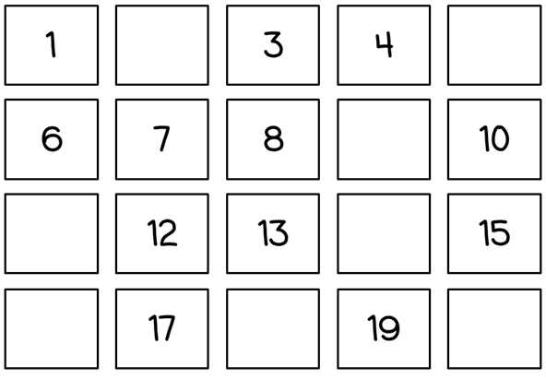

- Write the missing numbers(1-20).
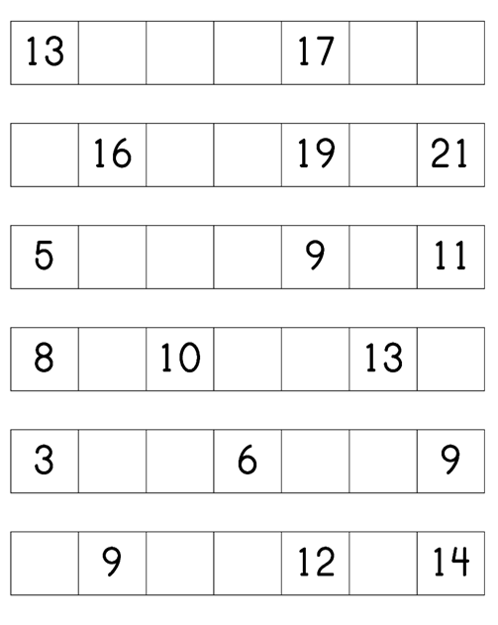
DATE TEACHER’S SIGN

CONCEPT BASED WORKSHEET
Objective: To think and write.
- Fill in the missing numbers by counting on in ones.
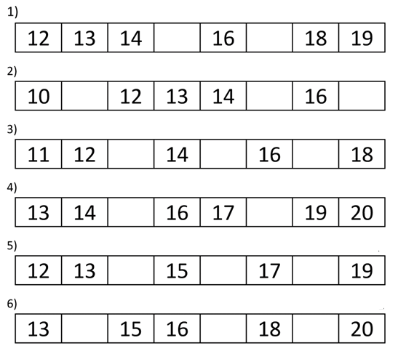
- Write the missing numbers.

DATE TEACHER’S SIGN

PEN PAPER TEST
Objective:To develop logical thinking with the help of numeric.
- Find and circle the smallest number.
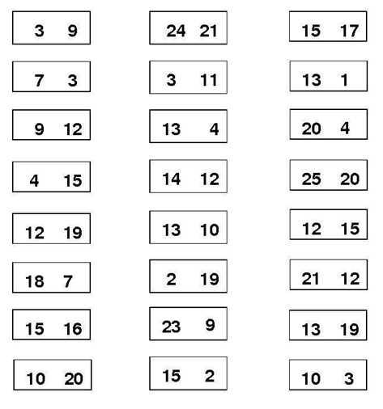
- Colour the smallest number in each flower.
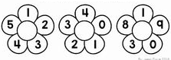
DATE TEACHER’S SIGN

CHECK POINT
Objective:To develop logical thinking with the help of numeric.
- Circle the biggest number in the row.
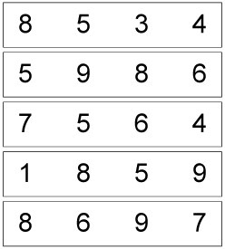

- Colour the number that is greater.
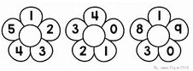
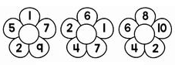

DATE TEACHER’S SIGN

APPLICATION BASED WORKSHEET
Objective: To identify the place values
- Make the group of ten and write the total number of objects. Also fill in the number of tens and ones in the space provided:
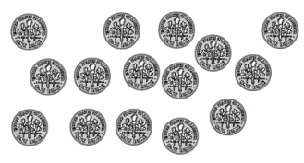
Tens | Ones

Tens | Ones

Tens | Ones

Tens | Ones
DATE TEACHER’S SIGN

PEN PAPER TEST
Objective: To apply the concept.
- Write the numbers 151 to 200.

DATE TEACHER’S SIGN

THINK AND WRITE
Objective: To know the numbers.
- Write the addition tables 1 and 2.

DATE TEACHER’S SIGN

MATHEMATICAL ABILITY
Objective: To check their writing skill

- Write number names from 11 to 20.

11 - ____________

12 - _____________

13 - _____________

14 - _____________

15 - _____________

16 - _____________

17 - _____________

18 - _____________

19 - _____________

20 - _____________

DATE TEACHER’S SIGN

