GRADE II
ENGLISH
DAILY PRACTICE PAPER
[DPP]
2019-2020

MID TERM
S.NO | DATE | CONTENT | REMARKS | TEACHER  SIGNATURE
1 |  | APPLICATION BASED
2 |  | CONCEPT BASED
3 |  | APPLICATION BASED
4 |  | CONCEPT BASED
5 |  | PAPER PENCIL TEST
6 |  | APPLICATION BASED
7 |  | RHYME WITH COLOURS
8 |  | CONCEPT BASED
9 |  | CONCEPT BASED
10 |  | VERB

UNIT-3
APPLICATION BASED
Objective : To identify singular and plural and form the sentence.
I.Fill in the blanks with the correct form of noun. Given in the bracket are in the singular form and plural form of the noun to be filled in.
1.My mother bought a new ____________. (car/ cars)
2.The __________ is kept on the table.(pen/pens)
3.Ram loves to read _________. (book/ books)
4.We saw a __________last night at the theatre.(movie/movies)
5.Suman has five _________. (apple/ apples)
6.There were two _______ on the lake at the sunset. (boat/boats)
7.How many __________ are there is your purse?(thing/things)
8.The _________is sitting on the table. (cat / cats)
9.There are countless ___________ in the sky. (star/stars)
10.How many ________ arethere in your class?(student/ students).
11. A rainbow has seven ________. (colour / colours)
12.Sita has a _______. (dog / dogs).
13. I helped my dad to wash the _____ this morning.( car/cars)
14. I checked out some ______ from the library. (book/books)
15.My mom read a _____ to me before bedtime.(book/books)

DATE TEACHER’S SIGN

CONCEPT BASED
Objective : Enhances the logical and relative thinking
I.Riddles
- What has hands but doesn’t clap? _________________
- What has to be broken before you can use it? _________
- What goes up but never comes back down? ___________
- I’m tall when I’m young, and I’m short when I’m old, what am I?_________
- What word is spelled wrong in every dictionary?_________
- What begins with an E but only has one letter?__________
- What is full of holes but still holds water? ___________
- Where can you find cities, towns, shops, and streets but no people? __________
- I have four legs but no tail usually I heard only at night. Who am I ? __________
10.What jumps when it walks and sits when it stand ? ________
11.Born of water.I drown in water. A blood thirsty beastyou can barely see.Who am I?_____________
12.What word in the English language still sounds the same after the consecutive removal of 4 of its letters?_________
13.They come out at night without being called, and are lost in the day without being stolen. what are they? ________
14.What has neither flesh, bone nornail yet has four fingers and a thumb?________
15.Which letter of the alphabet has the most water? ________

DATE TEACHER’S SIGN

APPLICATION BASED
I.Puzzles Time
Fill in the puzzle by using the pictures as clues. Find the correct spellings of words in the word bank.
¹
²
⁴

³
5
⁶
⁷

Down
1. It’s __________. 2. It’s __________.
3. What’s the ____________ like ? 5. It’s __________.
Across
1.It’s __________ 2.It’s __________

4.It’s __________ 5. It’s __________. 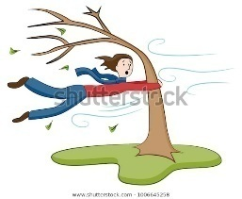

Weather Word Bank
6.It’s ___________.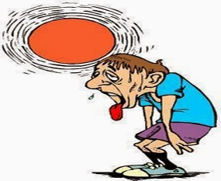 7.It’s ___________. 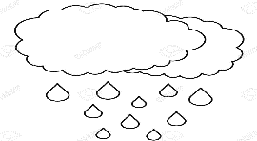
• Cloudy | • Snowy
• Cold | • Sunny
• Dry | • Weather
• Hot | • Wet
• Rainy | • Windy

DATE TEACHER’S SIGN

CONCEPT BASED
Objective :Enhances the linguistic skills
Write the opposites of the following.
1.Cheap × _________
2.Clean × _________
3.Deep × _________
4.Early × _________
5.Far × _________
6.Wide × _________
7.Heavy × _________
8.Here × _________
9.Interesting × _________
10.Warm × _________
Match the following
1. Soft - Rough
2.Young - Dangerous
3.Tight - Few
4. Many - Hard
5. Safe - Old
6.Smooth - Loose
7.Long - Hard
8.High - Rough

DATE TEACHER’S SIGN

PAPER PENCIL TEST
UNIT 4
Objective:
Read the paragraph and fill in the missing words from theword list.
play taking friends drops places sit

It had been raining all day. I could hear the __________ beat against the glass. I felt sad because I could not __________ with my friends outside. My dad said I could go __________ in his lap since I was in a bad mood. He said, “I get mad too when I can’t play with my __________. Let’s look at a map and pretend we’re __________ a trip to all of the different __________ we see on it!” It ended up being a fun afternoon!

Slowly Pulled Fast Spinning Stop
1.Claire _________ the door closed.
2.Tom was _________ round and round.
3.The car ________ to avoid a dog.
4.A train can move very _______.
5.A snail moves very _______.

DATE TEACHER’S SIGN

APPLICATION BASED
Objective: Learn the prepositions at the place.
Prepositions
About in under from untilup onbetween near beside
1.The dog was hidden _________ the table.
2.Nimai climbed _________ the tree.
3. The book was ________ frogs.
4.My mom is going to pick me _______ school.
5.We walked home _______ the store.
6.The fruits are _______ the bowl.
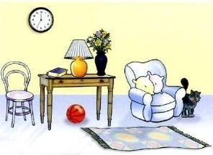
- The clock is ____________ the wall.
- The ball is ____________ the table.
- The cat is ________ the armchair.
- The table is _______ the armchair.
- The carpet is _______ the floor.
- The lamp is _______ the table.
- The flowers are ________ the vase.
- The table is _________ the chair and the armchair.
DATE TEACHER’S SIGN

RHYME WITH COLOURS
Objective: Learn words ending with same sound.
Rhyming words of similar sounds
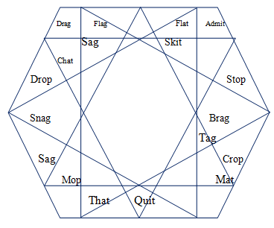

- Colour in blue for the words ending in “ag”
- Colour in green for the words ending in “at”
- Colour in yellow for the words ending in “op”
- Colour in pink for the words ending in “it”
DATE TEACHER’S SIGN

UNIT 4
CONCEPT BASED
Objective: Improve the logical thinking and sentence formation.
Rearrange these words to form the sentences.
1.Very is hot it?
Ans:___________________________________
2.Can you blue the ride bike?
Ans :___________________________________
3.Dress i new have a.
Ans: ___________________________________
4.Play will you me with?
Ans :____________________________________
5.At the look peacocks!
Ans :____________________________________
6.Honey a makes bee sweet.
Ans : ____________________________________
7.where apple is the?
Ans : ____________________________________
8.Eat i like banana to a.
Ans :_____________________________________

DATE TEACHER’S SIGN

CONCEPT BASED
Objective: Improve the logical thinking and sentence formation.
Draw a line connecting the group of words that make a complete sentence.
1.The big boat a. barks at the mailman.
2.The busy farmer b. is to take out the trash.
3.Many bright stars c.needs to be fixed.
4.A brown horse d. rattles her toy
5.My new dog e. taste delicious
6.The old house f. feeds the chickens
7.My brother’s job g. shine at night.
8.Many beautiful flowers h. sailed in strong winds
9.The cute baby i. bloom in the spring.
10. The juicy plums j. eats hay.

DATE TEACHER’S SIGN

VERB
Objective : Improves knowledge about tense forms.
Has, Had and Have

- I ___________ homework today. Present tense
- Sita ___________ to wake up early. Past tense
- We _________ to work together in math class Past tense
- Nitai ___________ a good idea Present tense
- You ___________ to help walk the dog. Present tense
- He________ to set the table before dinner. Past tense.
- Ram and Lakshmana ________hot lunch today. Present tense
- I ________ fun playing with my cousins. Past tense
- You __________ a pencil under your desk. Past tense
10.Cheetahs ________________ spots. Present tense
11.My sister and I ________ a pet dog named Daisy.
12.An elephant ____ a long trunk.
13.Madhu ____ to go to practice after school.
14.I _____ a book about animals in my desk.
15.We _____ idly for dinner last night.
DATE TEACHER’S SIGN

