GRADE II
MATHEMATICS
DAILY PRACTICE PAPER
[DPP]
2019-2020

MID TERM
S.NO | DATE | CONTENT | REMARKS | TEACHER  SIGNATURE
1 |  | Concept Based Worksheet.
2 |  | Critical Thinking
3 |  | Numerical Ability
4 |  | Mathematical Ability
5 |  | Application  Based
6 |  | Numerical Ability
7 |  | Concept Based Worksheet.
8 |  | Logical Thinking Enhancing
9 |  | Pen Paper Test
10 |  | Concept Based Worksheet.
11 |  | Free Hand Drawing
12 |  | Application Based
13 |  | Riddles
14 |  | Concept Based Worksheet.
15 |  | Measuring Volume
16 |  | Learning The Units
17 |  | Pen Paper Test

3. HOW MUCH CAN YOU CARRY?
CONCEPT BASED WORKSHEET
Objective: To know the concept of heavy and light.
Fill in the blanks with heavier or lighter:

1)Apples are __________ than chips.
2)The bears are __________ than an elephants.
3) I am __________than my mother.
4)Hens are __________ than a goat.
5)Dog is __________ than a fish.
6)2 Apples are __________ than a 2 bananas.
7)A toddler is __________ than a boy.
8)A car is __________ than a bicycle.
9)A empty water bottle is__________ than a lunch box.
10)A Desktop is __________ than Laptop.

DATE TEACHER’S SIGN

CRITICAL THINKING
Objective: To think and solve the word problem.

Read the story and answer the questions:
Once there lived a woman, she had some cattles like 10 hens,5 goats and 3halfs.10 hens each hens weights 2kg, 5 goats in that 2 goats weight is 5kg,3 goats weights 15 kg and 3 calfs which weights 65 kg each.
Questions:
1.What is the total weight of goats ? --------KG
2.which cattle is heavier calf or hen? -------------
3.what is the total weight of 2 calfs? --------KG
4.If we add 5 hens of same weight what may be the total weights of hens? ----------KG
5.What will be the weights of 2 hens and 3 calfs? -----------KG
6.What will bethe weights of hen if she sold 3 hens from those 10, whether weights become heavier or lighter? ------------------
7.The women can able to lift 45Kg ,if possible which cattle category she can lift? ---------
8. How many cattles are there in total? -----------
9.What is the total weight of hens? ------------
10.What is actual weight difference between the goat and calfs?
----------KG

DATE TEACHER’S SIGN

4.COUNTING IN 10’S:
NUMERICAL ABILITY
Objective: To know numeric’s.
Write 10 timetable in clouds:
10X10=
10X3=

10X2=
10X7=

10X6=
10X5=

10X9=
10X4=

10X1=
10X8=

DATE TEACHER’S SIGN

MATHEMATICAL ABILITY
Objective: To know skip count.
Counting numbers in 10’s:
1.
10 |  | 30 | 40 |  | 60
2.
2 |  | 22 | 32 |  | 52
3.
6 | 16 |  |  | 46
4.
110 |  | 130 |  |  | 160
5.
84 |  |  | 114 |  | 134
6.
67 |  |  | 97
7.
212 |  |  | 242 |  | 262
8.
780 |  | 800 |  | 820
9.
81 |  |  | 111 |  | 131
10.
128 |  | 148

DATE TEACHER’S SIGN

APPLICATION BASED WORKSHEET

Objective: Story based sums
1.Tim has four bins of cars.Each bin have 10 cars.How many cars does he have?
Sol:
Total no of bins : _____.
No of cars in each bin : _____.
Total no of cars : _____.

2.My pet dog likes to eat bones. Every day he likes to eat five bones.In four days how many bones will he eat?
Sol:
No of bones in each day : _____.
Total no of days : _____.
Total no of bones in 4 day : _____.

3.On Wednesday you saw 13 robbins in one tree and 7 robbins in another tree.How many robbins in altogether?
Sol:
No of robbins in one tree : _____.
No of robbins in another tree : _____.
Total no of robbins : _____.

4.Today is May 3rd your birthday is on 23rdMay.How many more days until your birthday?
Sol:
Today’s date : _____.
Your birthday falls on : _____.
Remaining days : _____.

5.Matt and his brother went out Matt saw 6 hamster ,his brother saw 24 hamsters.How many clouds they saw altogether?
Sol:
No of hamsters seen by Matt : _____.
No of hamsters seen by his brother : _____.
Total no of hamsters : _____.

DATE TEACHER’S SIGN

NUMERICAL ABILITY

Objective: To think and write
Counting in 10’s with the help of airthematic operations:

MENTAL MATH
35 | Now add 100.
47 | Now subract 20.
58 | Now (+) 60.
89 | Now add 90
96 | Now(–) 60.
54 | Now sum 110.
78 | Now (–) 50.
120 | Now subract 80.
91 | Now deduct 30.
32 | Now sum 70.

DATE TEACHER’S SIGN

DATE TEACHER’S SIGN

5.PATTERNS
CONCEPT BASED WORKSHEET
Objective: To think and answer logically.
What comes next?

DATE TEACHER’S SIGN

LOGICAL THINKING ENHANCING
Objective: To know and fill the sequence.
Read and write the correct sequence:
35 | 45 | 55 | 65 | 75
8 | 16 | 24 | 32 | 40
1A | 2B | 3C | 4D | 5D
Zz | Yy | Xx | Ww | Vv
6 | 9 | 12 | 15 | 18
1*2 | 2*4 | 3*6 | 4*8 | 5*10
100 | 90 | 80 | 70 | 60
eE | gG | iI | kK | mM
1.5 | 2 | 2.5 | 3 | 3.5
93 | 97 | 101 | 105 | 109

DATE TEACHER’S SIGN

PEN PAPER TEST
Objective: To apply the concept.
Determine which choice the best describe the rule pattern is using:
- Which choice is using the same addition rule as the pattern shown?
2, 12, 22, 32, 42
- 7, 17, 27, 37,47
- 5, 15, 35, 45, 25
- 43, 53, 65, 78, 3
- 89, 7, 90, 5, 76

- Which choice is using the same subtraction rule as the pattern shown?
33, 26, 19, 12, 5
a)9, 18, 27, 36, 48
b) 6, 13, 24, 34, 42
c) 37, 30, 23, 16, 9
d) 57, 50, 43, 35, 22

- Which choice is using the same skip count rule as the pattern shown?
8, 12, 16, 20, 24
- 45, 41, 34, 30, 22
- 88, 92, 96, 100, 104
- 9, 15, 21, 27, 33
- 7, 10, 13, 16, 19

- Start at 15 and add 7 at each time: ____, ____, ____,____,____.

- Start at 128 and deduct 8 for each time:____, ____, ____,____,____.

DATE TEACHER’S SIGN

6. FOOTPRINTS
CONCEPT BASED WORKSHEET
Objective: To understand what are the shapes.
Match the following:
1. |  | Cuboid
2. |  | Star
3. |  | Cone
4. |  | Cube
5. |  | Circle
6. |  | Rectangle
7. |  | Oval
8. | 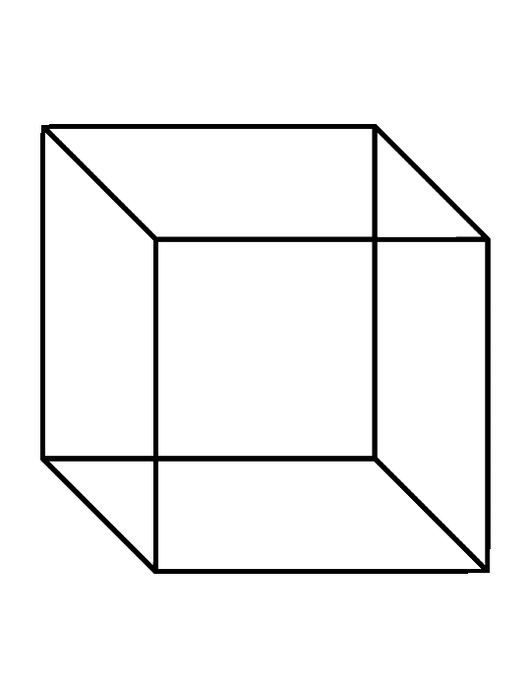 | Diamond
9. |  | Triangle
10. |  | Square

DATE TEACHER’S SIGN

FREE HAND DRAWING
Objective: To known to draw a picture using shapes.
Draw a picture using the shapes given below and colour the pictures by using the instruction given below :

- Red - - Green - Blue

- Orange - - Yellow - - Pink

DATE TEACHER’S SIGN

APPLICATION BASED WORKSHEET
Objective: To apply the concept based on numerical ability.
My shape Robot

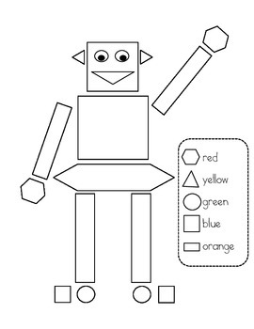

1)My robot has _________ circles.
2)My robot has _________ rectangles.
3)My robot has _________ squares.
4)My robot has _________ triangles.
5)My robot has _________ hexagons.

DATE TEACHER’S SIGN

RIDDLES
Objective: To think logically.
Word problem:
1.I have 4 sides all the same size and I have 4 corners.Who I am?____________.
2.I am thinking of an odd number,it is greater than 6 and less than 9.
What I am thinking? ____________.
3.In a tree there was 7 birds a loud noise scared some birds,now there was only 3 birds in the tree.How many birds scared of loud noise?____________.
4.Today is Monday my birthday has 5 many more days.What is my birthday on?____________.
5.You have to share your 12 candy with your friend,How many will each get?____________.
6.Sam has 9 balloons,3 are red 4 are blue and 2 are yellow.How many balloons are there in red and yellow colour?____________.
7.Can you solve;
+ = 15

_ = 5

X = ____

DATE TEACHER’S SIGN

7.JUGS AND MUGS
CONCEPT BASED WORKSHEET

Objective: To know the estimating concept.
Circle the objects that holds more than the other in each pair.
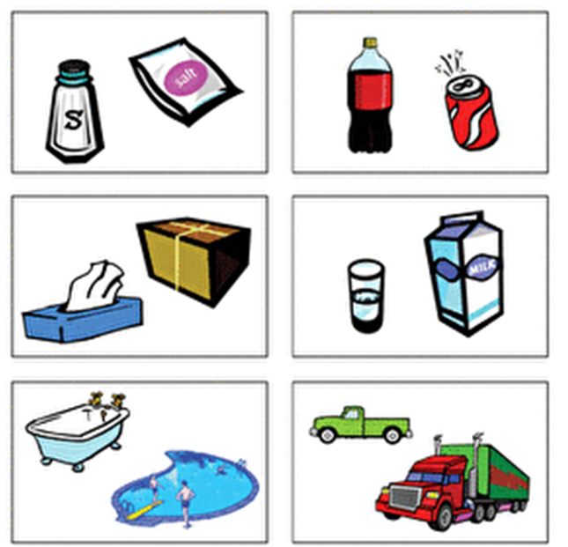

DATE TEACHER’S SIGN

MEASURING VOLUME

Objective :To know the measuring volume.

Estimate the each object can hold. Then find the actual amount that the container can hold.

Item | Estimate | Actual
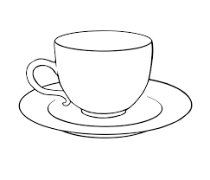 | ________ spoons. | ________ spoons.
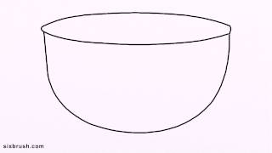 | ________ glasses. | ________ glasses.
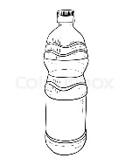 | ________ glasses. | ________ glasses.
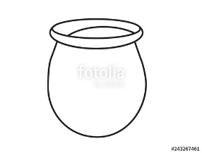 | ______ waterbottles . | ______ waterbottles .
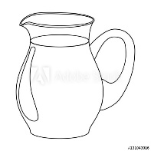 | ________ glasses. | ________ glasses.
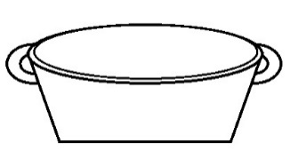 | ________ pots. | ________ pots.
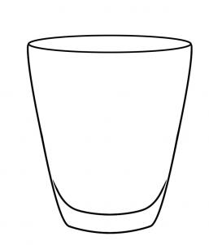 | ________ spoons. | ________ spoons.
DATE TEACHER’S SIGN

LEARNING THE UNITS.
Objective: To know the units for the liquids.
Read and write the answers:
1000ml = 1 l.
ml = milli litre
l = litre
Convert l (litre) into ml (millilitre) and viceversa:
1)5 l = _______ ml.
2) 7 l = _______ ml.
3)9 l = _______ ml.
4)2 l = _______ ml.
5)11 l = _______ ml.
6)6 l = _______ ml.
7)4 l = _______ ml.
8)2.5 l = _______ ml.
9)8 l = _______ ml.
10)12 l = _______ ml.
11)9.2 l = _______ ml.
12)7.1 l = _______ ml.
13)6.3 l = _______ ml.
14)1 l = _______ ml.
15)3 l = _______ ml.
DATE TEACHER’S SIGN

PEN PAPER TEST
Objective: To apply the concept.
Solve the following word problems:

1)Seena filled 9 pots with water.She fills 100ml on each pots.How much water she filled in all the pots? _____________.

2)There are 3 empty bottles in a bench. Each bottle can hold 1l of juice.How much juice is required to fill all the bottles? _____________.

3) Solve: 630 ml + 370 ml = _________l.

4) A cow can give 8l of milk a day. How much milk can cow give in 3 days? _____________.

5)The volume of 1 cane of slice is 500 ml . What is the volume of 5 cane? _____________.

6) Magil ask Abi to fill a glass with 10ml of water . How much glass can he fills with 50ml of water?_____________.

7)Vedha had 7l of lime juice in that vedha and his friend Karthi drank 3l of juice. How much juice is remaining with Vedha?_____________.

DATE TEACHER’S SIGN

