GRADE II
MATHEMATICS
DAILY PRACTICE PAPER
[DPP]
2019-2020

POST MID TERM
8.TENS AND ONES
CONCEPT BASED WORKSHEET
Objective : To know the concept of tens and ones.
Write ones and tens in the correct place:
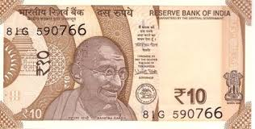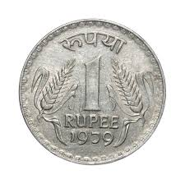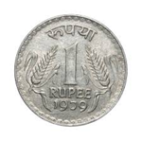 | Tens | Ones
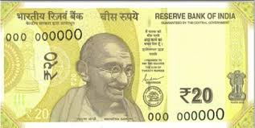

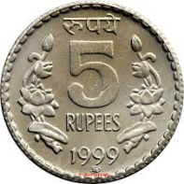

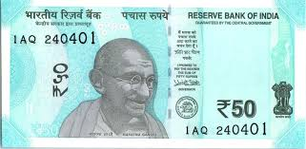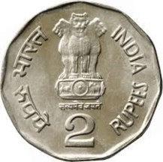

DATE TEACHER’S SIGN

CRITICAL THINKING
Objective: To think and solve the problems.
Add . Then follow the clue to find the right key. Write the Answer in the key hole.
- Find the key with the greatest number in the tens place.
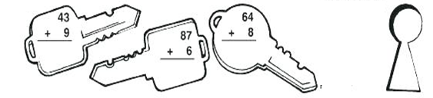
- Find the key with the greatest number in the ones place.
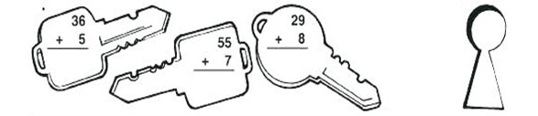
- Find the key with even numbers in the ones and tens place.
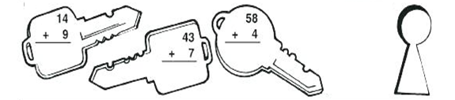
- Find the key with zero in the ones place.
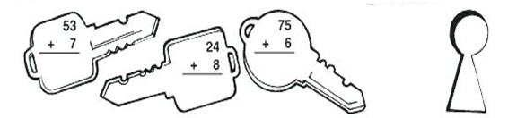
- Find the key with the same number in the ones and tens place.
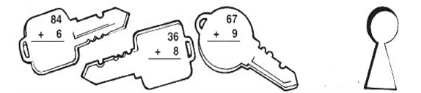
DATE TEACHER’S SIGN

Numerical ability
Objectives : To develop their numerical ability.
Write the number names and ones and tens:
NUMBERS | NUMBER NAME | TENS AND ONES | DRAW
12 | Twelve | - tens  2 ones
28 |  | _______ tens  _______ones
57 |  | _______ tens  _______one
94 |  | _______ tens  _______ones
42 |  | _______ tens  _______ones
60 |  | _______ tens  _______ones

PLACE VALUE

98 = tens + ones

87 = tens + ones

11 = ten + one

60 = tens + ones

56 = tens + ones

DATE TEACHER’S SIGN

APPLICATION BASED WORKSHEET
APPLICATION BASED WORKSHEET
Draw beads on the Abacus for the given numbers .First one has been drawn for you. 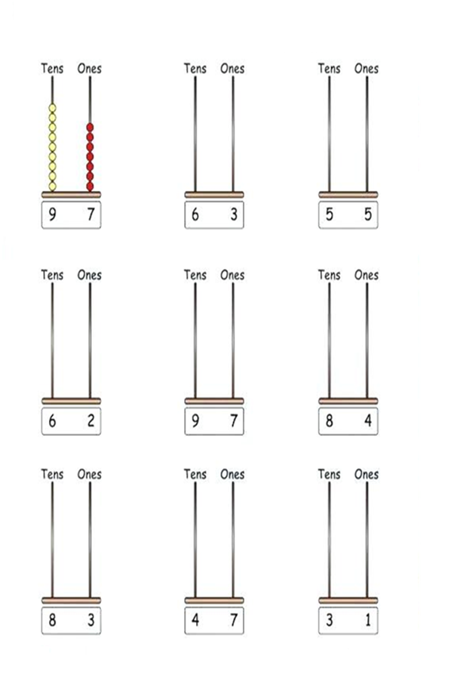
DATE TEACHER’S SIGN

PEN PAPER TEST
Objectives: To apply the concept
Find the Place Value
73 = + tens + ones

95 = tens + ones

23 = tens + ones

48 = tens + ones

54 = te tens + ones

Fill in the blanks:
a) 1 ten and 9 ones is ____________
b) 2 tens and 6 ones is ____________
c) 3 tens and 5 ones is ____________
d) 4 tens and 4 ones is ____________
e) 5 tens and 3 ones is _____________
Draw beads on the abacus for the given numbers:
i) 45 ii)35
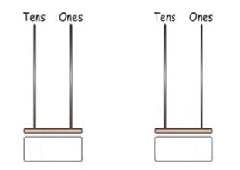

DATE TEACHER’S SIGN

9. MY FUNDAY
CONCEPT BASED WORKSHEET
DAYS OF THE WEEK:
Write the unscramble words:
UNASYD

NOMYAD

ESUTADY

DWESENAYD

SRTHDYUA

IRDFYA

YASARUDT

DATE TEACHER’S SIGN

LOGICAL THINKING
Objective: To know the Months of the year
i)Fill in the blanks :

Last Month | This Month | Next Month
 | November
 | February
 | June
 | January
 | August
 | October
 | December
 | July

Write missing letters:
- M ____ R ____ H

- A ____R ____ ____

- S ____P T ____ MB ____R

- M ____Y

e) J ____ ____ E

DATE TEACHER’S SIGN

UNDERSTANDING BASED WORKSHEET

Write the months in the appropriate column:
January , February , March , April , May , June, July , August , September , October , November, December.

30 Days | 31 Days

February has 28 days. Four year once it has 29 days so that year is a leap year.

DATE TEACHER’S SIGN

APPLICATION BASED WORKSHEET
Objective : To think and write
Answer the questions according to the calendar:

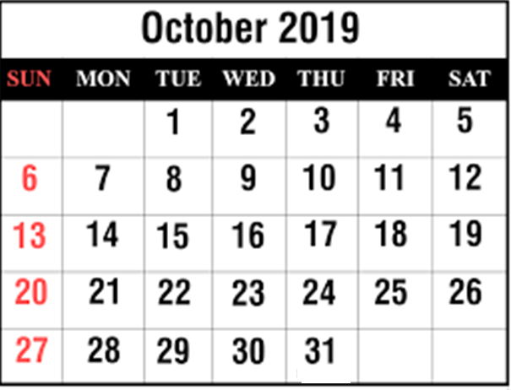

1.What is the date of the last Monday of October? __________________
2.How many Thursdays are there in October? __________________
3.Which day of the week is October 29th ? __________________
4. Which day of the week is October 6^{th?} __________________
5. How many days are there in October? __________________

DATE TEACHER’S SIGN

PEN PAPER TEST
Objectives: To apply the concept.
I.Fill in the blanks:
1.Write the month in which your birthday falls? ________________
2.How many days are in a week? ________________
3.How many months are in a year? _________________
4. Write the next leap year. _________________
5. Write the name of the 5th month. _________________

II. Write the name of the months:

III. Write days of the week:
1)
2)
3)
4)
5)
6)
7)
DATE TEACHER’S SIGN

10. ADD OUR POINTS
KNOWLEDGE BASED WORKSHEET
ADDITION

T | O
1 | 6
 | 2
T | O
2 | 5
3 | 2
H | T | O
1 | 2 | 2
 | 0 | 5

+
+
+

T | O
0 | 6
7 | 6

T | O
3 | 5
1 | 9
T | O
1 | 6
4 | 6

+
+
+

T | O
5 | 6
2 | 8
T | O
6 | 7
1 | 9

H | T | O
1 | 7 | 9
 | 7 | 5

+
+
+

DATE TEACHER’S SIGN

APPLICATION BASED WORKSHEET
Objectives:To Think And Write.
Money calculation

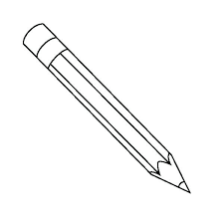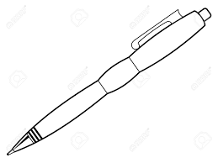
3 2 5

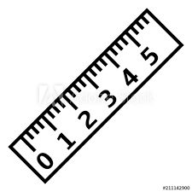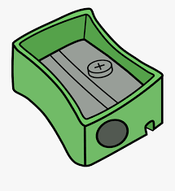
10 6 4
________________________________________________________________
FILL IN THE BLANKS
1.To buy a pencil and eraser I need ____________
2.To buy a scale and sharpener I need ________
3.With Rs.9 I can buy a ______________ , ________________ and _______________
4. Scale + Pen = _____________
5. Total cost of all things ________
6.To buy a water bottle and pen I need ________________

DATE TEACHER’S SIGN

MATHEMATICAL ABILITY
Objectives: To develop their numerical ability.
Write the answer:
1.10 + 34 = 2. + 12 = 22

3. 15 + = 30 4. 13 + 24 =

5. + 15 = 30 6. 20 + = 50

7.23 + 7 = 8. + 8 = 20

9.5+ = 40 10. 15 + 15 =

Objectives:To improve their thinking skills
State whether the following statements are true or false.
- If Indhu had 5 toys and her aunt gave her 7 more , then the total number of toys with her is 12.

- Divya had 6 balloons of green colour and 9 balloons of yellow colour
in total she had 13 balloons.
- Swara bought 5 pockets of biscuits and 5 pockets of chocolates .Finally
She had 11 pockets of snacks.
- Iniya had 3 dog toys , 4 vehicle toys and 5 bird toys. The total number
of toys she had is 12.
- Gayathri invited 8 friends from school and 9 friends from her
neighbourhood to her birthday party. The number of guests invited
the birthday party is 17.
DATE TEACHER’S SIGN

PEN PAPER TEST
Objective : To apply the concept
Fill in the boxes using 1-digit numbers:
a)

+ + = 7

^{b)}

b)
+ + + = 8

c)
+ + + = 12

Match the following:

a) | 8 | i) | 1+3
b) | 9 | ii) | 2+4
c) | 4 | iii) | 4+1
d) | 6 | iv) | 6+2
e) | 5 | v) | 8+1

DATE TEACHER’S SIGN

12. LINES AND LINES
CONCEPT BASED WORKSHEET
Objective : To improve the Creative thinking.
Draw pictures using lines and curves

DATE TEACHER’S SIGN

SKILL BASED WORKSHEET
Objectives: To improve thinking skill.
Write any 2 alphabets and 2 numbers by using match sticks.

DATE TEACHER’S SIGN

DRAWING SKILL
Objectives:To improve innovative thinking.
I.Join the dots with curved or straight lines. Make a own designs:

. . . . . . . . . . .
. . . . . . . . . . .
. . . . . . . . . . .
. . . . . . . . . . .
. . . . . . . . . . .
. . . . . . . . . . .

.
Tick () those that have curved lines in them and cross (x) those that do not have curved lines in them.
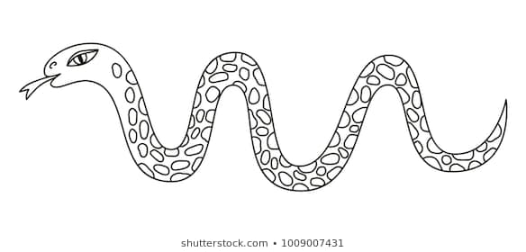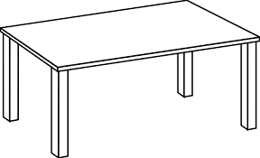

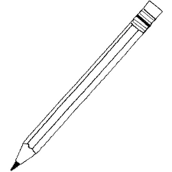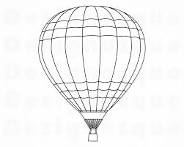

DATE TEACHER’S SIGN

DRAWING SKILL
Objectives:To initiate innovative thinking.
In the box given, draw any 1 activity by using slanting line and sleeping line:

DATE TEACHER’S SIGN

PEN PAPER TEST
Objectives: To apply the concept.
Tick in the yes box, if the figure has straight lines and tick in the No box if the figure has no straight lines.
Yes | No
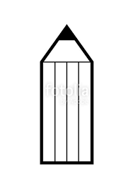
Yes | No
Yes | No
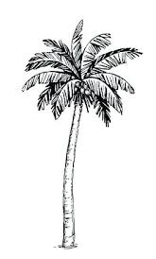

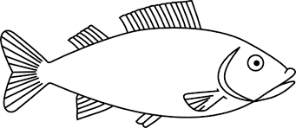
Name the following lines:
a)= ____________ b) = __________

Subtract:

T | O
6 | 4  _
2 | 3
T | O
5 | 6
2 | 1

_
T | O
7 | 9
5 | 3  _
H | T | O
6 | 9 | 7
3 | 1 | 4

_

H | T | O
5 | 9 | 7
0 | 4 | 6  _
H | T | O
4 | 8 | 7
3 | 0 | 0  _

Write 4th , 5th and 6th tables:

4th table | 5th table | 6th table
DATE TEACHER’S SIGN

