GRADE III
ENGLISH
DAILY PRACTICE PAPER
[DPP]
2019-2020

MID TERM
S.NO | DATE | CONTENT | REMARKS | TEACHER  SIGNATURE
1
2
3
4
5
6
7
8
9
10
11
12

UNIT III
POEM: LITTLE BY LITTLE
PAPER PENCIL TEST
Objectives: Able to rearrange the words to make a meaningful sentence.
Rearrange the words to form meaningful sentences.

- Like / fruits / I / and / vegetables
_____________________________________________________________________
- Soldiers / fought / The / bravely
_____________________________________________________________________
- wrote / a / letter / He
_____________________________________________________________________
- day / new / Everyday / is / a
_____________________________________________________________________
- Neha / music / likes
_____________________________________________________________________
- with/ I / playing / my /dog / enjoy
_____________________________________________________________________
- mother / cook / my / great / is/ a
_____________________________________________________________________
- letter / I / to / post / the / forgot
_____________________________________________________________________

DATE TEACHER’S SIGN

NOUN FINDER
Objectives: Able to find the countable and uncountable noun
Categorize Countable (C) and Uncountable (UC) nouns.

- Room -

- News -

- Books -

- Money -

- Smoke -

- Cotton -

- Pencil -

- Shop -

- Birds -

- Milk -

DATE TEACHER’S SIGN

PICTURE COMPREHENSION
Objectives: Able to see the picture and write few sentences about it.
Write five sentences to describe the picture and give a suitable title.
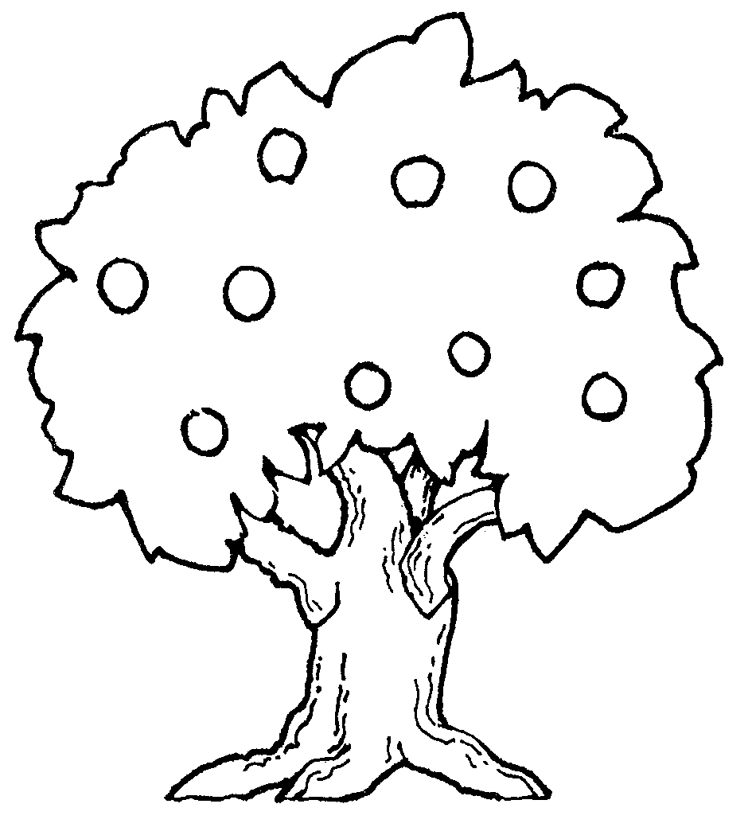
TITLE:

1.

2.

3.

4.

5.

DATE TEACHER’S SIGN

PICTURE COMPREHENSION
Objectives: Able to see the picture and write few sentences about it.
Write five sentences to describe the picture and give a suitable title.
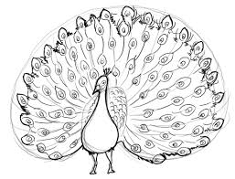
TITLE:

1.

2.

3.

4.

5.

DATE TEACHER’S SIGN

PROSE: THE ENORMOUS TURNIP
SPOT THE CORRECT ANSWER
Objectives: Able to find the correct answer.
Circle the odd one out.
- Potato Brinjal Onion Apple
- Banana Orange Carrot Mango
- Enormous Big Large Tiny
- Black White Table Pink
- Rose Rabbit Lion Elephant
- Parrot Peacock Purple Crow
- Daisy Daffodil Sheep Diascia
- King Prince God Duchess
- Doctor Teacher Postman Priest
- Monkey Dog Fish Cat
- Man Phone Fridge Piano
- Read Write Play Bench
- I He She They

DATE TEACHER’S SIGN

PAPER PENCIL TEST
Objectives: To write the plural form of the noun.
Write the plural form of the singular noun.
- Child -
- Fish -
- Foot -
- Man -
- Leaf -
- Person -
- Mouse -
- Woman -
- Tooth -
- Deer -
- News -
- Day -
- Goose -
- Box -
- Friend -
DATE TEACHER’S SIGN

PARAGRAPH COMPREHENSION
Objectives: Able to read the passage and answer the following questions.
Read the given passage and answer the questions below:
Pushing and Pulling
We move things by pushing them or by pulling them. Heavy things are hard to move. Sometimes when we want to move things we push them. When we push things, we move them away from us. Wheels make it easier to push heavy thing. Engines help to push big and heavy things. Sometimes when we want to move things we pull them. When we pull things, we move them towards us.

ANSWER THE FOLLOWING QUESTIONS:
- How do we move things?
- Push b) Pull c) both a and b
- When we push things, we move them away from us.
a)True b) False
- What make it easier to push heavy things?
a) Wheels b) hands
4.What does happen when we pull things?
a) we move them towards us b) we move them backward us
5.____________ helps to pull big and heavy things.
a) Wheels b) Engines

DATE TEACHER’S SIGN

UNIT IV
POEM: SEA SONG
Tell Me More
Objectives: To identify the correct masculine form of the following noun.
Match the correct Feminine and Masculine forms of the following nouns:
Masculine Feminine
- Actor - Mare
- Prince - Actress
- God - duchess
- Horse - Cow
- Tiger - Hen
- Rooster - Witch
- Bull - Aunt
- Uncle - Princess
- Wizard - Tigress
- Duke - Goddess

DATE TEACHER’S SIGN

SPOT THE CORRECT RHYMING WORDS
Objectives: To find the correct rhyming word.
Pick the rhyming words from this box and pair them in the spaces below.

Cab Lace Pack Clad Bale
Dare Flare Compare Flake Snail

- Snake -
- Prepare -
- Glare -
- Blare -
- Trail -
- Male -
- Sad -
- Black -
- Race -
- Tab -

DATE TEACHER’S SIGN

POEM COMPREHENSION
Objectives: To read the stanza and answer the following questions.
Read the given stanza and answer the following questions.
YUM! I LIKE GUM!
Yum! I like gum!
I like to chew gum.
I like to chew gum and hum.
My mum has gum.
She gives me some.
Yum! Yum!
I like to chew gum.
Answer the following questions:
- I like _________
- Plums b) gum c) buns
- I like to chew and ________
- Play b) hum c) run
- Mum gives me ___________
- Some b) plums c) jam
- Who has gum?
- Mum b) dad c) aunt
- What is the title of this poem?
- Yum! I like gum b) Yum! I like plum

DATE TEACHER’S SIGN

PROSE: A LITTLE FISH STORY
APPLICATION BASED WORKSHEET
Objectives: To write the past form of the action word.
Write the past form of the action word:
- Look -
- Pick -
- Move -
- Push -
- Walk -
- Learn -
- Work -
- Play -
- Love -
- Form -
- Bark -
- Shout -
- Collect -
- Add -
- Call -

DATE TEACHER’S SIGN

DEGREES OF COMPARISON
Objectives: To write the correct form of the degree for given adjectives.
Complete the table with comparative and superlative degrees of the following adjectives.
Adjectives | -er | -est
Big | Bigger | Biggest
Fat
Tiny
Small
Heavy
Deep
Tall
Near
Old
Long
Rich
Cold
Slow
Light
Fast

DATE TEACHER’S SIGN

PARAGRAPH COMPREHENSON
Objectives: To read the passage and answer the following questions.
Read the given passage and answer the questions below:
The Ant and the Grasshopper
In a field one summer's day a Grasshopper was hopping and singing. An Ant passed by, bearing along with great toil an ear of corn. "Why not come and chat with me," said the Grasshopper. "I am helping to lay up food for the winter," said the Ant. "Why bother about winter?" said the Grasshopper. But the Ant went on its way and continued its toil. When the winter came the Grasshopper had no food and found itself dying of hunger while it saw the ants distributing every day corn and grain from the stores they had collected in the summer. Then the Grasshopper knew: It is best to prepare for days of need.

Answer each question.
- What was the Grasshopper doing?
a) playing b) hopping and singing
2. “Why not come and chat with me.” These words were said by _______________
a)Cat b)Dog c)Grasshopper
3. What did the Ant reply to the Grasshopper? ___________________________________________________
4. What happen when the winter came? ___________________________________________________
5. How did the Ant spend the winter? ____________________________________________________
DATE TEACHER’S SIGN

