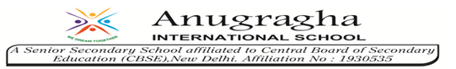

**GRADE III**

**ENVIRONMENTAL SCIENCE**

**DAILY PRACTICE PAPER**

**[DPP]**

**2019-2020**

**POST MID TERM**

**CHAPTER:11**

**FROM HERE TO THERE**

**CHECK YOUR KNOWLEDGE**

**Objective: To know the different modes of transport :**

**I.Fill in the blanks:**a) Slowest means of transport is __________ (bus , train, bullock cart)  
b) There are___________ means of transport. ( three, two, four)  
c) Only________can run on railway track. ( truck, ships, trains)  
d) A train runs on _____________ (road / rail)  
e) ______________ is used to carry patients. ( bus / ambulance )

**II.Match the following:**

a)Bus - Air transport

b)Aero plane - Land transport

c)Auto rickshaw - Water transport

d)Elephants - Has three wheels

e)Ships - Carry loads

**III.Circle the odd one:**

(a)    Passenger train          Freight train        Motor boat          Mono train

(b) Donkey Camel Cat Elephant

(c) Boat Helicopter Rocket Aero plane

(d) Bus Car Train Cycle

(e) Ship Boat Steamer lorry

**DATE TEACHER’S SIGN**

**APPLICATION BASED WORKSHEET**

**Objective: To know about the uses of transport:**

**IV.True or false**:  
a) We will use bus to go to Sri Lanka from India. __________________  
b) A train runs on rail. __________________  
c) Besides petrol or diesel, CNG is also used as fuel. __________________  
d) Bus is the fastest means of transport. __________________  
e) Fire brigade is vehicle for special purpose. __________________

**V.Write answer in one word**

1. Vehicle that carries patients __________________
2. Vehicle runs without fuel __________________
3. Vehicle that helps to put off the fire __________________
4. Vehicle used to plough the fields __________________
5. Vehicle that helps to travel in space __________________

**DIAGRAM BASED WORKSHEET**

**Objective: To know about different types of transport**

**VI. Identify the mode of transport and write the correct answer:**

**[air transport, water transport, land transport]**

a) b)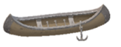c)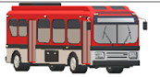d)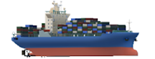

__________________ __________________ __________________ __________________

**VII. Look at the toy given and tick the right answer:**

[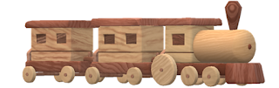](https://3.bp.blogspot.com/-3EiRS63_lsA/W26ZpQpBhwI/AAAAAAAADv4/J54KC63KzFkwf1SSzAGmzgCGql4qffvwgCLcBGAs/s1600/Toy+train.png)

**Questions:**

1.How many people can sit in it?

a.One b.Two c.Many

2.What is the mode of transportation?

a. Air Transportation b.Land Transportation c.Water Transportation

3.Who drives it?

a.An Engine Driver b.A Pilot c.A Passenger

4.What does it need to run on?

a.Road b.Track/Rail c.Water

**VIII.Identify these means of transport and write their names:**

a)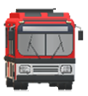 b)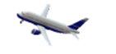 c)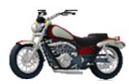

__________________ __________________ __________________

d)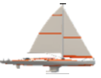 e) f)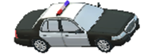

__________________ __________________ __________________

**DATE TEACHER’S SIGN**

**VIII.Draw a picture of any means of transport.**

**CHAPTER:12**

**DATE TEACHER’S SIGN**

**CHAPTER - 12**

**WORK WE DO**

**CONCEPT BASED WORKSHEET**

**Objective: To know about workers**

**I.Choose the correct answer:**

1.People work to earn___________ .

a)money b) freedom

2. Teachers, nurses, drivers are__________.

a)service providers b) goods provider  
3.Shopkeepers, and businessmen are_______.

a)money provider b)goods provider

4.The one who makes earthen pots is a_______________________.

a)carpenter b)doctor c)potter

5.One who repairs pipelines ________________________.

a)plumber b)electrician c)mason

**II.Fill in the blanks with the words given:**

**(fruit-seller, barber, worker, cobbler, students)**

(a)The ________________ at the tea stall gives a cup of tea.

(b)The group of  ________________ are late for school today.

(c)Teacher’s sandal is broken. She is going to  ________________ to get it repaired.

(d) Ramulu, the  ________________, has come with his fruit-cart.

(e)Namu, the  ________________ has laid out his shop- but whom will he shave?

**DATE TEACHER’S SIGN**

**CONCEPT BASED WORKSHEET**

**Objective: To know about different types of community helpers**

**III.Match these community helpers with the work they do:**

**Community Helper Work they do**

1.Fire Fighter - Catch thieves

2.Soldier - Mends shoes

3.Tailor - Puts out fire

4.Policeman - Guards the country

5.Cobbler - Stitches clothes

**IV.Write True or False**a) The teacher’s sandal had broken. __________________  
b) Champa is sitting there with her basket full of fruits. __________________

c) Doctors and nurses work in hospital. __________________

d) Most of the children are not able to go to school. __________________

e) Material for the construction is brought by trucks. __________________

**V.In the list below put a around the buildings, which are in your neighbourhood?**

**Post Office Hospital Temple Telephone booth**

**School Church Government office Multi-storeyed building**

**Railwaystation Police station Dharamshala Hotel**

**Bus stand Cinema Hall Bank Petrol Pump Shop**

**Gurudwara Mosque Court**

**DATE TEACHER’S SIGN**

**CHAPTER - 13**

**SHARING OUR FEELINGS**

**CHECK YOUR PRIOR KNOWLEDGE**

**Objective: Able to know about blind people**

**I.Fill in the blanks with the given words:**

**[ Eyes, , Love, Care, Louis Braille, Blind, Situation ]**

(a)We can understand the problems of others better by putting ourselves in their ________________.

(b) We see through our ________________.

(c) The Braille script is used by ________________people.

(d) ________________invented the Braille script.

(e) Old people need ________________and ________________.

**OUT OF THE BOX**

**II.True or false:**

a) We should not make fun of physically challenged people. ________________

b) We don’t want to share our feelings with anyone. ________________

c) We should be thoughtful towards blind people. ________________

d) Braille is a special way of reading and writing for people who cannot hear. ________________

e) In Braille script a row of raised dots is made on a thick paper. ________________

**DIAGRAM BASED WORKSHEET**

**Objective: Able to know the blind personalities**

**III. Observe the following pictures and write the names of the personalities.**

1.  ____________________ 2.  _________________

**DATE TEACHER’S SIGN**

**CHAPTER - 14**

**THE STORY OF FOOD**

**CONCEPT BASED WORKSHEET**

**Objective: Able to know about food**

**I.Choose the correct answer:**

1. Which of these food is good for our health?

a.Potato chips b.French fries c.Burger d.Sprouts

2.Which of these is not a dairy product?

a. Milk b.Paneer c.Toffee d. Butter

3. We should eat ___________food.

a.fast b.healthy c.unhealthy

4.The food we eat should be____________

a.uncooked b. cooked properly c.junk food

5.We should eat our food in____________utensils.

a.clean b.dirty c.filthy

**OUT OF THE BOX**

**II.Fill in the blanks with suitable words:**

**[ Three, Energy, Sugarcane, Mint, Peas ]**

1. We eat the leaves of ____________Plant.
2. We eat the stem of _____________Plant.
3. We eat the seeds of _____________Plant.
4. We should have at least _____________ meals a day.

e) Food gives us _____________ to work and play.

**III. True or false**

a) Food we eat comes only from animals. ____________________

b) We get different medicines from plants. ____________________

c) Girls and boys both should help at home. ____________________

d) We eat mostly uncooked food. ____________________

e) We eat different parts of a single plant. ____________________

**DATE TEACHER’S SIGN**

**III.True or false**

**IV. Match the following:**

a) Cabbage i) Seed

b) Grapes ii) Root

c) Cauliflower iii) Flower

d) Coriander iv) fruit

e) Carrot v) Leaf

**V. Name the medicinal plants that are used for**

a)Cough and cold _________________________

b)Skin disease _________________________

c)Toothache _________________________

d)Stomach ache _________________________

**VI.Put the food items in the proper boxes.**

[Ginger Mango Gram Spinach Cauliflower Banana *Amla* Lotus stem Curry leaves Potato Jackfruit Carrot French beans Mustard Radish Flowers of *Kachnar]*

|  |  |  |  |  |  |
| --- | --- | --- | --- | --- | --- |
| **Leaves** | **Fruits** | **Flower** | **Seed** | **Stem** | **Root** |
|  |  |  |  |  |  |
|  |  |  |  |  |  |
|  |  |  |  |  |  |
|  |  |  |  |  |  |
|  |  |  |  |  |  |
|  |  |  |  |  |  |
|  |  |  |  |  |  |

**VII.Circle the odd one**

a) Potato tomato onion egg

b) Turmeric chilli jeera mustard

c) Pumpkin orange banana jack fruit

e) Fish chicken garlic mutton

g) Potato Corn Turnip Onion

h) Honey Meat Eggs Banana

**DATE TEACHER’S SIGN**

**CHAPTER - 15**

**MAKING POT’S**

**APPLICATION BASED WORKSHEET**

**Objective: Able to know about pots**

**I.Choose the correct answer:**

a) Pots are made from______________ (mud, bricks, clay)

b) Potter uses potter’s________________to shape pots. ( tyre, round, wheel)

c) Pots are dried under________________ (sunlight, moonlight)

d) After drying the pots, they are heated in a ______________to make them stronger. (box, kiln, house)

e) Pots are _____________for us. (useful, useless)

**II.Fill in the blanks:**

**(stone, clay, baking, trowel, pot)**

1. In the beginning, pots were made of stone and ______________.

2. Clay pots are made stronger by ______________them in fire.

3. People made pots of ______________by digging and scraping stones with their hands.

4. River asked the crow to get a ______________.

5. The clay-pit asked the crow to get a ______________ from the blacksmith.

**III.Write ‘True’ or ‘false’ for the following statements:**

1.Potter wanted clay from the clay-pit.

2.Blacksmith lent a trowel to dig the clay.

3.A potter needs only clay for making pot.

4.Pots are baked in Sunlight.

5.A potter needs trowler to shape the pot.

**IV. Macth the columns:**

a)Potter - clay

b)Clay-pit - water

c)Blacksmith - pots

d)River - bird

d)Crow - trowel

**DATE TEACHER’S SIGN**

**DIAGRAM BASED WORKSHEET**

**Objective: Able to write about the steps involved in making pots**

**V.OBSERVE THE PICTURE AND WRITE THE STEPS INVOLVED IN MAKING POTS:-**

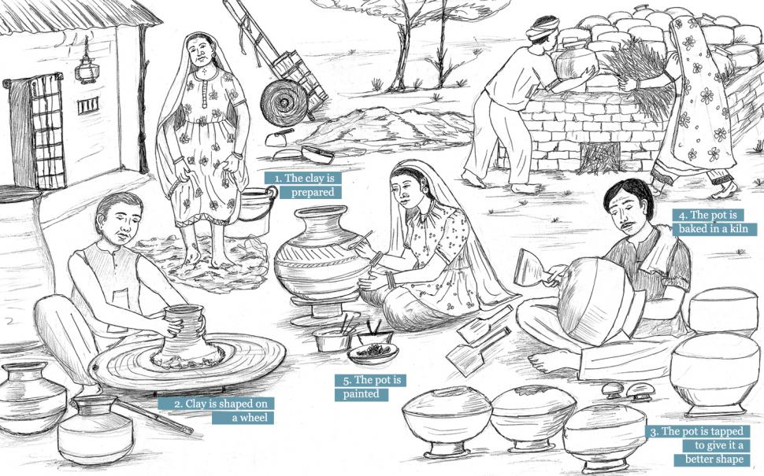

1. ______________________________________________________________________________
2. ______________________________________________________________________________

3. _______________________________________________________________________________

4._______________________________________________________________________________

5. _______________________________________________________________________________

**DATE TEACHER’S SIGN**

**Objective: Able to draw the potter’s wheel**

**VI.Draw a potter’s wheel.**

**DATE TEACHER’S SIGN**

**CHAPTER - 16**

**GAMES WE PLAY**

**APPLICATION BASED WORKSHEET**

**Objective: Able to know about games**

**I. Fill in the blanks:**

1. **________________** is a good exercise for the body and mind.

2.We need _________________players in football.

3.The games we play in homes are called _________________games.

4.The games we play in the ground are called _______________games.

5.____________is India’s national game.

**II. Match the following:**

a) Badminton i) 52

b) Ludo ii)Queen-Pawn

c) Cricket iii)Shuttle – cock

d) Cards iv) Dice

e) Chess v) Bat- ball

**III. Write true or false:**

a) Volleyball is an indoor game. ____________________

b) Chess is an outdoor game. ____________________

c) We inculcate punctuality, while playing games. ____________________

d) Games keep us physically and mentally healthy. ____________________

**IV. How many players are needed to play:**

1. Carrom _______ (c) Chess _______
2. Ludo _______ (d) Kabaddi ______

**DATE TEACHER’S SIGN**

**DIAGRAM BASED WORKSHEET**

**Objective:Able to write the things which is used to play**

**Write down the names of the given things/objects:**

**a) b)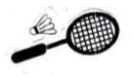 c)**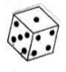

**_________________ _____________________ ____________________**

**d) e)**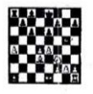

**______________________ _________________________**

**VI.Write the name of the game that the following sports person associated with:**

**[Cricket, Chess, Hockey,Tennis]**

1. SACHIN TENDULKAR _____________________________
2. SANIA MIRZA _____________________________
3. VISWANATH ANAND _____________________________
4. DHANRAJ PILLAI _____________________________

**DATE TEACHER’S SIGN**

**CHAPTER 17**

**HERE COMES A LETTER**

**CHECK YOUR PRIOR KNOWLEDGE**

**Objective: Able to know about the communication in olden days.**

**I. Fill in the blanks:**

a) We put letter in the __________________

b) Television is an electric means of _____________.

c) _____________deliver the letters,postcared or moneyorders.

d) We send e-mail through________________.

e) People sent messages by ______________in olden days.

**II. True or False:**

1. In olden days letters were sent by pigeons. ___________

2. Letters have been a very popular means of communication in earlier days. ___________

4. Newspaper informs about the happenings around the world in the past. ___________

5. We put letters to be sent in a letter box. ___________

6. We can talk on mobile phone even while travelling. ___________

**OUT OF THE BOX**

**III. Match the following:**

1. STD - Short Message Service

2.ISD - Subscriber Trunk Dialing

3.SMS - World Wide Web

4.WWW - International Subscriber Dialing

**IV. Identify these types of letters and write their names:**

a)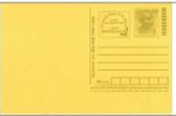 b)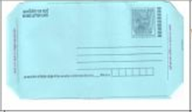 c)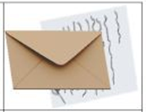

_______________________ ______________________ _______________________

**DATE TEACHER’S SIGN**

**V. Complete the word:**

1.We post our letter in it. P ______ ______ ______ ______ ______ ______

2.Postman delivers. L ______ ______ ______ ______ ______

3.Affixed it on parcel. S ______ ______ ______ ______

4.A place where we can buy inland letter. P ______ ______ ______ ______ ______ ______

5.Money is send by it. M ______ ______ ______ ______ ______ ______ ______ ______ _____

**DIAGRAM BASED WORKSHEET**

**Objective: Able to know about some phone names**

**VI. Look at the picture and write their names:**

**[Mobile Phone, cordless phone, vintage phone, rotary phone, telephone]**

**a)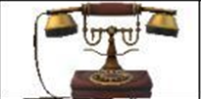 b)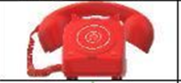 c)**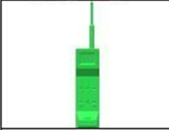

**__________________________ __________________________ __________________________**

**d)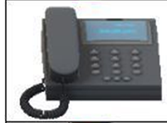 e)**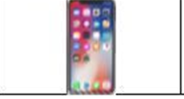

**__________________________ __________________________**

**DATE TEACHER’S SIGN**

**DIAGRAM BASED WORKSHEET**

**Objective: Able to draw the postbox.**

**Draw the picture of postbox and color it in red.**

**DATE TEACHER’S SIGN**