GRADE III
EVS
DAILY PRACTICE PAPER
[DPP]
2019-2020

MID TERM
S.NO | DATE | CONTENT | REMARKS | TEACHER  SIGNATURE
1 |  | APPLICATION BASED WORKSHEET
2 |  | CHECK YOUR PRIOR KNOWLEDGE
3 |  | CONCEPT BASED WORKSHEET
4 |  | DIAGRAM BASED WORKSHEET
5 |  | DIAGRAM BASED WORKSHEET
6 |  | CHECK YOUR KNOWLEDGE
7 |  | DIAGRAM BASED WORKSHEET
8 |  | APLLICATION BASED WORKSHHET
9 |  | DIAGRAM BASED WORKSHEET
10 |  | APPLICATION BASED WORKSHEET
11 |  | QUICK QUIZ

CHAPER – 6
FOODS WE EAT
APPLICATION BASED WORKSHEET
Objective: To know the different type of food items which is made of rice and wheat
I.Group the following food items :
Bread Idli Upma Chappathi Dosa
Biriyani Appam Poori Pulav Puttu
RICE | WHEAT

II. Write the things that are used to make the following:
1. Omelette - 6.Panner -
2. Jam - 7. Chips -
3. Jaggery - 8. Bread -
4. Puri - 9. Cornflakes -
5. Idli - 10. Lassi -

DATE TEACHER’S SIGN

CHAPTER – 7
SAYING WITHOUT SPEAKING
CHECK YOUR PRIOR KNOWLEDGE
Objective: To understand the different type of sense organs
I.Match the following
a) Eye - taste
b) Nose - smell
c) Ear - vision
d) Tongue - feeling / tough
e) Skin - hearing

II. Which sense organ is used for the following:
(eyes, ears, nose, skin, tongue)
a.There is a gas leak in the kitchen

b.Neem leaf is bitter

c.Touching the hot plate

d.The moon and the stars are in the sky

e.The door bell rings

DATE TEACHER’S SIGN

OUT OF THE BOX
Objective: To know about physically challenged people
III. Match the following:
- People who cannot see - Deaf
- People who cannot hear - Dumb
- People who cannot speak - Blind

IV. Match the following
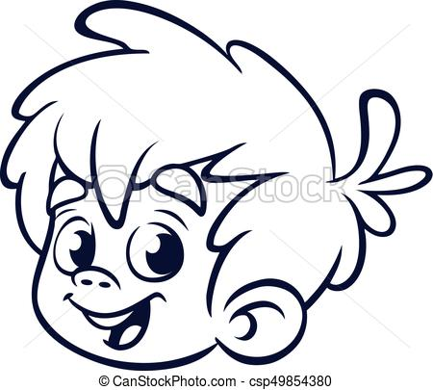 - Angry
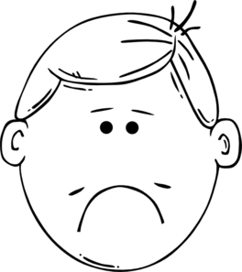 - Afraid
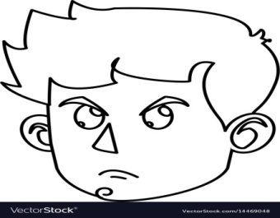 - Happy
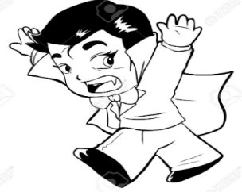 - Sad

DATE TEACHER’S SIGN

PROSE: THE ENORMOUS TURNIP
CHAPTER – 8
FLYING HIGH
CONCEPT BASED WORKSHEET
Objective: To understand the features of birds
I. True or false
- Owls cannot see at night. __________
- Birds use their beaks to feed their young ones. __________
- Hens scratch the ground in search of insects. __________
- Weaver birds weave nests from grass, twigs etc. __________
- Sparrows have a crown on their head. __________
DIAGRAM BASED WORKSHEET
II.Look at the beaks and name the bird:
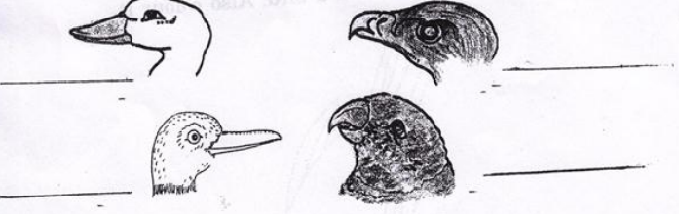

DATE TEACHER’S SIGN

CHAPTER – 9
IT’S RAINING
DIAGRAM BASED WORKSHEET
Objective: To draw the diagram of water cycle
I.Draw the water cycle and label it.

DATE TEACHER’S SIGN

CHECK YOUR KNOWLEDGE
Objective: To admire the nature.
II.Draw 2 different shapes of clouds
III. Name five things which we see on the rainy day.
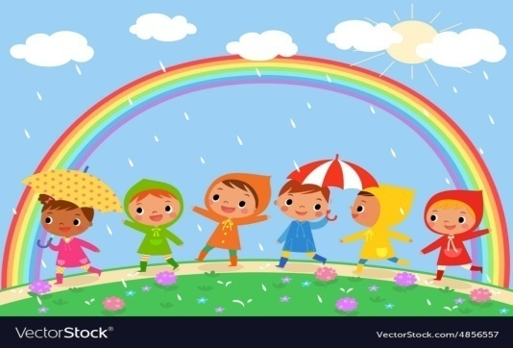
1.____________________________________________
2.____________________________________________
3.____________________________________________
4.____________________________________________
5.____________________________________________
IV. Name any five animals which live in water.
- _______________ d._________________
- _______________ e._________________
- _______________
DATE TEACHER’S SIGN

DIAGRAM BASED WORKSHEET
Objective: To know the different colours of rainbow
IV. Colour the rainbow

DATE TEACHER’S SIGN

CHAPTER – 10
WHAT IS COOKING
APLLICATION BASED WORKSHEET
Objective: To identify the name of the utensils and different cooking methods:
I.Write the name of the utensils
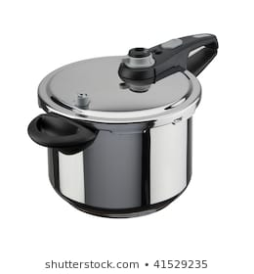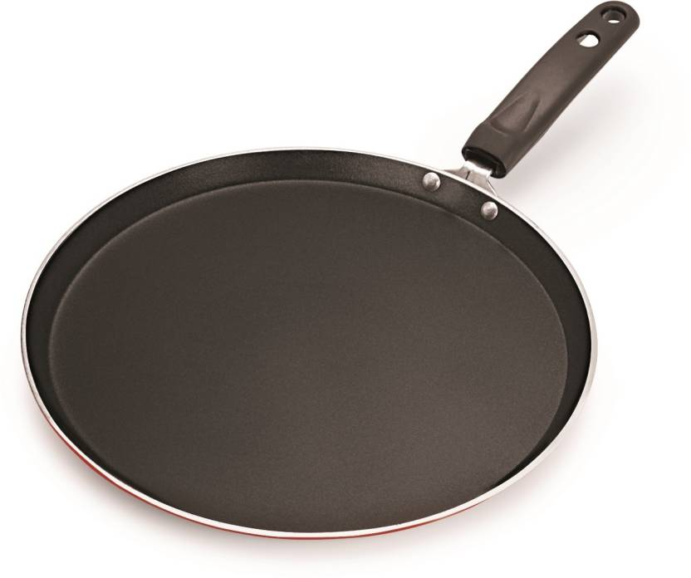
________________________ _____________________
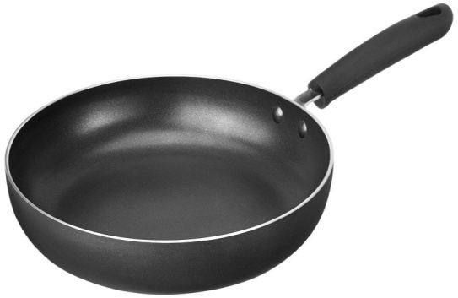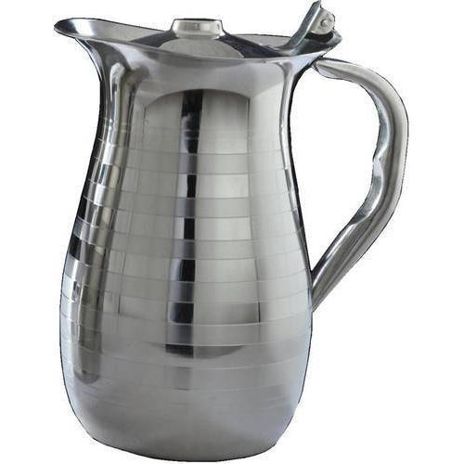
________________________ ______________________

II. Write any two things cooked by each method:
Cooking method | Name of the things
Cooking
Roasting
Frying
Baking
Steaming

DATE TEACHER’S SIGN

DIAGRAM BASED WORKSHEET
Objective: To know the difference between raw and cooking food
III. Colour the following:
Raw-green
Cooked food-red
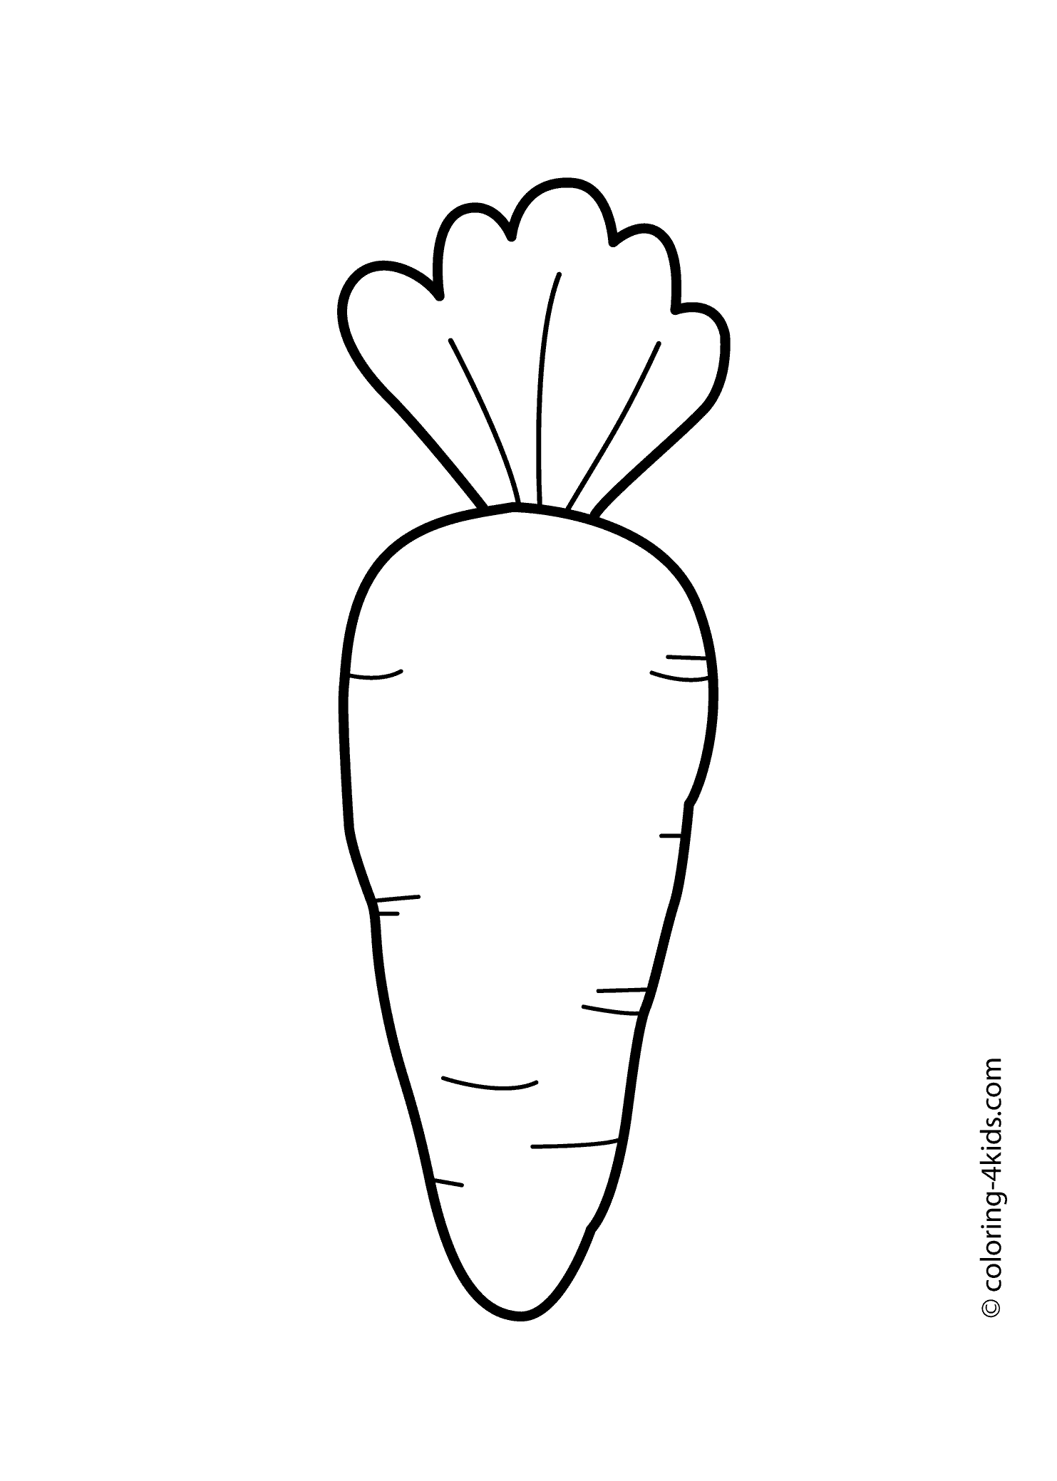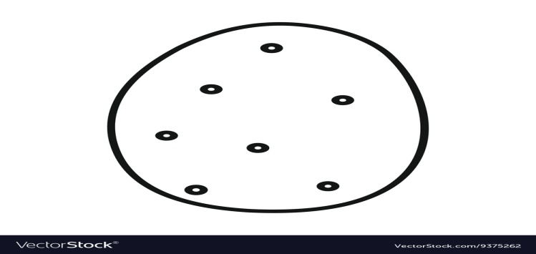
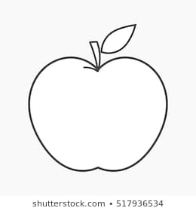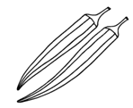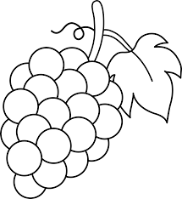

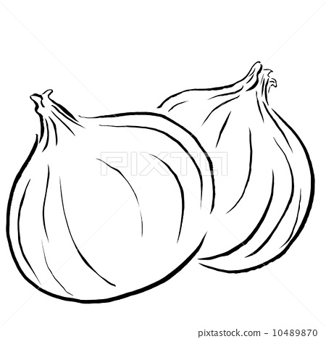
DATE TEACHER’S SIGN

CHAPTER -11
FROM HERE TO THERE
APPLICATION BASED WORKSHEET
Objective: To know the name of the vehicle , mode of moving and Number of wheels
Name of the vehicle | Moves on land, in water or in air | Number of wheels
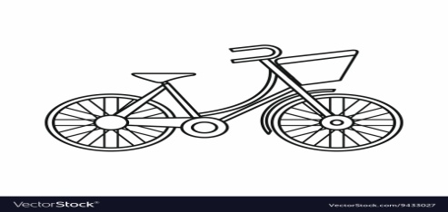

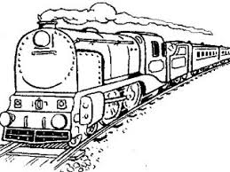
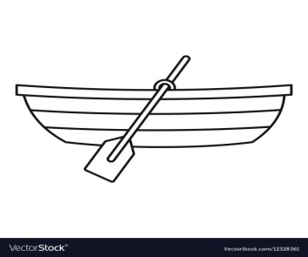
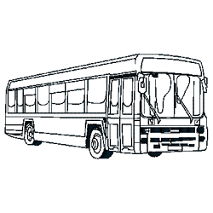
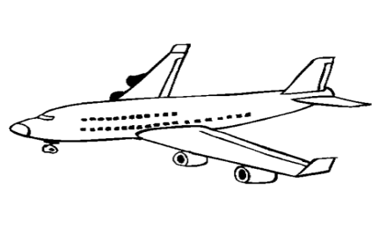
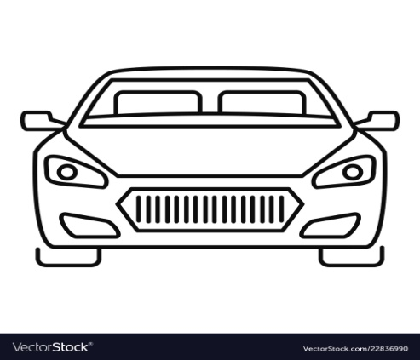

DATE TEACHER’S SIGN

QUICK QUIZ
Objective: To write the uses of vehicles
I. Fill in the blanks:
( bus, aeroplane, train, car, helicopter)
1.Carries passengers on the road ___________
2. Runs on road ___________
3. Has a fan and it flies ___________
4.Runs on rails ___________
5.Flies very fast ___________

II. Give examples:
a.Run on petrol ,gas ,diesel ___________
b.Run by electricity ___________
c.Driven by human beings ___________
d.Driven by animals ___________

DATE TEACHER’S SIGN

