

**GRADE III**

**MATHEMATICS**

**DAILY PRACTICE PAPER**

**[DPP]**

**2019-2020**

**MID TERM**

|  |  |  |  |  |
| --- | --- | --- | --- | --- |
| **S.NO** | **DATE** | **CONTENT** | **REMARKS** | **TEACHER**  **SIGNATURE** |
| **1** |  | **Give and Take** |  |  |
| **2** |  |  |  |  |
| **3** |  |  |  |  |
| **4** |  |  |  |  |
| **5** |  |  |  |  |
| **6** |  |  |  |  |
| **7** |  |  |  |  |
| **8** |  |  |  |  |
| **9** |  |  |  |  |
| **10** |  |  |  |  |
| **11** |  |  |  |  |
| **12** |  |  |  |  |

**3.GIVE AND TAKE**

**BACKWARD COUNTING**

**Objective: Able to count the numbers backwards**

**1. Count backwards and fill in the blanks:**

**a) 19 - ___________ , ___________ , ___________ , ___________.**

**b) 40 - ___________ , ___________ , ___________ , ___________.**

**c) 68 - ___________ , ___________ , ___________ , ___________.**

**d) 54 - ___________ , ___________ , ___________ , ___________.**

**e) 14 - ___________ , ___________ , ___________ , ___________.**

**f) 23 - ___________ , ___________ , ___________ , ___________.**

**g) 65 - ___________ , ___________ , ___________ , ___________.**

**h) 100 - ___________ , ___________ , ___________ , ___________.**

**i) 21 - ___________ , ___________ , ___________ , ___________.**

**j) 33 - ___________ , ___________ , ___________ , ___________.**

**DATE TEACHER’S SIGN**

**ADD AND SUBTRACT**

**Objective:To perform addition and subtraction using the number grid:**

**1) Add the given numbers using the grid**

|  |  |  |  |  |  |  |  |  |  |
| --- | --- | --- | --- | --- | --- | --- | --- | --- | --- |
| **91** | **92** | **93** | **94** | **95** | **96** | **97** | **98** | **99** | **100** |
| **81** | **82** | **83** | **84** | **85** | **86** | **87** | **88** | **89** | **90** |
| **71** | **72** | **73** | **74** | **75** | **76** | **77** | **78** | **79** | **80** |
| **61** | **62** | **63** | **64** | **65** | **66** | **67** | **68** | **69** | **70** |
| **51** | **52** | **53** | **54** | **55** | **56** | **57** | **58** | **59** | **60** |
| **41** | **42** | **43** | **44** | **45** | **46** | **47** | **48** | **49** | **50** |
| **31** | **32** | **33** | **34** | **35** | **36** | **37** | **38** | **39** | **40** |
| **21** | **22** | **23** | **24** | **25** | **26** | **27** | **28** | **29** | **30** |
| **11** | **12** | **13** | **14** | **15** | **16** | **17** | **18** | **19** | **20** |
| **1** | **2** | **3** | **4** | **5** | **6** | **7** | **8** | **9** | **10** |

**a) 45+ 5 = __________ b) 32+ 8 = ___________**

**c) 60 + 7 = __________ d) 57 + 9 = __________**

**2) Subtract the given numbers using the grid:**

|  |  |  |  |  |  |  |  |  |  |
| --- | --- | --- | --- | --- | --- | --- | --- | --- | --- |
| **91** | **92** | **93** | **94** | **95** | **96** | **97** | **98** | **99** | **100** |
| **81** | **82** | **83** | **84** | **85** | **86** | **87** | **88** | **89** | **90** |
| **71** | **72** | **73** | **74** | **75** | **76** | **77** | **78** | **79** | **80** |
| **61** | **62** | **63** | **64** | **65** | **66** | **67** | **68** | **69** | **70** |
| **51** | **52** | **53** | **54** | **55** | **56** | **57** | **58** | **59** | **60** |
| **41** | **42** | **43** | **44** | **45** | **46** | **47** | **48** | **49** | **50** |
| **31** | **32** | **33** | **34** | **35** | **36** | **37** | **38** | **39** | **40** |
| **21** | **22** | **23** | **24** | **25** | **26** | **27** | **28** | **29** | **30** |
| **11** | **12** | **13** | **14** | **15** | **16** | **17** | **18** | **19** | **20** |
| **1** | **2** | **3** | **4** | **5** | **6** | **7** | **8** | **9** | **10** |

**a) 45 - 5 = __________ b) 32 - 8 = __________**

**c) 60 - 7 = __________ d) 57 - 9 = __________**

**DATE TEACHER’S SIGN**

**BREAK ME AND FIND THE SUM**

**Objective : Able to split and write the place value**

**1. Break the number and find the sum.**

70

10

2

2

**1) 72 + 12 =**

70

2

2

10

4

80

84

**2) 62+38**

**3) 46+21**

**4) 35+12**

**DATE TEACHER’S SIGN**

**PROSE: THE ENORMOUS TURNIP**

**MENTAL ABILITY**

**Objective: Able to do mind calculations**

**I. Add mentally and write the number:**

**1. 11 more than 20 _____________**

**2. 10 more than 49 _____________**

**3. The sum of 28 and 10 is _____________**

**4. 9 added to 41 gives _____________**

**5. 19 added to 7 gives _____________**

**6. 10 less than 100 is _____________**

**7. 12 less than 60 is _____________**

**8. Take away 20 from 70 _____________**

**9. Take away 15 from 75 _____________**

**10.Take away 7 from 7 _____________**

**11.76 less than 76 is _____________**

**12.50 less than 150 _____________**

**13.45 more than 40 _____________**

**14.The sum of 20 and 68 is _____________**

**15.41 added to 9 gives _____________**

**DATE TEACHER’S SIGN**

**4. LONG AND SHORT**

**CONVERT ME**

**Objective: Able to convert from m to cm and vice versa**

**1. Fill in the blanks**

**1) The standard unit for measuring length is _________________**

**2) 1 m = _________________ cm**

**3) 4 m = _________________ cm**

**4) 8 m = _________________ cm**

**5) 2 m 50 cm = _________________ cm**

**6) 7 m 90 cm = _________________ cm**

**7) 9m 10 cm = _________________ cm**

**8) 500 cm = _________________ m**

**9) 700 cm = _________________ m**

**10) 850 cm = _________________ m _____________________ cms**

**DATE TEACHER’S SIGN**

**MAKE A GUESS**

**Objective: Able to know the measures**

**I. Estimate the lengths of the following objects and tick**

**1.Length of a blackboard ( less than 1m) ( more than 1 m)**

**2. Length of a cot ( less than 1m) ( more than 1 m)**

**3.Length of a pillow ( less than 1m) ( more than 1 m)**

**4.Length of a door ( less than 1m) ( more than 1 m)**

**5. Length of a table ( less than 1m) ( more than 1 m)**

**6.Length of a pen ( less than 1m) ( more than 1 m)**

**7. Length of a sari ( less than 1m) ( more than 1 m)**

**8.Length of a box ( less than 1m) ( more than 1 m)**

**9.Length of a bus(less than 1 m) (more than 1 m)**

**10.Length of a soap(less than 1 m)(more than 1 m)**

**DATE TEACHER’S SIGN**

**UNIT IV**

**MEASURE ME**

**Objective: Able to measure the given lengths using a scale**

1. **Using scale measure the lengths of the following objects**

**i) ii)**

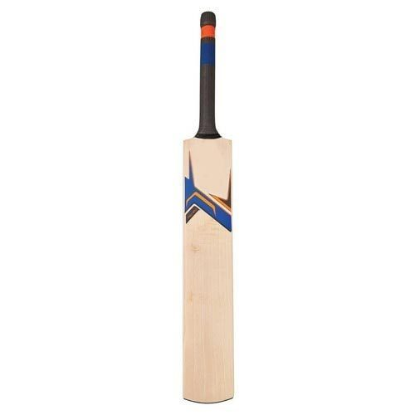 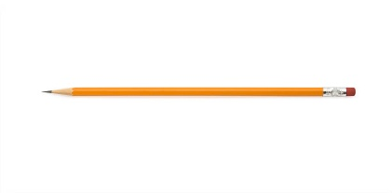

**_______________cms _____________________cms**

**iii) iv)**

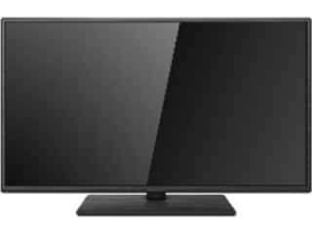 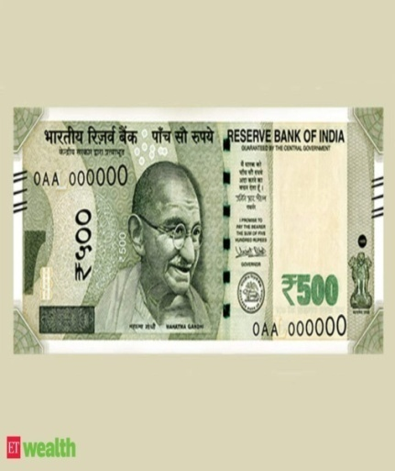

**______________________________cms ___________________________cms**

**DATE TEACHER’S SIGN**

**5. SHAPES AND DESIGNS**

**FIND ME**

**Objective: To understand shapes**

**1.Name these shapes and colour them.**

**_____________________________**

**_____________________________**

**_____________________________**

**_____________________________**

**DATE TEACHER’S SIGN**

**EDGES AND CORNERS**

**Objective: To understand the concept of edges and corners**

1. **Count the number of Edges and Corners in these figures.**

**Edges _________________ Corners_________________**

**Edges _________________ Corners_________________**

**Edges _________________ Corners_________________**

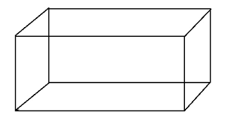 **Edges _________________ Corners_________________**

**DATE TEACHER’S SIGN**

**COUNT AND WRITE**

**Objective: Able to find the shapes**

**1. Count the number of squares, rectangles, triangles and circles in the following picture.**



**Number of = _____________**

**Number of = _____________**

**Number of = _____________**

**Number of =_____________**

**DATE TEACHER’S SIGN**

**COLOR IT**

**Objective: To identify the shapes and colour.**

1. **Colour the Squares in Red, Circles in Blue, Rectangles in Yellow and Triangles in Green.**



**DATE TEACHER’S SIGN**