

**GRADE III**

**MATHEMATICS**

**DAILY PRACTICE PAPER**

**[DPP]**

**2019-2020**

**POST MID TERM**

**6. FUN WITH GIVE AND TAKE**

**SHOPPING**

**Objective: Able to subtract**

1**.Look at the price list and answer the following questions.**

Note book ` 8 Crayons ` 12 Toffees ` 1

Chocolate ` 6 Fruit drop 6 Felt Pen ` 5 Ball Point Pen 6

Scale ` 7 Chewing gum ` 3 Pencil ` 2

a. What is the cheapest item on sale? __________________

b. How much more expensive is a chocolate than a packet of chewing gum?

**2.Can you help the shopkeeper in completing the following bills ?**

**Find the cost of each item from the picture of the shop. If every customer pays** ` **20 to the shopkeeper,how much change must he return?**

1)Ball Point Pen _____ 2) Notebook _____ 3) Felt Pen _____

Change returned _____ Change returned _____ Change returned _____

4) Eclairs _____ 5)Crayons _____ 6) Chewing gum _____

Change returned _____ Change returned _____ Change returned _____

**3) Find the cost of these.**

1) 5 Pencils ________ 2) 3 Notebooks ________

3) 3 Chocolates ________ 4) 2 Eclairs _______

**DATE TEACHER’S SIGN**

**SPORTS SHOP**

**Objective: To understand subtraction**

Ball ` 5 Bat ` 35 Racket `20 Shuttle cock ` 2

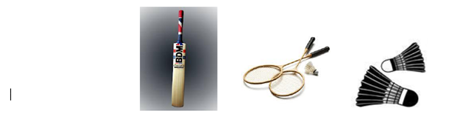

Pads ` 35 Skates ` 40 Gloves ` 25

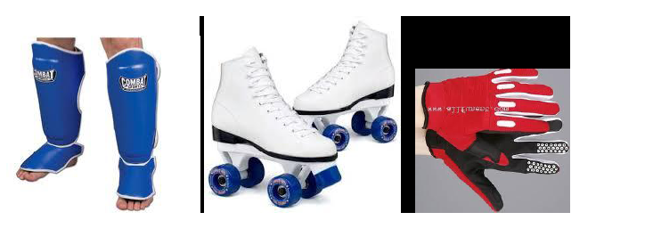

Chess board `10 Doll ` 105 Toy cart ` 16

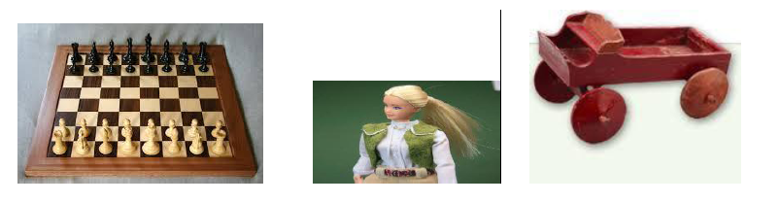

1.The most expensive item is __________________that cost ` __________________________.

2) The cheapest item was ____________________ for ` __________________________________.

3) I had ` 50. I bought a pair of gloves. I had ` ____________________left.

4) My friend bought a ball , a shuttlecock and a chess board. He spent `___________________

5) He had ` 75 with him. The shopkeeper returned him ` _______________________________

**DATE TEACHER’S SIGN**

**SUBTRACT ME**

**Objective: To verify the subtraction sums using addition.**

**1.Subtract and check the answer using addition:**

**a)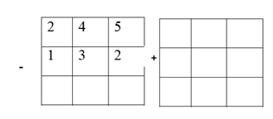b)**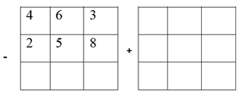

**c)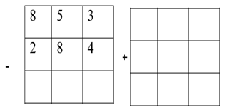 d)**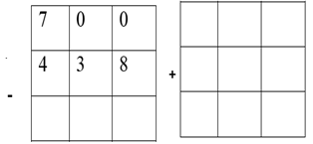

**e)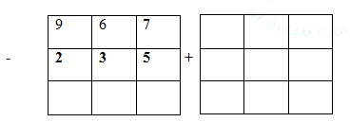f)**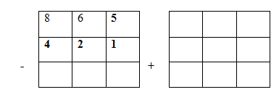

**g)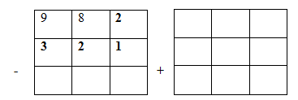h)**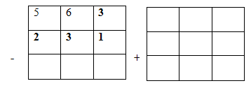

**DATE TEACHER’S SIGN**

**SUBTRACT ME**

**Objective : Able to subtract with regrouping.**

**7**

**0**

**8**

**6**

**4**

**3**

**-**

**3**

**5**

**9**

**4**

**2**

**1**

**-**

**1**

**6**

**8**

**-**

**1**

**8**

**9**

**-**

1. **2. 3. 4.**

**Subtract the following without borrowing:**

|  |  |  |  |
| --- | --- | --- | --- |
| T | H | T | o |
| 5 | 9 | 8 | 4 |
| 2 | 4 | 3 | 1 | - |
|  |  |  |  |

|  |  |  |  |
| --- | --- | --- | --- |
| T | H | T | o |
| 4 | 0 | 7 | 8 |
| 1 | 0 | 5 | 3 | - |
|  |  |  |  |



|  |  |  |  |
| --- | --- | --- | --- |
| T | H | T | o |
| 7 | 5 | 6 | 1 |
| 5 | 2 | 1 | 0 | - |
|  |  |  |  |

|  |  |  |  |
| --- | --- | --- | --- |
| T | H | T | o |
| 6 | 4 | 5 | 9 |
| 3 | 4 | 3 | 7 | - |
|  |  |  |  |

|  |  |  |  |
| --- | --- | --- | --- |
| T | H | T | o |
| 5 | 8 | 8 | 9 |
| 4 | 2 | 1 | 0 | - |
|  |  |  |  |

|  |  |  |  |
| --- | --- | --- | --- |
| T | H | T | o |
| 8 | 7 | 3 | 2 |
| 4 | 5 | 1 | 1 | - |
|  |  |  |  |

|  |  |  |  |
| --- | --- | --- | --- |
| T | H | T | o |
| 9 | 5 | 4 | 3 |
| 6 | 2 | 1 | 1 | - |
|  |  |  |  |

|  |  |  |  |
| --- | --- | --- | --- |
| T | H | T | o |
| 7 | 8 | 9 | 5 |
| 4 | 3 | 5 | 2 | - |
|  |  |  |  |

**DATE TEACHER’S SIGN**

**SUBTRACT ME**

**Objective: Able to know with regrouping numbers**

**1.Subtract the following:**

|  |  |
| --- | --- |
| **T** | **0** |
| **7** | **2** |
| **4** | **5** | **-** |
|  |  |

|  |  |
| --- | --- |
| **T** | **0** |
| **9** | **6** |
| **6** | **7** | **-** |
|  |  |

|  |  |  |
| --- | --- | --- |
| H | T | **O** |
| **2** | **3** | **8** |
| **1** | **0** | **9** | **-** |
|  |  |  |

|  |  |  |
| --- | --- | --- |
| H | T | **O** |
| **7** | **8** | **2** |
| **5** | **4** | **6** | **-** |
|  |  |  |

**2.Find the following:**

(i) 251 less than 672 ___________________ (ii) 254 less than 589 ___________________

(iii) 654 less than 742 ___________________ (iv) 250 less than 460 ___________________

(v) 450 less than 758 ___________________

**3. Fill in the blanks:**

(i) 632 - 0 = ............... (ii) ............... - 0 = 517

(iii) 410 -  ............... = 410 (iv) 129 - 129 =  ...............

**DATE TEACHER’S SIGN**

**MENTAL ABILITY**

**Objective: To understand addition and subtraction**

**1.Find the answers:**

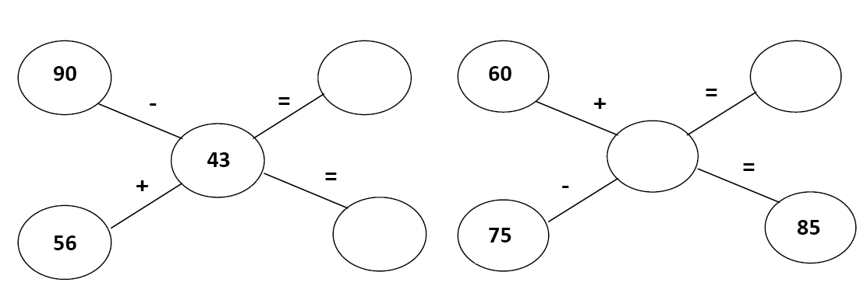

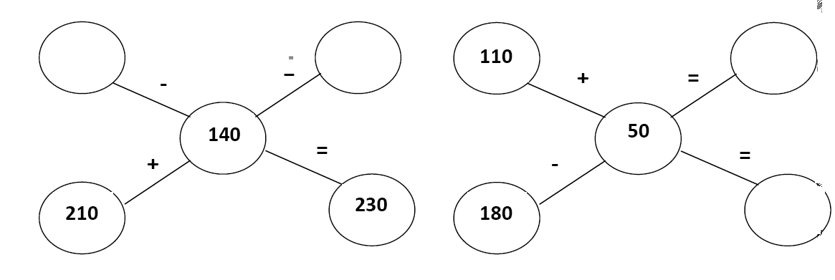

**2.There are 67 bird families living near the mountain . If 32 bird families flew away for winter,how many bird families were left near the mountain?**

**DATE TEACHER’S SIGN**

**7.TIME GOES ON**

**DRAW HANDS**

**Objective: To read the time**

**Draw hands on the clock.**

**7 o’ clock 4 o’ clock**



**11 o’ clock 6 o’ clock**



**8 o’ clock 3 o’ clock**



**DATE TEACHER’S SIGN**

**FIND THE TIME**

**Objective : To understand hours and minutes**

**1.What’s the time on the clock?**

1)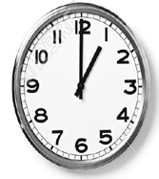 2)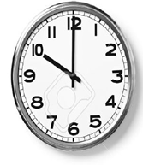3)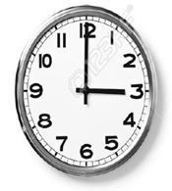 4)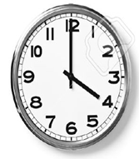

_______________ ________________ _____________ ______________

5)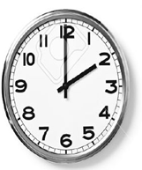 6)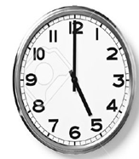 7)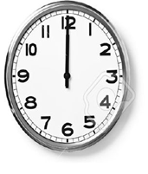 8)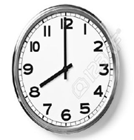

_______________ ________________ _____________ ______________

9)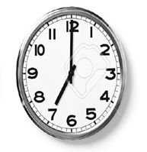10)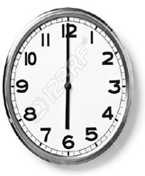11)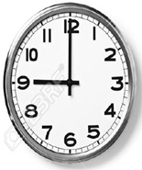12)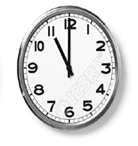

_______________ ________________ _____________ ______________

**DATE TEACHER’S SIGN**

**FIND SECONDS AND MINUTES**

**Objective: To understand seconds, minutes and hours**

**1.How long does it take? Use the words given below:**

**[Seconds minutes hours days months]**

a. To drink a glass of water __________________ b. To brush your teeth __________________

c. For the sun to rise __________________ d. To blink your eyes __________________

e. To switch on the light __________________ f. For a plant to grow __________________

g. To do your homework __________________ h. To eat your dinner __________________

i. To have a bath __________________ j. To pack your school bag __________________

**2.What will the time be?**

a. 1 hour after 10:30 __________________________________

b. 15 minutes after 3:30 __________________________________

c. 10 minutes before 1:20 __________________________________

d. 20 minutes before 5:00 __________________________________

e. 30 minutes after 4:00 __________________________________

**DATE TEACHER’S SIGN**

**READ THE TIME**

**Objective: Able to know the differences between minutes and hours**

**Match the watch with the correct time:**

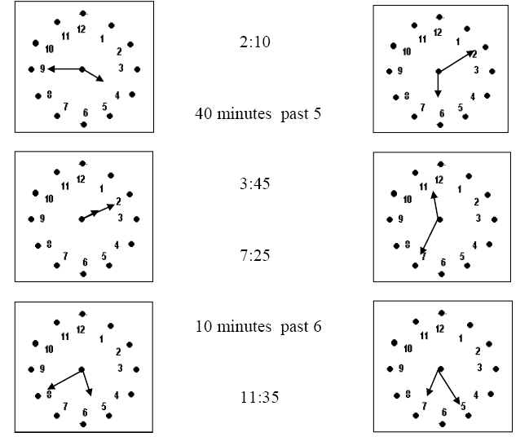

**2.Draw the clocks and show the following time:**

(i) 2:30 (ii) 4:45 (iii) 11: 15

**DATE TEACHER’S SIGN**

**OUT OF BOX**

**Objective: To understand minutes and hours.**

**Lets Revise time:**

a. 1 hour = _______________minutes.

b. ______________ Hand is smaller than the _______________hand.

c. At noon and midnight both hands point to ________________

d. There are __________hours in a day.

e. 1 week = ____________________ days

f.1 month = ________________ weeks.

g. 1 year = ___________________ months.

h. There are __________________ days in the month of January.

i. The time 2 hours after 11:10 will be ________________

j. The time 15 minutes after 1 will be ________________

**Write the time with AM or PM.**

1. 2 hours after noon __________

2. 3 hours before mid night _________

3.6 o’ clock in the evening ________

4.5 o’ clock in the morning ________

5. 8 o’ clock in the morning­­ ________

6. 7 o’ clock in the evening ________

**DATE TEACHER’S SIGN**

**8.Who is heavier?**

**8.WHAT HEAVIER?**

**ESTIMATION AND COMPARISON**

**Objective: To know estimation and comparison of weight.**

**Circle the objects that weigh less than ½ kg.**

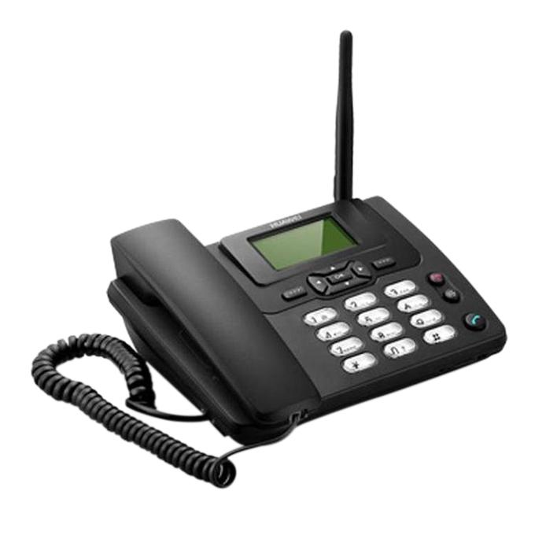 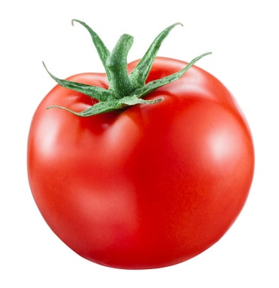 

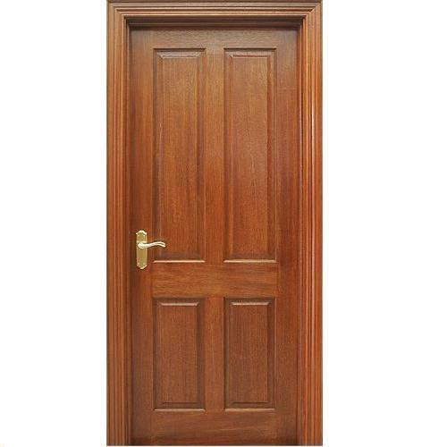 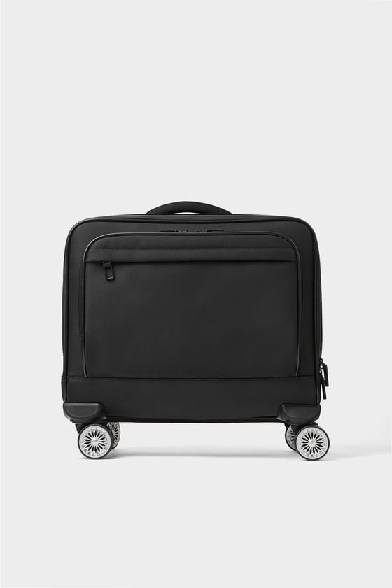 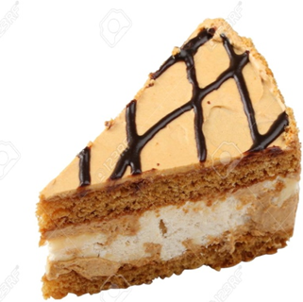

**Tick the object that will weigh less:**

  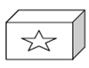 

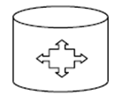  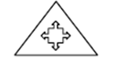 

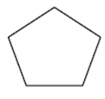  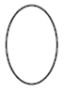 

**DATE TEACHER’S SIGN**

**MEASUREMENT**

**Objective: To understand the differences between g and kg.**

**What will you use , g or kg to measure the weight of the following:**

1. A pencil __________ 2. A big watermelon _________

3. A cake __________ 4. An orange _________

5. A sack of wheat __________ 6. A spoon of sugar _________

7. An apple __________ 8. A big pumpkin _________

9. A chocolate __________ 10. A Tomato _________

**Observe the given picture and choose the appropriate unit of measurement.**

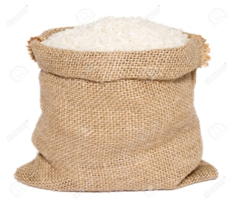The weight of rice is measured in _________ (g/ kg)

 The weight of a soap is measured in ____________(g/kg)

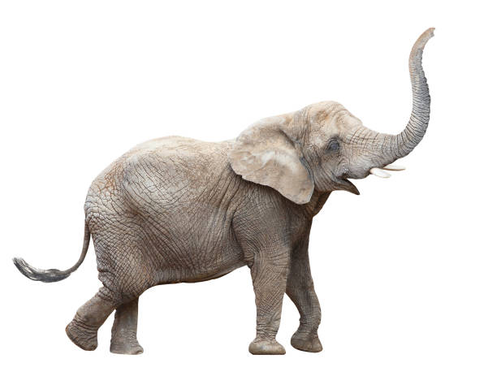The weight of an elephant is measured in _________(g/ kg)

**DATE TEACHER’S SIGN**

**DOUBLE THE MEASURE**

**Objective: To double the given weights.**

**Do as directed and complete the table:**

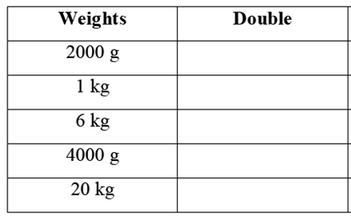

**Draw the weights that you will use to weigh the items given in the table:**

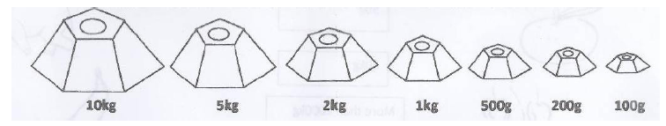

|  |  |
| --- | --- |
| **Items** | **Weights used** |
| 50 kg of wheat |  |
| 9 kg of beans |  |
| 4 kg of tomatoes |  |
| 700 g of rice |  |
| 500 g of sugar |  |

**DATE TEACHER’S SIGN**

**COMPARE THE WEIGHTS**

**Objective: To understand heavier and lighter.**

**1.Use the balances and tell whether the statements below are true or false. Each has the same mass.**

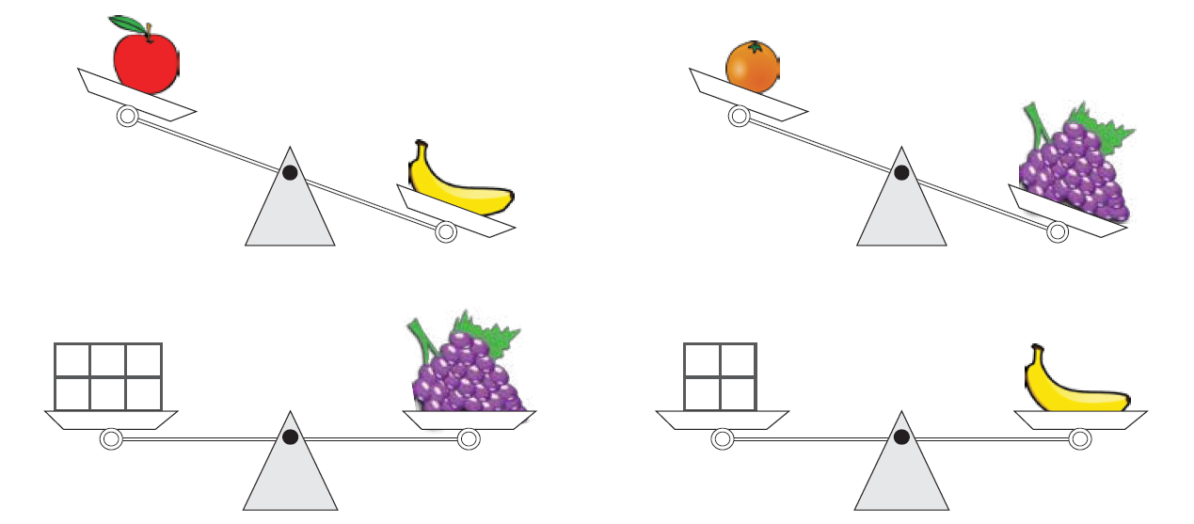

1.The banana is heavier than the apple. ________

2.The orange is heavier than the grapes. ________

3.The mass of the grapes is 9 units. ________

4.The mass of banana is less than 5 units. ________

5.The banana is lighter than the grapes. ________

6.The apple is heavier than the grapes. ________

7.The mass of the apple is more than 4 units. ________

8.The mass of the orange is less than 6 units. ________

**DATE TEACHER’S SIGN**

**10. PLAY WITH PATTERNS**

**Continue Pattern**

**Objective : To understand the pattern**

**Observe the pattern and continue**:

1.

_________,_________,_________

2.

__________ ____________ ________

3.

_________ __________ _________

4.

__________ ___________ ___________

5.

__________ _____________ __________

**Complete the following number patterns:**

i. 5, 10, 15, 20, _______, _______, _______, _______

ii. 8, 18, 28, 38, _______, _______, _______, _______

iii. 99, 199, 299, 399, _______, _______, _______, _______

iv. 275, 274, 273, 272, _______, _______, _______, ______

**DATE TEACHER’S SIGN**

**EVEN AND ODD NUMBER**

**Objective: To able to know even and odd numbers**

**Complete the following statements:**

1. All numbers that end with 0, 2, 4, 6 and 8 are called ____________ numbers.
2. All numbers that end with 1, 3, 5, 7 and 9 are called ____________ numbers.
3. If we add 1 to an even number we get a ______________number.
4. If we add 1 to a odd number we get an ______________number.
5. If we add an odd number to a odd number we get an ____________ number.
6. If we add an even number to a odd number we get a ___________ number.
7. The greatest 1 digit even number is ________________.
8. The smallest 1 digit odd number is ________________.
9. The greatest 2 digit odd number is ________________.
10. The smallest 2 digit odd number is ________________.
11. 45, 48, 51, _______,________,________
12. 20,24,28, _______,_________,________

**Choose the correct answer:**

1.Which of the following is an odd number?

i) 734 ii) 246 iii) 492 iv) 599

2. Which of the following is an even number?

i) 523 ii) 135 iii) 972 iv) 105

3. If we add 1 to any odd number ,we get _________________

i)0 ii)1 iii)odd number iv)even number

4.If we add 1 to any even number, we get __________________.

i)0 ii)1 iii)odd number iv)even number

**DATE TEACHER’S SIGN**

**FIND EVEN AND ODD**

**Objective: To understand the even and odd numbers**

**Solve the following and write even or odd against each answer:**

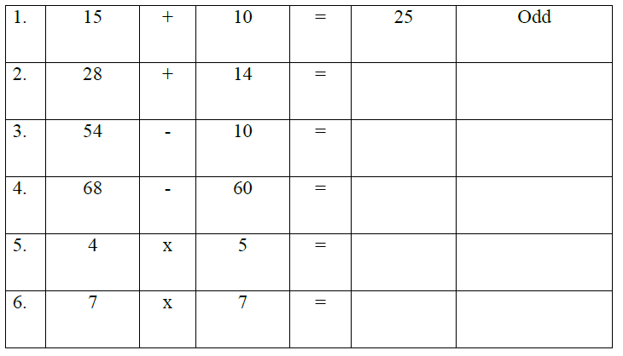

**Colour as directed:**



1 digit odd numbers – Yellow 1 digit even numbers – Orange

2 digit odd numbers – Blue 2 digit even numbers – green

3 digit odd numbers – pink 3 digit even numbers - red

**DATE TEACHER’S SIGN**

**SECRET CODE**

**Objective: To find the secret messages**

**Some secret messages are given below. Decode these messages and write:**

a) 1g 2o 3o 4d 7m 5o 8r 9n 8i 2n 5g

_______________________________________________

b) 11w 2e 5l 8c 6o 3m 0e

_______________________________________________

c) AAWBBH NNE MMR DDE VVA WWR MME KKY GGO XXU?

________________________________________________

d) XXiSSaTTmEEiFFnQQtVVhMMeAApUUlCCaHHyZZgAArUUoMMuLLnRRd

_________________________________________________

**Arrange these names in alphabetical order and number these names:**

Mohan Shilpa Lila Nandu Chitra Pawan Venu Ahmed Zeena Sameer

___________ ___________

___________ ___________

___________ ___________

___________ ___________

___________ ___________

**DATE TEACHER’S SIGN**