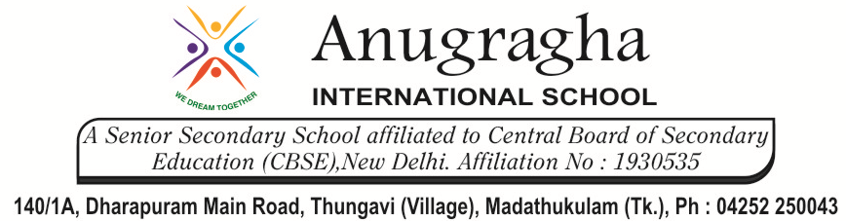

MIDTERM TEST-AUG-2019

KBQ -01
NAME |  | AD.NO
CLASS | VI - | EX.NO
G.D | 09.08.19 | SUB | SST [HIS]
S.D | 14.08.19 | CH:4 WHAT BOOKS AND BURIALS TELL US
Short Answer Type Questions:

- In what ways are the books we read today different from the Rigveda?
- In what ways do you think that the life of a raja was different from that of a dasa or dasi?
- Describe the occupations of the people in the Vedic Age.
- Who were Dasas/Dasyus?
- How did social differences exist in burials in India?
- Were some burial spots meant only for families?
- How did special burial take place at Inamgoan?

Long Answer Type questions:

- How were Vedas a big source of knowledge?
- What do Megaliths tell us about North-West and Deccan?
- How battles were fought according to the Rigvedas?

