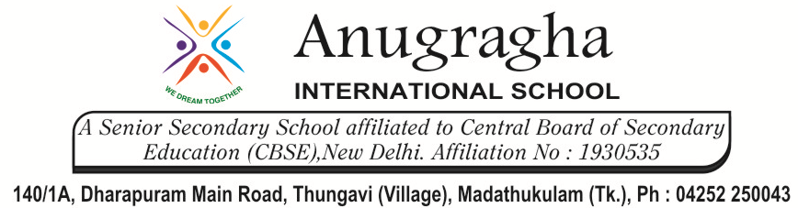

MIDTERM TEST-AUG-2019

KBQ - 01
NAME |  | AD.NO
CLASS | VII - | EX.NO
G.D | 15.08.19 | SUB | SCIENCE[CHE]
S.D | 19.08.19 | CH:5 AICDS, BASE AND SALTS
Short Answer Type Questions:
1.How do you prepare lime water?
2.Write two uses of the following: a)calcium hydroxide b) Sodium hydroxide .
3.Why is carbonic acid added to soft drinks?
4.What is the best way to treat indigestion?

Long Answer Type questions:

1.State differences between acids and bases.
2.Give the color of the following indicators in acidic and basic medium: Blue litmus, turmeric, china rose, methyl orange, phenolphthalein, and red litmus.
3.State the nature of following solution and give effects of these solution on litmus paper.
a)Detergent solution b) Lime water c)Soft drink d)Sugar solution e)Vinegar.
4.Explain two neutralization reactions related to daily life situation.
5.What are indicators? Explain with examples.

HOTS:
1.Acids are not stored in metallic containers. Why?
2.What happens when aerated drink is put no blue litmus paper?
3.Is the distilled water acidic/basic/neutral? How would you verify it?
4.What happens in the stomach when a very spicy food is eaten?
5.Why is an antacid tablet taken when you suffer from acidity?
6.Coffe is bitter in taste. Is it an acid or a base. Why?
7.Ammonia is found in many household products such as window cleaners. It turns red litmus blue. What is its nature?

