MIDTERM TEST
CRT-01
NAME : | CLASS: III- | SUBJECT: EVS | DATE:
CH -6. FOODS WE EAT |  | MARKS: | 25
SUBJECT TEACHER’S SIGNATURE |  | PARENT’S SIGNATURE
1.Choose the correct answer: 5x1=5
1.Which of the following is made from rice?
(a) Chapati (b) Bread (c) Idli
2.Which of these an items can be eaten easily by old persons?
(a) Chapati soaked in dal (b) Nuts (c) Corn
3.Which of the following is made from wheat?
(a) Pulao (b) Idli (c) Dosa
4.From which of the following we can get food?
(a)Air (b) Plants (c) Water
5.Which of these food give us energy?
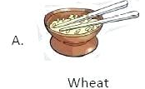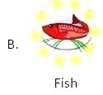 c. 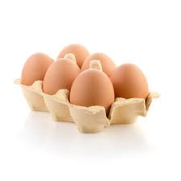Egg
2.Match the following: 5x1=5
1. Carbohydrates - Milk
2.Proteins - Fruits and vegetables
3.Calcium - Egg
4. Vitamins & Minerals - Ghee
5.Fat - Rice
3.Write what all can be prepared from rice . 4x1=4
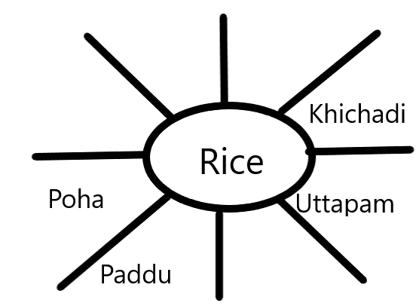

4.Circle in green all the food items that we get from plants and in red those we get from animals:
5x1=5
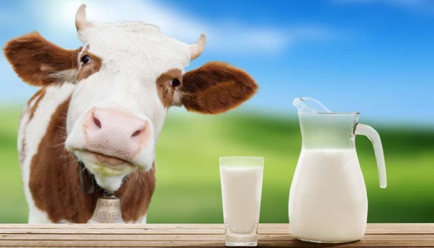

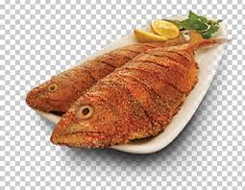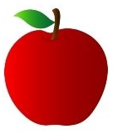

7.Answer the following questions (any-2): 3x2=6
a)Name any two food items that help us to grow.
_______________________________________________________________________________________________________________________________________________________________.

b)What are the nutrients required by our body?
_______________________________________________________________________________________________________________________________________________________________.

