CRT-I-JUL-2019
CLASS | III | SUB |  |  | MATH
Ch:1 Where to look from? |  |  | DATE: | MARKS: /20

- Tick the correct view to look at these things. 5x1=5
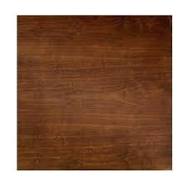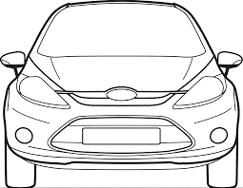
Front, Top, Side Front, Top, Side
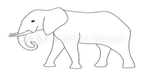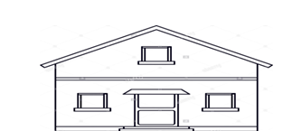
Front ,Top,Side Front ,Top,Side

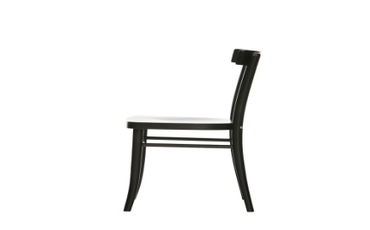
Front, Top, Side

- Use dot grid to draw any-5shapes: 5x1=5

III. Draw Using the dotted line, can you divide the following pictures into two similar halves

10x1=10
a) b) 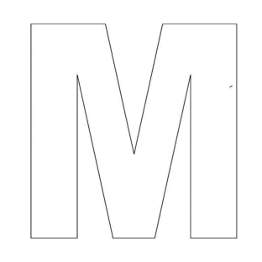 c)

d)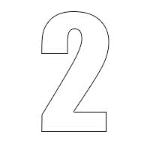e)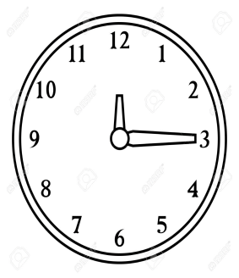 f)

g)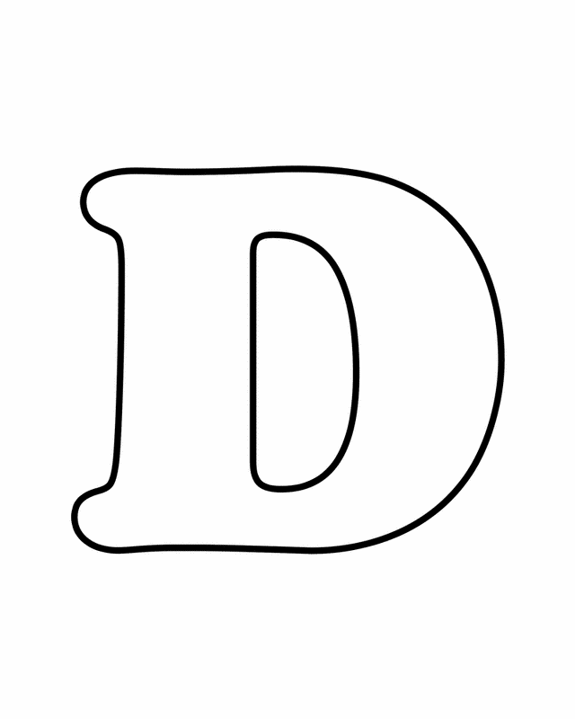h)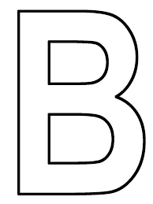i)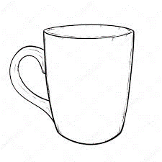j)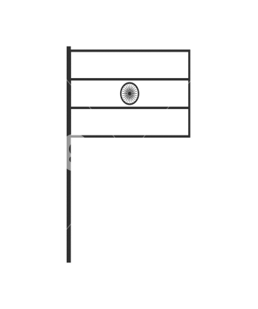

&&&&&& ALL THE BEST &&&&&&

