|  |  |  |  |
| --- | --- | --- | --- |
|  | | | |
| **MIDTERM TEST**  **CRT-02** | | | |
| **NAME :** | **CLASS: III-** | **SUBJECT: MATHS** | **DATE:** |
| **CH – 5. SHAPES AND DESIGNS** | | **MARKS:** | **25** |
| **SUBJECT TEACHER’S SIGNATURE** |  | **PARENT’S SIGNATURE** |  |

**Colour the clown following the directions given below: 5x1=5**

Triangles: Red Squares: Yellow

Rectangles: Blue Circles: Green

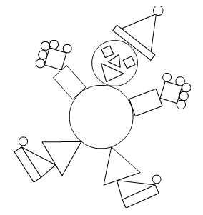

**How many triangles are there in the following figures? 3x1=3**

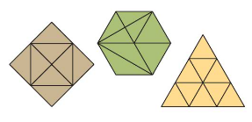

Recognize the following figures and write the names of the shape for each picture in the box provided. 6x1=6

[squares, rectangle, triangles, cubes, cuboids, cylinders, cones and spheres.]

1.  2. 

3.  4. 6.



Sun-_____________

**V.Write 4th table : 2x3=6**