**VI. Match the following: 5x1=5**

a) Badminto i) 52

b) Ludo ii)Queen-Pawn

c) Cricket iii)Shuttle – cock

d) Cards iv) Dice

e) Chess v) Bat- ball

**VII. Write the name of the game that the following sports person associated with: 4x1=4**

**[Cricket, Chess, Hockey,Tennis]**

1. SACHIN TENDULKAR b) SANIA MIRZA
2. VISWANATH ANAND d) DHANRAJ PILLAI

**VIII. Short answer questions: 3x2=6**

1. What is our national game?
2. Why should we play?
3. Which is the fastest means of communication?

|  |  |  |
| --- | --- | --- |
|  | | |
| **POST MIDTERM TEST**  **CRT-04** | | |
| **CLASS: III-** | **SUBJECT: EVS** | **DATE:** |
| **CH:16.Games we Play, 17.Here comes a Letter** | **MARKS: 25** | **TIME: 40 MINS** |

**I. Fill in the blanks: 2x1=2**

1. We need _________________players in football.

2. Television is an electric means of _____________.

**II. State True or False: 2x ½ =1**

1. We inculcate punctuality, while playing games.
2. In olden days letters were sent by pigeons.

**III.Complete the word: 2x1=2**

1.We post our letter in it. P ______ ______ ______ _____ ______ ______

2.Postman delivers. L ______ ______ ______ ______ ______

**IV. Look at the picture and write their names: 5x1=5**

**[Mobile Phone, cordless phone, vintage phone, rotary phone, telephone]**

**a) b)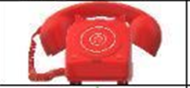 c)**

**d)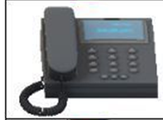 e)**