MIDTERM TEST
CRT-01
NAME : | CLASS: IV- | SUBJECT: CS | DATE: 20.08.19
CH -3.-MORE ABOUT TUX PAINT |  | MARKS: | 25
SUBJECT TEACHER’S SIGNATURE |  | PARENT’S SIGNATURE
1.Choose the correct answer: 5x1=5
1)To deselect a picture you have selected for a slide show___________________
a)click the selected picture b)Press the Delete button
c)Press the Quit tool d)Press the Backspace key
2)If the sliding button scale at the bottom-left corner of the screen next to the Play button is not selected
a)slides in the slide show move automatically
b)slides in the slide show move manually by pressing the Spacebar, Enter, or Right arrow.
c)click the Next button to move to the next slide.
d)options (b) and (c)
3)Pictures in a slideshow are marked as
a) A,B,C….. b) a,b,c ……… c)1,2,3,…….. d)I,II,III,…..
4)Click this button to select the pictures for slide show.
a)Open b)Slides c)Erase d)Back
5)The button is used to start the slide show.
a)Play b)Back c)open d)New
2.Fill in the blanks : 5x1=5
a)Click the ___________________ button at the bottom-right corner of the slide show to return to the list of pictures.
b)The ______________________ tool is like a rubber stamp or a sticker .
c)You can mute the sound by pressing _______________ keys.
d)C lick _________________________key to exit the slide show.
e)A ______________________ is a systematic display of selected pictures one by one.
3.Write True or False: 5x 1=5
a)You cannot deselect a picture, once for the slide show. _______________
b)The Slides button is used to display the storyboard. _______________
c)All stamps are colored. _______________
d)To move to the various categories of stamps, use the left and right arrows. _______________
e)You can increase or decrease the size of the stamp. _______________
4.Identify the following: 4x1=4
[Help Area, Selector, Drawing Canvas, Color Palette]
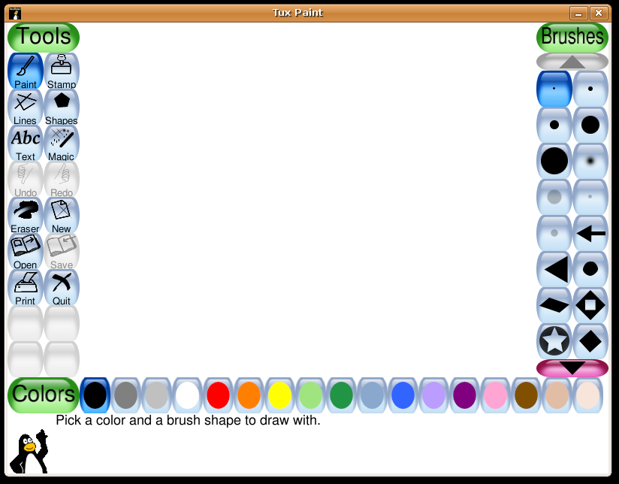
4
3
2
1
1.____________________ 2.________________________
3.____________________ 4.________________________

5.Answer the following questions(any-3): 3x2=6
a)What is slide show?
_______________________________________________________________________________________________________________________________________________________________.
b)How can you exit from the slide show?
_______________________________________________________________________________________________________________________________________________________________.

c)What are the different ways to advance the slide in a slide show manually?
_______________________________________________________________________________________________________________________________________________________________.
d)How will you start the slide show?
_______________________________________________________________________________________________________________________________________________________________.

