**IV. Write any five sentences to describe the picture and give suitable title.**

**5x1=5**

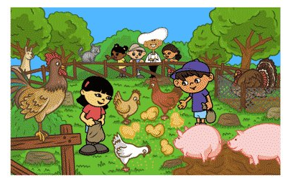

**V. Write the full forms of the following words: 4x ½ =2**

1. Mustn’t 2. Didn’t 3. Hasn’t 4. I’m

**VI. Write the adjective in the following sentences. 2x ½ =1**

1. The garden is beautiful.

2. The elephant is a huge animal.

**VII. Fill in the blanks with the verbs. 2x ½ =1**

1. Devesh ____________ the fish. (feed)  
 2. Father ______________ with the dog. (walk)

**VIII. Choose the best answer:- 2x ½ =1**

#### 1. I ............................... go to bed at 10 o’clock.

a. once b. ever c. usually

#### 2. I have …………………. been to the USA.

a. never b. ever c. one

**IX. Answer the following questions(any-3): 3x2=6**

1. What does the poet want us to do at night?
2. What happens when the day is over?
3. How did Miss Sullivan help Helen?
4. Who agreed to help Helen?

|  |  |  |
| --- | --- | --- |
|  | | |
| **POST MIDTERM TEST**  **CRT-01** | | |
| **CLASS: IV-** | **SUBJECT: ENG** | **DATE:** |
| **UT:5 (Peom:Don’t be Afraid of the Dark, Helen Keller)** | **MARKS: 25** | **TIME: 40 MINS** |

**I. Read the passage carefully and answer the following questions: 5x1=5**

**Pushing and Pulling**

We move things by pushing them or by pulling them. Heavy things are hard to move. Sometimes when we want to move things we push them. When we push things, we move them away from us. Wheels make it easier to push heavy thing. Engines help to push big and heavy things. Sometimes when we want to move things we pull them. When we pull things, we move them towards us.

**Questions:**

1. How do we move things?
2. True or False: When we push things, we move them away from us.
3. What make it easier to push heavy things?

4. What does happen when we pull things?

5. The title of passage_______________.

**II. Write the opposites: 4x ½ =2**

1. War x 2. Start x 3.Night x 4. Gentle x

**III. Write the nouns (naming words) in the below sentences. 4x ½ =2**

1. I love red cars.

2. John and Mary went to the supermarket and bought eggs and cheese.

3. We had pizza for dinner.

4. We get medicine from plants.