UNIT TEST-II-JUN-2019
NAME: |  |  |  | DATE:
CLASS | IV | SUB |  |  | CS
Les:2 More About Windows 10 |  |  | MARKS: /20

- Choose the correct option: 4x1=4
- To select multiple contiguous items, use this key
- Alt b) Ctrl c) Shift d) Esc
- This will change the desktop background , color and sound effects
- Wall paper b) theme c) Screen Saver d) All of them
- You can access anything stored on your computer through this icon
a)File Explorer b) This PC c) Recycle Bin d) Both (a) and (b)
4. To copy a file or folder, first select it and then
a) Click copy in the clipboard group of the Home tab. b) Press Ctrl + C
c) Select copy option of context menu d) Any one of Above.
II. Fill in the blanks: 4x1=4
- The Background image of the desktop is called__________________
- The ______________ tile provides access to frequently updated information such as news, weather and calendar events.
- A ______________ is a location for organizing and storing files
- Press _________________ to select all the items in a folder.
- Write T for the true statement and F for the false one : 4x1=4
- The Libraries are virtual folders_________________
- To rename a file or folder press F5. __________________
- You can move a tile by dragging it to a new location __________________.
- You cannot remove any tile from the start screen_______________.
- Answer the following: 2x2=4
- Write steps to delete all the files in Recycle Bin.

- What are the four options that appears when you resize a tile?

V.In the figure given below, label the navigation pane, the content pane, a file and a folder: 4x1=4

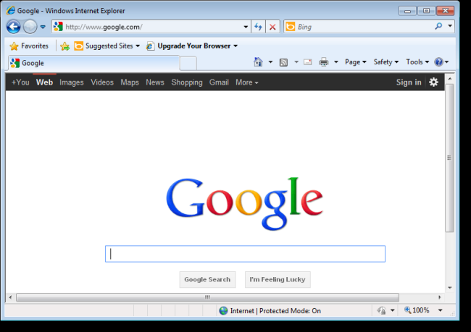

&&&&&& ALL THE BEST &&&&&&

