**IV. Write any five sentences to describe the picture and give suitable title.**

**5x1=5**

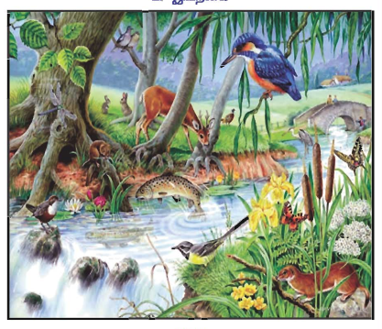

**V. Rewrite the sentences with the plural form of the words underlined. 2x1=2**

1. The puppet is beautiful.

2. This shoe is polished.

**VI. Write a or an to complete each sentence. 3x1=3**

1. Yesterday I saw ____________ ant hill.
2. Texas is ____________ large state.
3. We will wait no longer than ____________ hour.

**VII. Answer the following questions: 3x2=6**

1. Name those who tried to make the Cow and move.
2. Why did the cow refuse to get up?
3. Why did the cow and refuse to get up?

|  |  |  |
| --- | --- | --- |
|  | | |
| **POST MIDTERM TEST**  **CRT-02** | | |
| **CLASS: IV-** | **SUBJECT: ENG** | **DATE:** |
| **UT:6 (The Donkey I had a Little Pony,The Milkman’s Cow,)** | **MARKS: 25** | **TIME: 40 MINS** |

**I. Read the passage carefully and answer the following questions: 5x1=5**

**The Ant and the Grasshopper**

In a field one summer's day a Grasshopper was hopping and singing. An Ant passed by, bearing along with great toil an ear of corn. "Why not come and chat with me," said the Grasshopper. "I am helping to lay up food for the winter," said the Ant. "Why bother about winter?" said the Grasshopper. But the Ant went on its way and continued its toil. When the winter came the Grasshopper had no food and found itself dying of hunger while it saw the ants distributing every day corn and grain from the stores they had collected in the summer. Then the Grasshopper knew: It is best to prepare for days of need.

**Answer each question.**

1. What was the Grasshopper doing?

2. “Why not come and chat with me.” These words were said by

3. What did the Ant reply to the Grasshopper?

4. What happen when the winter came?

5. How did the Ant spend the winter?

**II. Fill in the blanks using the words given at the end of the sentences: 2**

1. We should be _________ to animals.(Kind/ cruel)
2. Children ______________ walk on their heads.(can/cannot)
3. Insects ____________ crawl on the wall.( can/cannot)
4. The grocer was ______________ to move the cow.(able/ unable)

**III. Write the Simple past tense of the given word: 4x ½ =2**

1. Begin 2. Tug 3. Say 4. grow