**4. Relationship between Radius and Diameter :**

1)Diameter = ____________ X Radius

2)Radius = ____________

2

**III.Fill in the column: 5x1=5**

|  |  |
| --- | --- |
| **RADIUS** | **DIAMETER** |
| 4 cm |  |
|  | 12 cm |
| 8 cm |  |
|  | 10 cm |
| 2 cm |  |

[ Hint: Diameter = 2 X Radius Radius = diameter / 2 ]

**IV. Solve the following: 3x1=3**

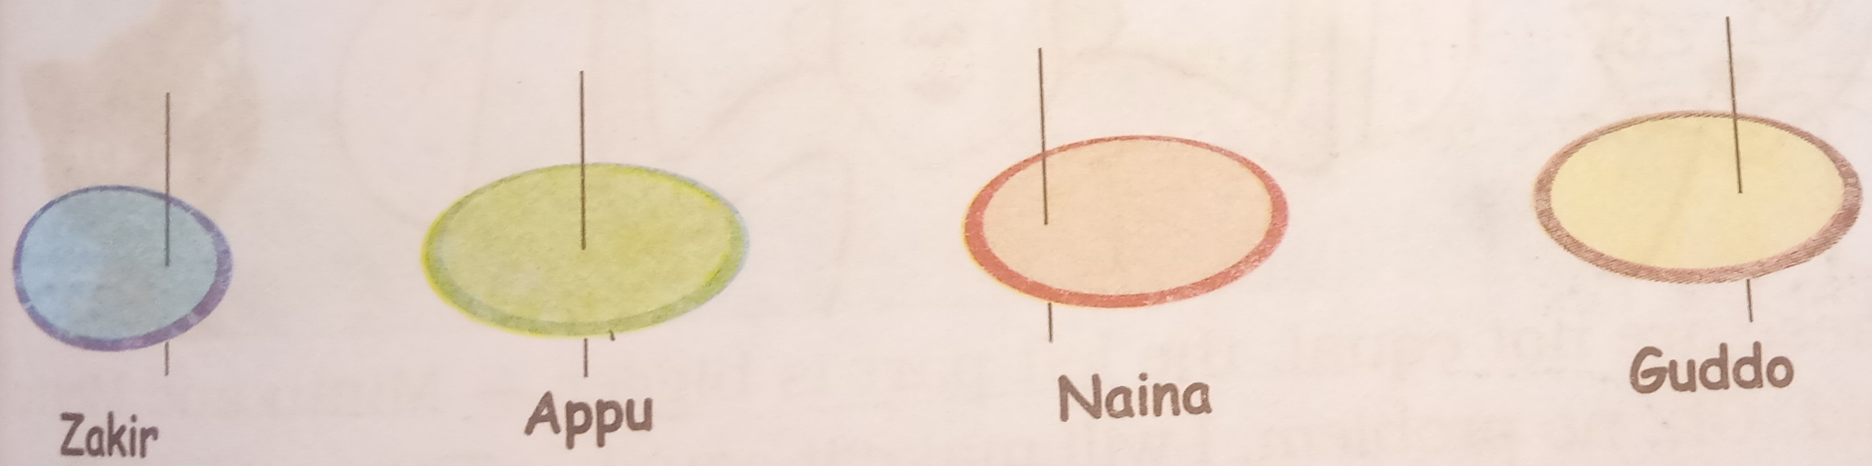

1. Whose top will not spin at all?

2. In whose top is the stick nearest to the centre?

3. Whose top will spin the best?

**V. Write 12th table : 5**

|  |  |  |
| --- | --- | --- |
|  | | |
| **POST MIDTERM TEST**  **CRT-02** | | |
| **CLASS: IV-** | **SUBJECT: MAT** | **DATE:** |
| **CH:8. Carts and Wheels** | **MARKS: 25** | **TIME: 40 MINS** |

**I. Fill in the blanks: 4x1=4**

* + 1. 1. A ____________ is a simple closed curve.
    2. 2. _____________ is the line that runs between the circle and its centre.
    3. 3. _____________ divides the circle into two equal halves.
    4. 4. _____________is the distance around the circle; it is the length of the circle.

**II. Solve the following: 4x2=8**

1. Using compass, draw circles of the given radius.

a. 3 cm b. 4 cm

2. Draw the radius and diameter of the given circles and measure it and find the relationship between radius and diameter

Circle A

 1)Radius : _______ 2)Diameter: _______

3. Draw a circle with a radius 6 cm. With the same centre draw another circle of radius 4 cm. Within this circle, draw a third circle of radius 2 cm within this circle.