**IV. Write five sentences to describe the picture and give suitable title.**

**5x1=5**

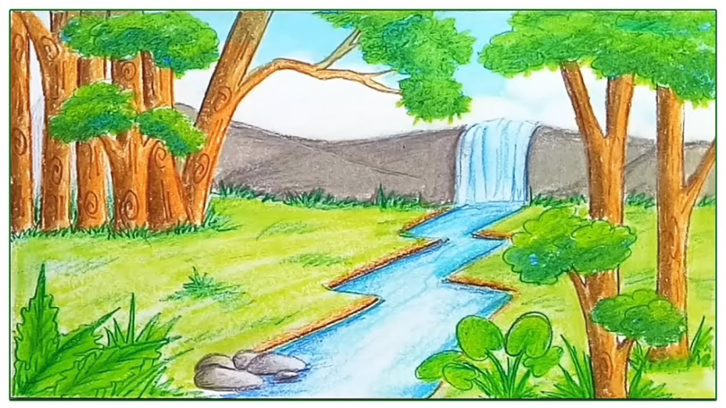

**V. Fill in the blank with "I" or "me." 2x1=2**

1. Mom drove _____ to school today.
2. _____ really want that chocolate cake.

**VI. Fill in the blank with "she" or "her." 2x1=2**

1. Harry wrote a love poem for _____.
2. Martha is certain of _____ facts.

**VII. Fill in the blank with "we" or "us." 2 x ½ =1**

1. She can not come with _____ today.
2. After _____ eat, let's see a movie.

**VIII. Answer the following questions: 3x2=6**

1. What did he claim to know?
2. Who came to Akbar’s court?
3. What did he learn about the birds?
4. Who was Hiawatha?

|  |  |  |
| --- | --- | --- |
|  | | |
| **POST MIDTERM TEST**  **CRT-03** | | |
| **CLASS: IV-** | **SUBJECT: ENG** | **DATE:** |
| **UT:7 (Hiawatha, The Scholar’s Mother Tongue)** | **MARKS: 25** | **TIME: 40 MINS** |

**I. Read the passage carefully and answer the following questions: 5x1=5**

Long ago, there ruled a king named Dashratha in Ayodhya. He was a very kind ruler. He loved hunting very much. Every hunting day he went to a nearby forest. He was also a very good shot. There lived a blind old couple in his kingdom. They had a son, Shravan Kumar. He was a very obedient boy. He always served his old parents. They were very happy with him. They always blessed him.

One day his mother said, "My dear son! You have served us for a long time, now we have only one desire. Now we wish to go on a pilgrimage. But, alas! we cannot go. We are blind and helpless." On hearing this, he said, "Dear mother, please don't worry. I shall do everything to fulfil your desire."

**Questions:**

1. Where did Dashratha rule ?
2. In whose kingdom did the blind couple live ?
3. Whose son was Shravan Kumar ?
4. What was the only desire of the blind couple ?
5. What did Dashratha love ?

**II. Choose the correct word from the box and fill in the blanks: 4x ½ =2**

1. This sum is _______________(right/ write)
2. Do you _____________ a secret? (no, know)
3. The King sits on the ________________(thrown, throne).
4. The squirrel has a long____________.(tail, tale)

**III. Fill in the blank with "they" or "them." 2x1=2**

1. Everybody knows _____ spilled the beans.
2. If the peaches are not ripe, we will not buy _____.