MIDTERM TEST
CRT-01
NAME : | CLASS: V- | SUBJECT: MATHS | DATE: 27/08/19
CH -4. PARTS AND WHOLES |  | MARKS: | 25
SUBJECT TEACHER’S SIGNATURE |  | PARENT’S SIGNATURE
I.Find the fraction: 4x1=4
1.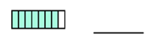 2.
3. 4.
II. Shade the figure with the Indicated Fraction: 4x1=4
1. 2.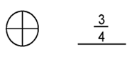
3.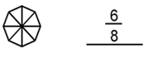 4.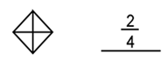
III. Write the reciprocal (multiplicative inverse) of the following. 5x1=5

a) 4 b) 1/5 c) 55/76 d) 42/76 e) 8/34

IV. Find the equivalent fractions: 5x1=5
a) $\frac{4}{6}=\frac{___}{12}$ b)$\frac{2}{4}=\frac{___}{12}$ c)$\frac{1}{6}=\frac{___}{12}$ d)$\frac{2}{5}=\frac{___}{10}$ e)$\frac{1}{4}=\frac{___}{8}$
V.a) Write as fractions: 1x1=1
i) 16÷4 = _______________
b)Write as a division fact: 1x1=1
ii) 69/11 = _______________
VI.Write 9th table: 1x5=5

