POST MIDTERM TEST
CRT-02

CLASS: V- | SUBJECT: ENG | DATE:
UT:6 (Class Discussion, The Talkative Barber) | MARKS: 25 | TIME: 40 MINS

I. Read the passage carefully and answer the following questions: 5x1=5
The sun is a huge star made of very hot gases. There are eight planets which revolve around the sun. These planets are Mercury, Venus, Earth, Mars, Jupiter, Saturn, Uranus, Neptune. We live on Earth. The Earth is the only planet that has life upon it. The Earth moves on its orbit around the sun. It takes a time period of one whole year to make one complete round around it. This movement of the Earth causes day and night. Those parts of the Earth facing the sun have day time and the other parts have night time. The Earth has big masses of land which are called continents and big masses of water which are called oceans. Our homes are part of a city which in turn is a part of a country.
Answer the following questions.
1. What is the sun made of?
2. Name the planets.
3. The Earth takes ________________________ to make one complete round.
4. The movement of the Earth causes _________________________.
5. What are the big masses of land and water called?
II. Write five sentences to describe the picture and give suitable title. 5x1=5
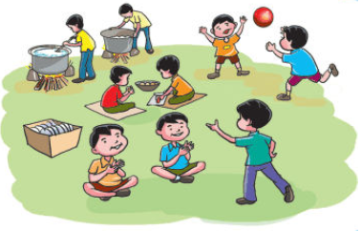
III. Read Sheela’s notice. Discuss the questions that follows: 4x1=4
Notice
The Drama Committee will meet in the classroom on Monday, at two o’cock,. We’ll plan a play for our Annual Day.
Will each one of you please bring a play?

Questions:
1.Who was to meet?
2. When were they to meet?
Where were they to meet?
What were they to do?

IV. Write the opposites of the following using un-, im-, dis – 4x ½ =2
a) Obedient b) respect c) satisfy d) Prefect

V. Use the joining words given in the box to fill in the blanks: 3x1=3
[or , till, while]
- Please wait with me _______________________ the bus arrives.
- Do you like football ___________________ cricket?
- My father packed my lunch ____________________ my mother combed my hair.

VI. Answer the following questions: 3x2=6
1)What activity was going on in the class?
2) Why did the Barber want a lot of food?
3) Why did the barber take so long to shave the Sultan?

