**II. Solve the following: 2x 2 ½ =5**

**You will get numbers in each by multiplying the numbers in the next to it**

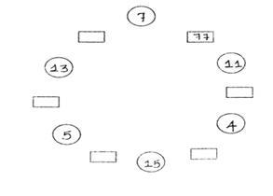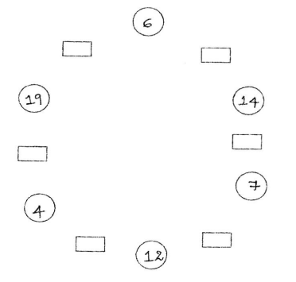

**III. Solve the following: 5**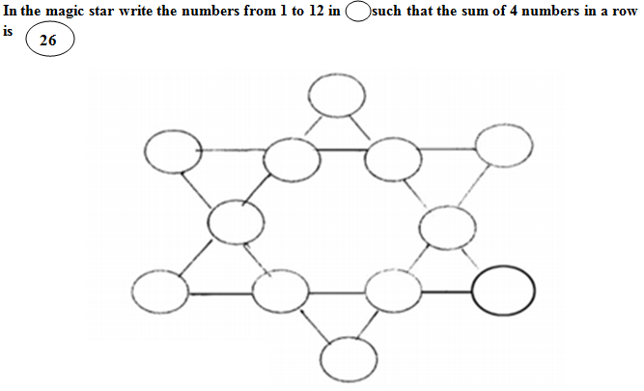

**IV. Write 16th table: 5**

|  |  |  |
| --- | --- | --- |
|  | | |
| **POST MIDTERM TEST**  **CRT-02** | | |
| **CLASS: V-** | **SUBJECT: MAT** | **DATE:** |
| **CH:7. Can you see the Pattern?** | **MARKS: 25** | **TIME: 40 MINS** |

**I. Solve the following: 2x5=10**

**1. Complete the following patterns:**

a)  b) 

c)  c) 

e) 

2. **Continue the pattern by making a 1/4 turn clockwise**

a)  b) 

c) 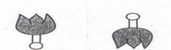 d) 

e) 