CRT-II-JUL-2019
NAME: |  |  |  | DATE:
CLASS | V | SUB |  |  | MATHS
3 – How many squares?  12. Smart charts |  |  | MARKS: /25

I. Find the perimeter and area for the following figures. 2x5 =10

a) 2cm
2 cm b)

4
4 cm 5 cm

II. Find the area for the following. 1x2 = 2

a)
5cm

4 cm

III. The area for the given rectangle is 20 sq.cm. Then find the area for the each of the triangles. 1x2=2

IV. Draw tally marks for the following. 2x1 =2

a) 9 _

b) 15 _

V. Observe the following bar chart and answer the questions: 4x1 = 4
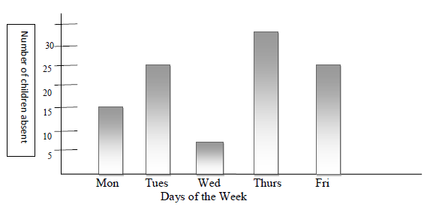
a) How many children were absent on Tuesday?
_____________________________________________________
b) How many more children were absent on Thursday than on Monday?
_____________________________________________________
c) On which day were the least children absent?
______________________________________________________
d) On which day the number of children absent was exactly the half of that on Thursday?
_______________________________________________________

VI. Look at the pie chart showing different sports liked by people. 5 marks
HOCKEY
CHESS TENNIS

CRICKET FOOTBALL

(a) Which is the most popular sport? _____________
(b) Which is the least popular sport? ____________
(c) Do more children enjoy Hockey or tennis? _________________
(d) Arrange the sports liked by children in increasing order.
____________________________ ____________________________
&&&&&& ALL THE BEST &&&&&&

