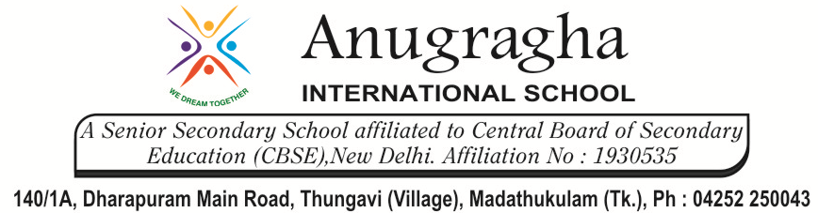

CRT-II-JUL-2019
CLASS | V | SUB |  |  | SCI
LESSON – 2.Food and Health |  |  | DATE: | MARKS: /25
I. Choose the correct option: 2x1=2
1. Which food item has proteins, fats and minerals?
a)Milk b) Fruits c) Rice d) Sugar
2. Which of the following provides energy to the body?
a) Bread b) Rice c) Sugar d) All of these
II. Fill in the blanks: 2x1=2
- ________________ help in strengthening the bones.
- Excess intake of fatty foods can lead to _________________
III.Write two examples for the following: 2x2=4
- Foods rich in roughage ______________, _______________
- Foods that can cause obesity ______________, _______________
IV.Write one word for the following: 2x1=2
1.Special substances used to prevent specific diseases __________________
2.The state in which a part of the body is no longer in a healthy condition ___________________
V.Give two examples of food items containing the following components: 2x2=4
1.Vitamins _________________ , ________________
2.Fats ___________________, _________________.
VI.Short Answer questions: 2x2=4
1.What do you understand by a balanced diet?

2. Is it possible to prevent diseases? Mention any two ways.

VII. Long answer questions: 1x3=3
1.What are the different types of non-communicable diseases?

VIII.Complete the concept map given below: 8x ½ =4
Components of Food
Proteins

Types of Disease

&&&&&& ALL THE BEST &&&&&&

