**II. Solve the following:**

**1.Fill in the blanks [3]**

|  |  |  |  |
| --- | --- | --- | --- |
| **S.No** | **Shape** | **No. of faces** | **No. of edges** |
| 1 | Cube |  |  |
| 2 | Cuboid |  |  |
| 3 | Cylinder |  |  |

**2. Join the corners of these figures and write the name of the solid. [2]**

a)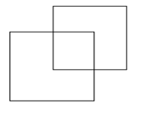 b) 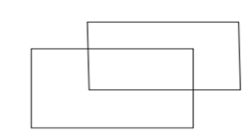

**III. Write 15th table: 5**

|  |  |  |
| --- | --- | --- |
|  | | |
| **POST MIDTERM TEST**  **CRT-03** | | |
| **CLASS: V-** | **SUBJECT: MAT** | **DATE:** |
| **CH:9. Boxes and Sketches** | **MARKS: 25** | **TIME: 40 MINS** |

**I. Solve the following: 5x3=15**

**1. Find the volume of the cubes whose edges are as follows**

a) 12cm b)10cm c) 2cm

**2. Find the volume of the cuboids whose dimensions are as follows**

    a) 12 ,8, 10  cm     b) 8,4,6 cm c) 6, 5,4cm

**3.** A room is 10 m long , 6 m wide and 8 m high. What is the volume of the room?

4. Punit makes a cuboid of length 5 cm , breadth 2 cm and height 3 cm then what is its volume?

5. A swimming tank is 15 m , 5 m , 10 m in dimension. What is the volume of the tank?