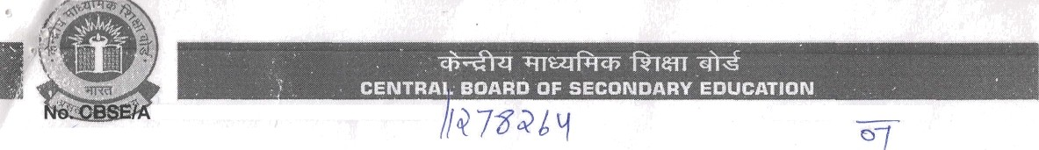
FF/SS-00961-1718/1930535/2017
e Manager,
Dated: 17.06.2017
Anugragha International School
140/1A, Udumalpet-Dharapuram Main Road, Thungavi Village, Madthukulam (T.K.) Tirupur, (G.T.)Coimbatore,Tamilnadu-642 203.

Sub: Ug gradation to + 2 stage - req.

Sir/Madam,
With reference to your application dated 20.06.2016 and subsequent inspection of the school, I am directed to convey sanction for pro isional affiliation to the abcde said school for Senior Se.condary School Certificate Examinat.on for a period cf threr. years w.e.f. t‘1.0•1.2017 to fs1.03.2020 in the following subjects:-

- Languages:- English Core.

Elective Subjects: Physics, Chemistry, Biology, Mathematics, Computer Science, Business
Studies, Accountancy, Economics & Physical Education.

The above sanction is subject to fulfillment of following conditions:-

' The school will follow the syllabus on the basis of curriculum prescribed by NCERT/CBSE and text books publishing by NCERT/CBSE for the Middle Classes. The school will follow syllabus and courses as per scheme of studies prescribed by the Board for Secondary/Sr. Secondary School Examination and changes made therein from time to time.
- The school will follow the RTE Act, 2009 and instructions issued thereon by the CBSE/Respective State Govt./UT Govt. from time to time.
- The school must follow Uniform System of Assessment, Examination and Report Card for classes VI- IX from Academic Year 2017-18 onwards as per the Board’s Circular hlo.: Acad-14/2017, dated 21.03.2017.
- The school must submit it’s information through Online Affiliated School Information System(OASIS) as per the Board’s Circular No:CBSE/Aff./4/Circular/2016, dated 10.11.2016, within 30 days from the receipt of this grant letter. Link for OASIS is available on Board’s website : www.cbse.nic.in
- The school will provide additional suitable facilities for classes XI and XII, as per requirements laid down in the rules.
G. !t '4’lil increase the *uube!“ r.f xcuip 'e ts i › the I.a!ncrator es/Workshops with adequate games facilities etc. in consonance with the requirements of the Board for Classes XI & Xli.
- The school will enroll students proportionate to the facilities available in the school as prescribed in the Affiliation Bye-Laws of the Board which shall not in general exceed the optimum number as under from Pre- Primary to Class XII -
Campus Enrolment No. of Sections (pre-primary No. of Sections at Sr. Secondary (XI area to X) &Xll)
  - 1.0 acre 1250 02 in each class 04 each in class XI and XII
  - 1.5 acre 1875 03 in each class 04 each in class XI and XII
  - 2.0 acre 2500 04 in each class 04 each in class XI and XII
  - School running on bigger campus of more than 02 acres, the number of students shall be restricted as per the actual facilities in the school which shall be proportionate to the optimum number mentioned at (a), (b) and (c) above.
  - Schools running on less than 01 acre campus shall restrict number of students as follows:-
Category Area of land No. of students
    - Secondary School 2000 sq. mtrs 600 upto Class X
    - Sr. Secondary School with two streams 3000 sq. mtrs 900 upto Class XII
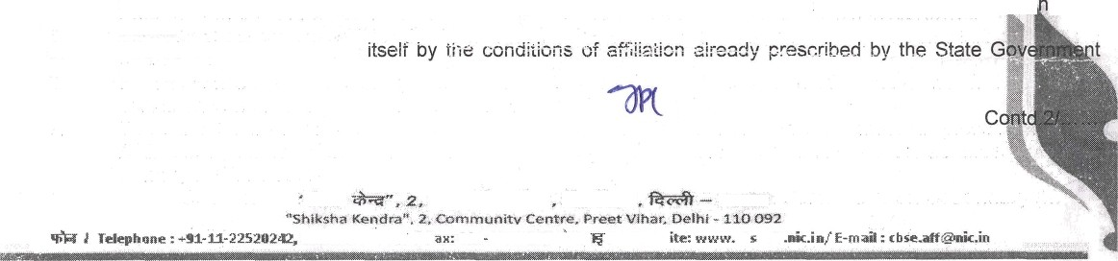
- The school will provide well equipped Library with all relevant reference books to the academic level of
9.
students and would keep at least 05 books per student subject to a minimum of 1500 books exc{udj g text books.
The schooi will also abide concerned.
11OOQ2

cb eaff

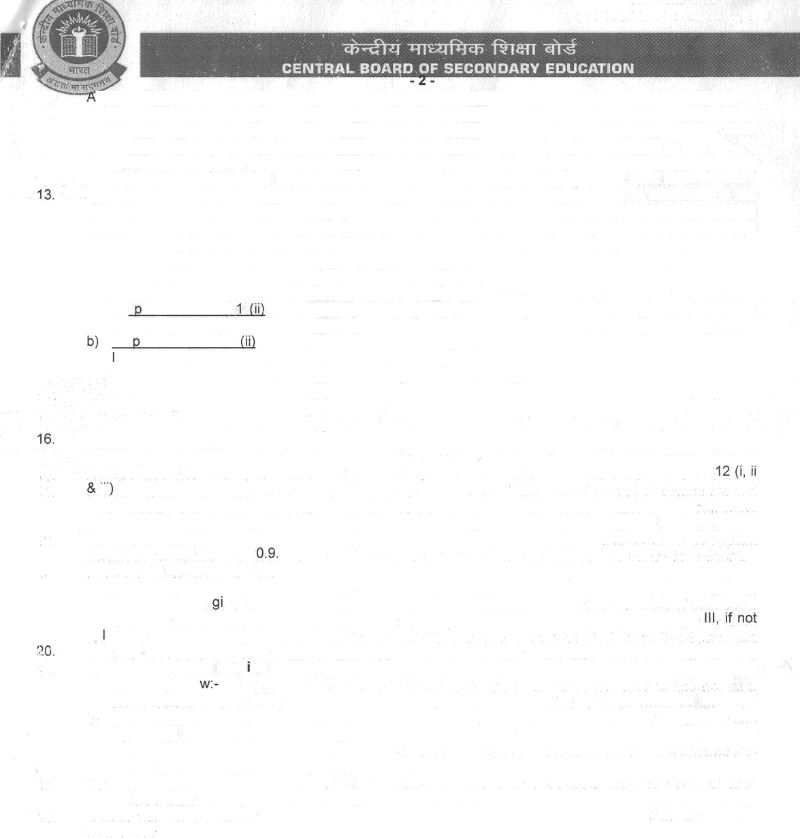
- ”s per Affiliation Bye-laws the optimum strength of a section should not exceed more than 40 students.
- School should have at least one adequately equipped computer lab with a minimum of 10 computers and would ensure computer student ratio of 1:20 at least. Proper software along with facility of Broad Band connectivity with the feature of ’internet always on’ from any service provider to be ensured.
- The section teacher ratio of 1:1.5 is to be maintained to teach various subjects and school shall appoint qualified and trained teaching staff on regular basis as per provisions of Affiliation Bye Laws of the Board. Fees should normally be charged under the heads prescribed by the Department of Education of the State/U.T. for schools of different categories. No capitation fee or voluntary donations for gaining admission in the school or for any other purpose should be charged / collected in the name of the school and the school should not subject the child or his or her parents or guardians to any screening procedure in accordance with Rule No. 11.1, 2 & 3. Also, as per Chapter II. Rule No. 11.1 of Affiliation Bye-Laws, fees charges should be commensurate with the facilities provided by the institution.
- The school should not use the arti /it'r+s Ie r cr•rnmerc:iaIi:•.ation:-
  - As er rule no. 19. It shall en -ufe that the school is run as a community service and not as a business and that commercialization does not take place in the school in any shape whatsoever.
As er rule no. 19.1 a Any franchisee school making payment on account of use of name, motto and ogo of franchiser institution or any other non-academic activities would be termed as commercialization of institution and to provide an affidavit that the school/society has not entered into any such contract to use Name, logo, motto for consideration of fee.
- Teachers are to be made educated regarding corporal punishment & should avoid any type of such involvement i.a.w. rule no. 44.1 (d & e).
School will not prepare any student/ start class for any other Board except CBSE from their CBSE affiliated school building/ premises.
- Admission to the school is to be made restricted under ru!e 6.1 of Examination bye laws and rule iif of Affiliation bye laws.
- The school has to constitute a committee for protection of woman from sexual harassment at the work place and to abide by the guidelines and norms prescribed by the Hon’ble Supreme Court of India in W.P. Criminal No.666-70 of 1992 Vishaskha and other State of Rajasthan and other delivered on 13.8.1997 mentioned under rule no. 1
- Each school affiliated/ to be affiliated with the Board shall frame Service Rules for its employees which will be as per Education Act of the state/U.T., if the Act makes adoption of the same obligatory, otherwise as per Service Rules ven in Affiliation Bye Laws. Further, Service contract will be entered with each employee as per the provisions in the Education Act of the state/ U.T., or as given in Appendix
ob igatory as per the State Education Act.
Pay and allowances to staff shou!cl he : e•zised time to time to bring it at par with that to State Government. Further, Salary and serv ce conditions r f staff shculd be provided i.a.w. rule no. 3.3 (v) and i ule no. 10 2 as appended belo
  - The school in India must pay salaries and admissible allowances to the staff not less than the corresponding categories of employees in the State Government schools cr as per scales etc. prescribed by the Government of India.” Further, the service conditions as per Rule 10 and Rules 24 to 49 of Affiliation Bye-Laws also be adhered to.
  - Salary should be paid through Electronic Clearing Service (ECS) from the date of first appointment of the teachers on probation.
- As per Rule 13.3 and 13.3 (i), the school shall supply information and returns called for by the Board/State/ Central Government/Local Authority within the prescribed time given for its furnishing to the authority concerned and the school should prepare its annual report containing comprehensive information including name, address postal and e-mail, telephone numbers, affiliation status, period of provisional affiliation, details of infrastructures, details of teachers, number of students and status of fulfillment of norms of affiliation Bye-Laws and upload same on the website before 15th September of every year.
- Continuous sponsoring of students at Board examination is to be made as per rule 13.12 (iv), Failure to do so will lead to suo moto withdrawal of the affiliation of the school for Secondary and Senior Secondary Examination as the case may be.
23 As per rule 13.12 (ii), no affiliated school shall endeavour to present the candidates who are not on its roll nor shall it present the candidates of its unaffiliated Branch/School to any of the Board’s Examinations.
- Running of classes of coaching institutions in the school premises in the pretext of providing coachin to the students for various examinations is not approved by the board. Strict action would be ta defaulters.
- As per rule no. 8.2 and 13.11, facilities for physically challenged student should be adequately p i and every school shall promote inclusion of student with disabilities/special needs in the normal sc per provisions of the ‘Persons with Disabilities Act 1995’.
Contd.

"Shfksha Kendra“, 2. Community Centre. Prcet ”•/'thar, Delhi - 110 092
h 7 Telephone : +9:1-M-225202 225 20y57 f Fax: 6 1-'y-“25' ¥5°• éT ” I \Yebsite: www.cbreatf.eéc.iz•/ E-ma"d: cbseW:1ezñ<.in

- Health, sanitation and fire safety should be adequately equipped i.a.w. rule no. 3.3 (vii), rule 8.5 and rule 23.11.
- School infrastructure and teachers for examinations conducted by the board and evaluation of answer scripts should be made available as per rule no. 13.4
- As per rule no. 8.8 (iv & v), every affiliated school to develop their own website containing comprehensive information such as affiliation status, details of infrastructure, details of teachers, number of students, address-postal and e-mail, telephone nos. etc.
- As per rule no. 3.3 h (vi), every school should organize at least one week training programme for teachers every year in association with any teachers training institute recognized by the State or Central Government or by any agency identified by the Board.
- Every secondary and senior secondary school shall appoint a person on full time basis for performing the duties of a Health Wellness teacher as per rule 53.5.
- Strict adherence to the provisions oi '?/iir.\ Life Protection Act while procuring plants and animals for the use in laboratories by the school mu t be made i.a.w. circular no 03 dated 21 May 2013.
- As per rule 15.1 (d), the school will follow the syllabus on the basis of curriculum prescribed by NCERT/ CBSE and text books publishing by NCERT/CBSE for the Middle classes as far as practicable or exercise extreme care while selecting books of private publishers. The content must be scrutiny to preclude any objectionable content that hurts the feelings of any class, community, gender, religious group in society. If found prescribed books having such content, the school will have to take responsibility of such content. Provided that the school would put a list of such books prescribed by it on its website with the written declaration duly signed by the Manager and the principal to the effect that they have gone through the contents of the books prescribed by the school and own the responsibility.
- As per RTE act 2009 and Chapter IX rule No. 53.2.2(a) and 53.3, a teacher appointed to teach Class I to V and VI to VIII should pass in the Central Teacher Eligibility Test (CTET)/ State -reacher Eligibility Test (TET) conducted by the appropriate Government in accordance with the guidelines framed by the NCTE for the purpose.
- The school should keep a copy of Affiliation/ Examination Bye Laws for reference purpose and also advised to visit CBSE websites www.cbseaff.nic.in & www.cbse.nic.in for updates.
- The school and its records shall be open for inspection by an officer/official of the Board or an authorized representative of the Board/State Educational Department at any time and the school shall furnish information as may be asked for by the Board/State Government from time to time.
- The school will strictly adhere with all rules regarding safety of students including Fire fighting and Transportation, etc. Further, school will provide adequate facilities for potable drinking water and clean healthy and hygienic toilets with washing facilities for boys and girls separately in proportion to the number
of students.
- The school will create Reserve Fund as per the requirement of the Affiliation Bye Laws.
- 5-6 names of persons not below the rank of Principal of Sr. Secondary School affiliated with the Board be recommended so that two of them may be approved by the Board as its nominee in the School Managing Committee. Of these 2-3 may be Principals of KV/JNV.
- The accounts should be audited and certified by a Chartered Accountant and proper accounts statements should be prepared in the name of school, as per rules. A copy each of the Statements of Accounts should be sent to the Board every year.
- It is mandatory for every affiliated school to become a member in the local Sahodaya of CBSE schools.
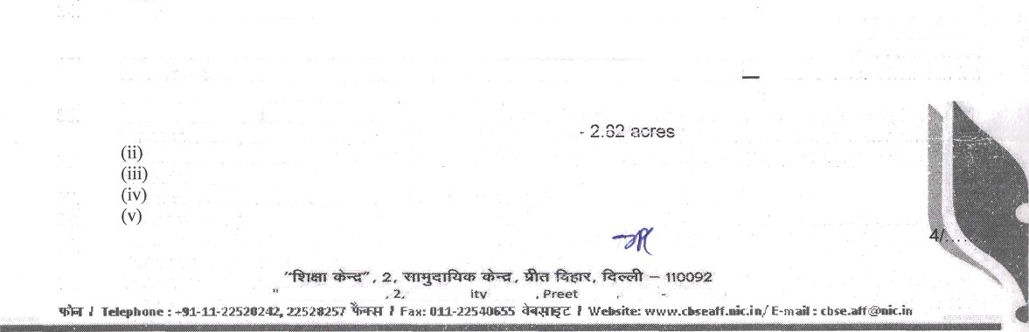
- The Board would not allow any transfer of property/sale of school by one society/ Management/ Trust to another Society/Management/Trust through agreement/sale deed and the school shall not be closed down in the same premises. In case such transaction is effected explicitly or implicitly the Board shall withdraw its affiliation with immediate effect.
43.

44.
year before the expiry of the date of provisional affiliation otherwise penalty @ Rs 10,000/- p.m. subject to maximum Rs 50,000/- will be charged for late execution of application.
The school will open CBSE pattern classes XI w.e.f. 01.04.2017. Accordingly, 1st Batch of class XII of the school will be appeared at the Board’s Examination to be held in the year 2019.
School will provide physical facilities as per norms of the Board. The facilities reported at the time of last inspection are as given under:-
(i) Area of schooi campus
Total built up area - 1519 meters
Playground size - 6960 sq feet
No. of class rooms - 22 (27’x22’)
No. of labs Physics - 44’x31’
Contd.
Shtksha Kumclra" Commun Centre

The school will apply for further Extension of Provisional Affiliation ’on online’ through www.cbseaff.nic.in with the prescribed fee of 25,000/- and other essential documents before 30! ^{h} June of th"e preceding

Chemistry - 44’x31’
Biology - 44’x31’
Home Science -27'x22
Maths lab - 27’x21
Computer Science - 33’x25’
(vi) Size and number of books in the Library 1320 sq feet, No. of Books 3079.

- In case of established violation of Affiliation Bye laws and any of the above mentioned conditions by any scheol, the school would be . li.‹ble fcr disaffilia?ion under Chapter V, Rule No. 17 of Affiliation Bye-laws.
- The society shall enter into a legal agreement with the Board detailing the broad terms and conditions for grant of affiliation, which will be binding on both the parties.
- The school is required to appoint Special Educator as per rule 13(11) of affiliation Bye laws of the Board and as mentioned in Board’s circular dated 25.06.2015

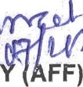
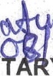
DEPUT'

FF)

