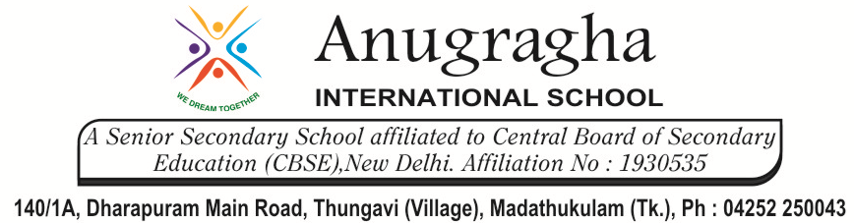
CLASS REVISION TEST-1
SCIENCE - CHEMISTRY
EX.NO |  | AD.NO |  | GRADE | X-LACELEAF
DATE | 02/11/19 | MARKS | 60 | TIME | 2 Hrs
SECTION - A
I. Choose the correct answer:- 7x1=7
1. Which of the following reactions involves the combination of two elements?
a. Ca + CO₂ -> CaCO₃
b. 4Na + O₂ -> 2Na₂O
c. SO₂ + (1/2) O₂ -> SO₃
d. NH₃ + HCl -> NH₄Cl
2. Which of the following is a physical change?
a. Formation of curd from milk
b. Ripening of fruits
c. Getting salt from sea water
d. Burning of wood
3. What happens when copper rod is dipped in iron sulphate solution?
a. Copper displaces iron
b. Blue colour of copper sulphate solution is obtained
c. No reaction takes place
d. Reaction is exothermic
4. CuO + H₂ -> H₂O + Cu, reaction is an example of –
a. redox reaction b. synthesis reaction
c. neutralisation d. analysis reaction
5. When CO₂ is passed through lime water, it turns milky. The milkiness is due to formation of
a. CaCO₃ b. Ca(OH)₂ c. H₂O d. CO₂
6. CuO + (X) -> CuSO₄ + H₂O. Here (X) is-
a. CuSO₄ b. HCl c. H₂SO₄ d. HNO₃
7. Plaster of pairs is made from-
a. lime stone b. slaked lime c. quick lime d. gypsum

II. Assertion and Reason:- 6x1=6
In the following questions, a statement of assertion is followed by a statement of reason. Mark the correct choice as:
a. If both assertion and reason are true and reason is the correct explanation of assertion.
b. If both assertion and reason are true but reason is not the correct explanation of assertion.
c. If assertion is true but reason is false.
d. If assertion is false and reason is true.
8. Assertion : Carbon dioxide turns lime water milky.
Reason : Carbon dioxide sullies the water.
9. Assertion : A chemical reaction becomes faster at higher temperatures.
Reason : At higher temperatures, molecular motion becomes more rapid.
10. Assertion : Calcium carbonate when heated gives calcium oxide and water.
Reason : On heating calcium carbonate, decomposition reaction takes place.
11. Assertion : Phenolphthalein gives pink colour in basic solution.
Reason : Phenolphthalein is a natural indicator.
12. Assertion : Salts are the products of an acid-base reaction.
Reason : Salt may be acidic or basic.
13. Assertion : When common salt is kept open, it absorbs moisture from the air.
Reason : Common salt contains magnesium chloride.

III. Answer in a word:- 6x1=6
14. Which one is a chemical change: Rusting of iron or melting of iron?
15. Name the oxidising and reducing agent in the following reaction: CuO + H₂ -> Cu + H₂O
16. If copper metal is heated over a flame it develops a coating. What is the colour and composition of
Coating?
17. Write the chemical name and chemical formula of washing soda.
18. Why HCl is stronger acid than acetic acid?
19. Name the acids present in i. nettle sting, ii. curd.

SECTION - B
IV. Answer the following questions:- 7x3=21
20. Give an example each for thermal decomposition and photochemical decomposition reactions.
Write balanced chemical equation also.
21. When a solution of potassium iodide is added to a solution of lead nitrate in a test tube, a reaction
takes place.
a. What type of reaction is this?
b. Write the balanced chemical equation to represent the above reaction.
22. Name the type of reactions represented by the following equations:
a. CaO + H₂O -> Ca(OH)₂
b. 3BaCl₂ + Al₂(SO₄) -> 3BaSO₄ + 2AlCl₃
c. 2FeSO₄ $\underset{→}{Heat}$ Fe₂O₃ + SO₂ + SO₃
23. pH has a great importance in our daily life. Explain by giving three examples.
24. Explain the action of dilute hydrochloric acid on the following with suitable chemical equations:
a. Magnesium ribbon,
b. Sodium hydroxide,
c. Crushed egg shells.
25. Five solutions A, B, C, D and E showed pH as 4, 7, 1, 11 and 9 respectively when tested with universal indicator. Which solution is
a. Neutral,
b. Strongly alkaline,
c. Strongly acidic,
d. Weakly acidic,
e. Weakly alkaline.
Arrange the pH in increasing order of H+ ion concentration.
26. Name the products formed in each case when:
a. Hydrochloric acid reacts with caustic soda.
b. Granulated zinc reacts with caustic soda.
c. Carbon dioxide is passed through lime water.

SECTION - C
V. Answer the following questions briefly:- 5x4=20
27. Balance the following reactions:
a. BaCl₂ + H₂SO₄ -> BaSO₄ + HCl
b. Ca(OH) ₂ + HNO₃ -> Ca(NO₃)₂ + H₂O
c. Pb(NO₃)₂ -> PbO + NO₂ + O₂
d. MnO₂ + HCl -> MnCl₂ + Cl₂ + H₂O

28. Identify the type of chemical reaction in the following statement and define each of them:
a. Digestion of food in our body.
b. Rusting of iron.
c. Heating of manganese dioxide with aluminium powder.
d. Blue colour of copper sulphate solution disappears when iron filings are added to it.
e. Dilute hydrochloric acid is added to sodium hydroxide solution to form sodium chloride and
water.
29. a. Define indicator. Name two indicators obtained from plants.
b. Write a balanced chemical equation for the reaction taking place when sodium oxide reacts with
water. How will this solution behave towards phenolphthalein and red litmus paper?
c. State what happens when sodium hydroxide solution reacts with hydrochloric acid.

30. Write balanced chemical equations for the following:
a. Bleaching powder is kept open in air.
b. Blue crystals of copper sulphate are heated.
c. Chlorine gas is passed through dry slaked lime.
d. Carbon dioxide gas is passed through lime water.
e. NaOH solution is heated with zinc granules.

31. a. Write the chemical formulae of washing soda and baking soda. Which one of these two is an
ingredient of antacids? How does it provide relief in stomachache?
b. What is baking powder? How does it make the cake soft and spongy?

