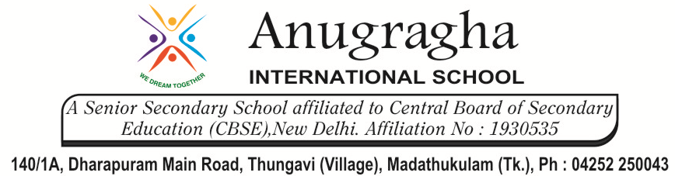
CLASS REVISION TEST-2
SCIENCE - CHEMISTRY
EX.NO |  | AD.NO |  | GRADE | X-LAVENDER
DATE | 17/11/19 | MARKS | 60 | TIME | 2 Hrs
SECTION - A
I. Choose the correct answer:- 10x1=10
1. Which of the following metal has highest melting point?
a. Copper b. Silver c. Sodium d. Tungsten
2. Which of the following only contain non-metals?
a. Carbohydrates b. Proteins c. Alloys d. Both a and b
3. Which of the following metal will not give H₂(g) with H₂O?
a. Na(s) + 2H₂O b. Mg (s) + 2H₂O
c. Zn(s) + H₂O d. Cu + H₂O
4. Aluminium does not oxidize readily in air because
a. it is high in the electrochemical series
b. it is low in the electrochemical series
c. the metal does not combine with oxygen
d. the metal is covered with a layer of oxide which does not rub off
5. Froth floatation method is used for the concentration of
a. oxide ore b. sulphide ore c. halide ore d. sulphate ore
6. An element X belongs to group 2 and period 3 of the periodic table. The chemical formulae of its nitrate, sulphate and phosphate respectively will be
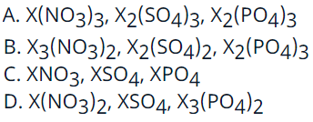
7. The atoms of elements belonging to the same group of periodic table have the same
a. number of protons b. number of electrons
c. number of neutrons d. number of electrons in the outermost shell
8. An element M has an atomic number 9 and atomic mass 17. Its ion will be represented by
a. M b. M ⁺² c. M ⁻ d. M ⁻²
9. The most metallic element in the fifth period is
a. silver b. rubidium c. gold d. rhodium
10. Noble gases were included in Mendelev’s periodic table in the
a. 1st group b. 7th group c. 8th group d. none of these

II. Fill in the blanks:- 5x1=5
11. Metal oxides which react with both acids as well as bases to produce salt and water are called ……… oxides.
12. Unwanted material with ore is called as …………..
13. Stainless steel contains ……….., ………… and ……………
14. Write two reasons responsible for the late discovery of noble gases.
15. The electronic configuration of two elements X and Y are 2, 8, 7 and 2, 8, 8, 3 respectively. Write the atomic numbers of X and Y.

III. Assertion and Reason:- 4x1=4
In the following questions, a statement of assertion is followed by a statement of reason. Mark the correct choice as:
a. If both assertion and reason are true and reason is the correct explanation of assertion.
b. If both assertion and reason are true but reason is not the correct explanation of assertion.
c. If assertion is true but reason is false.
d. If assertion is false but reason is true.
e. If both assertion and reason are false.

16. Assertion : Platinum, gold and silver are used to make jewellery.
Reason : Platinum, gold and silver are least reactive metals.
17. Assertion : Iron is found in the free state in nature.
Reason :. Iron a highly reactive element.
18. Assertion : In triad, the three elements have same gaps of atomic masses.
Reason : Elements in a triad have similar properties.
19. Assertion : Smaller the size of an atom greater is the electro-negativity.
Reason : Electronegativity refers to the tendency of atom to share electrons with other atom.

SECTION - B
V. Answer the following questions:- 7x3=21

20. a. How is copper obtained from Cu₂S? Give reactions.
b. Define the term alloy. Write the constituents of Bronze.
21. Aluminium oxide and zinc oxide react with both acids and bases to produce salt and water. What
are these oxides called? Write chemical equations in each case.
22. Distinguish between the following:-
a. Electrolytic reduction and electrolytic refining.
b. Mineral and ore.
c. Alloys and amalgams.
23. An element has atomic number 13.
a. What is the group and period number to which this element belongs to?
b. Is the element a metal or a non-metal? Justify your answer.
24. The atomic number of an element is 19.
a. Write the electronic configuration of this element and determine
i. the valency of this element, and
ii. whether this element is a metal or a non-metal?
b. Write the formula of the oxide of this element.
c. Is this element more reactive or less reactive than Na (atomic number 11) ? Justify your answer, giving example.
25. An element X (Atomic number 20) burns in the presence of oxygen to form a basic oxide.
a. Identify the element and write its electronic configuration.
b. State its group number and period number in the Modern Periodic Table.
c. Write a balanced chemical equation for the reaction when this oxide is dissolved in water.
26. How many groups and periods are there in the Modern Periodic Table? How do the atomic size and metallic character of elements vary as we move
a. down a group and
b. from left to right in a period?

SECTION - C
VI. Answer the following questions briefly:- 4x5=20
27. a. Define corrosion.
b. What is corrosion of iron called?
c. How will you recognize the phenomenon of corrosion of silver?
d. How can we prevent corrosion of iron?
28. a. Define activity series of metals. Arrange the metals: gold, copper, iron and magnesium in the order of their increasing reactivity.
b. What will you observe when:
i. Some zinc pieces are placed in copper sulphate solution.
ii. Some silver pieces are placed into green coloured ferrous sulphate solution.
29. The position of elements A, B, C, D, E, F and G in the Modern Periodic Table is given as under:
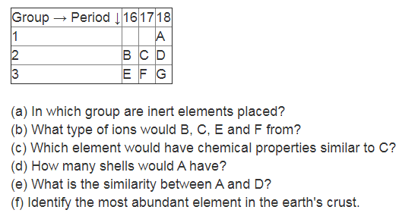
30. Name the elements which has
a. the electronic configuration 2, 8, 1.
b. a total of two shells with 4 electrons in the valence shell.
c. a total of three shells, with 3 electrons in the valence shell.
d. one shell which is completely filled with electrons.
e. twice as many electrons in the second shell as in the first shell.

