CLASS REVISION TEST-3
SCIENCE - CHEMISTRY
EX.NO |  | AD.NO |  | GRADE | X-LACELEAF
DATE | 05/11/19 | MARKS | 60 | TIME | 2 Hrs

SECTION - A
I. Choose the correct answer:- 7x1=7
1. Which of the following gases is called ‘marsh gas’-
a. H₂ b. CH₄ c. C₂H₄ d. C₂H₂
2. Which of the following will contain covalent double bond between its atoms?
a. H₂ b. O₂ c. NaCl d. Cl₂
3. Which of the following can show addition reaction?
a. C₂H₄ b. C₂H₆ c. C₂H₅OH d. CH₃CH₂CH₃
4. Which of the following is not the property of homologous series?
a. They differ by-CH₂ units b. They differ by-14 units by mass
c. They call contain double bond d. They can be represented by a general formula
5. Correct formula for propanoic acid is
a. CH₃COOH b. CH₃ – CH₂ – COOCH₃
c. HOOCCH₂CH₃ d. CH₃COOCH₃
6. Carbon exists in the atmosphere in the form of
a. carbon monoxide only
b. carbon monoxide in traces and carbon dioxide
c. carbon dioxide only
d. coal
7. When methane is burnt in an excess of air, the products of combustion are –
a. C and H₂O b. CO and H₂O c. CO₂ and H₂ d. CO₂ and H₂O

II. Fill in the blank:- 2x1=2
8. Next homologue of ethane is …………………..
9. The purest form of carbon is ……………………
III. Match the following:- 4x1/2=2
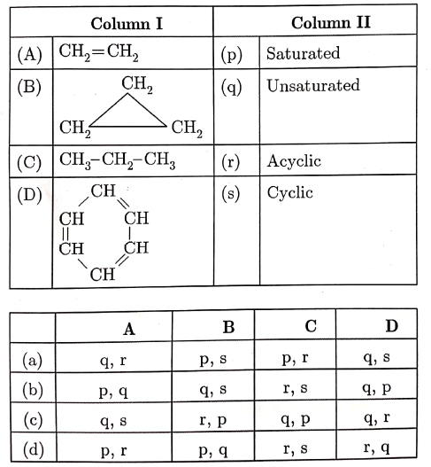
IV. Assertion and Reason:- 3x1=3
In the following questions, a statement of assertion is followed by a statement of reason. Mark the correct choice as:
a. If Both assertion and reason are true and reason is the correct explanation of assertion.
b. If Both assertion and reason are true but reason is not the correct explanation of assertion.
c. If Assertion is true but reason is false.
d. If Both assertion and reason are false.
11. Assertion : Carbon monoxide is extremely poisonous in nature.
Reason : Carbon monoxide is formed by complete combustion of carbon.
12. Assertion : In the esterification, carboxylic acid and alcohol reacts in the presence of acid to
give ester.
Reason : Esterification is the reverse of saponification.

13. Assertion : Carbon has ability to form long carbon chains.
Reason : Carbon has a unique property of ability to form long straight and branched chains
called catenation.

V. Answer in a word:- 5x1=5
14. Name the following compounds:
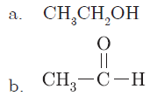
15. Write the name and structure of an alcohol with three carbon atoms in its molecules.
16. Draw the structural formula of methanoic acid.
17. Write the number of covalent bonds in the molecule of ethane.
18. Write the name and formula of 2nd member of homologous series having general formula C_{n}H_{2n-2}.

SECTION - B
IV. Answer the following questions:- 7x3=21
19. Compare the structures of benzene and cyclohexane by drawing them.
20. List four characteristics of homologous series.
21. Draw electron dot structures of (i) C₂H₄ (ii) C₂H₅OH.
22. What is homologous series? Which of the following organic compounds belong to the same
homologous series?
C₂H₆, C₂H₆O, C₂H₆O₂, CH₄O
23. a. Why are most carbon compounds poor conductors of electricity?
b. Write the name and structure of a saturated compound in which carbon atoms are arranged in
a ring. Give the number of single bonds present in this compound.

24. Complete the following reactions:
a. CH₃COOH + N₂CO₃
b. CH₄ + O₂
c. C₂H₅OH + Na
25. What are hydrocarbons? Write the general formula of (a) saturated hydrocarbons (b) unsaturated hydrocarbons and draw the structure of one hydrocarbon of each type.

SECTION - C
V. Answer the following questions briefly:- 5x4=20
26. An ester has the molecular formula C₄H₈O₂. Write its structural formula. What happens when this ester is heated in the presence of sodium hydroxide solution? Write the balanced chemical equation for the reaction and name the products. What is a saponification reaction?

27. Complete the following chemical equations and write the chemical name of the products formed.

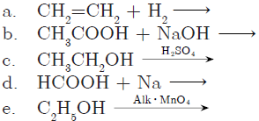

28. a. How is vinegar made?
b. What is glacial acetic acid? What is its melting point?
c. Why are carboxylic acids called weak acids?
d. Write the name and formula of compounds formed when the ester CH₃COOC₂H₅ undergoes
saponification.

29. List in tabular form three physical and two chemical properties on the basis of which ethanol and
ethanoic acid can be differentiated.

30. Give reasons for the following:
a. Element carbon forms compound mainly by covalent bonding.
b. Diamond has high melting point.
c. Graphite is good conductor of electricity.
d. Acetylene bums with sooty flame.
e. Kerosene does not decolourise bromine water whereas cooking oil does.

