CLASS REVISION TEST-2
PHYSICS
EX.NO |  | AD.NO |  | GRADE | XII-EINSTEIN
DATE | 30/11/19 | MARKS | 70 | TIME | 3 Hrs
SECTION - A
I. Choose the correct answer:- 20x1=20
Based upon the following paragraphs, 2 multiple choice type questions have to be answered. Each question has 4 choices, out of which only one is correct.(Q1 and Q2)
A point charge Q is moving in a circular orbit of radius R in the x-y plane with an angular velocity ω. This can be considered as equivalent to a loop carrying a steady current qω/2π. A uniform magnetic field along the positive z-axis is now switched on, which increases at a constant rate from 0 to B in one second. Assume that the radius of the orbit remains constant. The application of the magnetic field induces an emf in the orbit. The induced emf is defined as the work done by an induced electric field in moving a unit positive charge around a closed loop. It is known that, for an orbiting charge, the magnetic dipole moment is proportional to the angular momentum with a proportionality constant λ
1. The magnitude of the induced electric field in the orbit at any instant of time during the time interval of the magnetic field change, is:
a. BR/4 b. BR/2 c. BR d. 2BR
2. The change in the magnetic dipole moment associated with the orbit, at the end of time-interval of the magnetic field change, is:
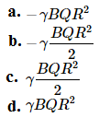
-------------------------------------------------------------------------------------------------------------
(Q3 and Q4): Consider a simple RC circuit as shown in Figure 1.
Process 1: In the circuit the switch S is closed at t = 0 and the capacitor is fully charged to voltage V₀ (i.e., charging continues for time T >> RC). In the process some dissipation (E_{D}) occurs across the resistance R. The amount of energy finally stored in the fully charged capacitor is E_{C}.
Process 2: In a different process the voltage is first set to V₀/3 and maintained for a charging time T >> RC. Then the voltage is raised to 2V₀/3 without discharging the capacitor and again maintained for a time T >> RC. The process is repeated one more time by raising the voltage to V₀ and the capacitor is charged to the same final voltage V₀ as in Process 1. These two processes are depicted in Figure 2.
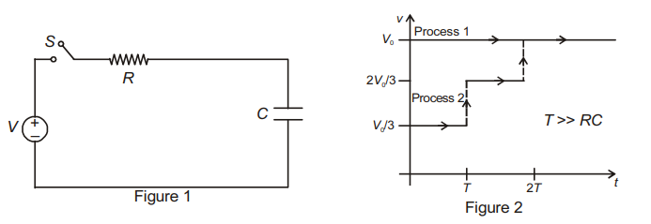
3. In process 1, the energy stored in the capacitor E_{C} and heat dissipated across resistance E_{D} are related by:
a. E_{C} = E_{D} b. E_{C} = E_{D} ln 2 c. E_{C} = 2E_{D} d. E_{C} = (1/2) E_{D}
4. In process 2, total energy dissipated across the resistance E_{D} is:
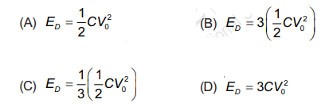
--------------------------------------------------------------------------------------------------------
Matching-Column type question(Q5-Q7):
Column I gives three physical quantities. Select the appropriate units for these from the choices given in column II. Some of the physical quantities may have more than one choice.
Q.no | Column I | Column II
5 | Capacitance | i. ohm-second
6 | Inductance | ii. coulomb² joule⁻¹
7 | Magnetic induction | iii. coulomb (volt)⁻¹  iv. newton (ampere metre)⁻¹  v. volt second (ampere)⁻¹

(Q8-Q10): Paragraph type question:-
A charged particle (electron or proton) is introduced at the origin (x = 0, y = 0, z = 0) with a given initial velocity v. A uniform electric field E and a uniform magnetic field B exist everywhere. The velocity v, electric field E and magnetic field B are given in columns 1, 2 and 3, respectively. The quantities E₀, B₀ are positive in magnitude.
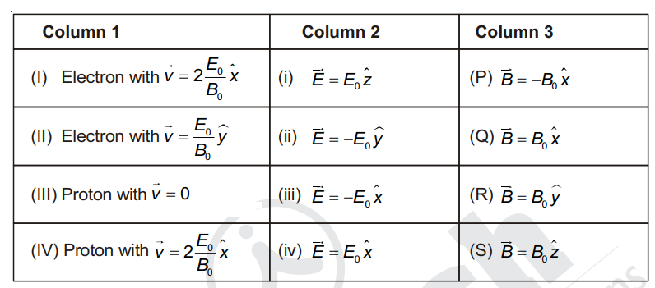
8. In which case will the particle move in a straight line with constant velocity?
(A) (III) (ii) (R) (B) (II) (iii) (S) (C) (IV) (i) (S) (D) (III) (iii) (P)
9. In which case will the particle describe a helical path with axis along the positive Z-direction?
(A) (III) (iii) (P) (B) (IV) (i) (S) (C) (II) (ii) (R) (D) (IV) (ii) (R)
10. In which case would the particle move in a straight line along the negative direction of Y-axis (i.e., move along – y)?
(A) (III) (ii) (P) (B) (II) (iii) (Q) (C) (IV) (ii) (S) (D) (III) (ii) (R)
--------------------------------------------------------------------------------------------------------------------
11. Two identical wires A and B, each of length ‘l’ carry the same current I. Wire A is bent into a circle of radius R and wire B is bent to form a square of side ‘a’. If B_{A} and B_{B} are the values of magnetic field at the centres of the circle and square respectively, then the ratio B_{A}/B_{B} is:
a. $\frac{π^{2}}{16\sqrt{2}}$ b. $\frac{π^{2}}{16}$ c. $\frac{π^{2}}{8\sqrt{2}}$ d. $\frac{π^{2}}{8}$
12. A uniform electric field and a uniform magnetic field are acting along the same direction in a certain region. If an electron is projected along the direction of the fields with a certain velocity, then:
(a) its velocity will decrease
(b)its velocity will increase
(c)it will turn towards right of direction of motion
(d) it will turn towards left of direction of motion

13. A galvanometer of resistance G is shunted by a resistance S ohm. To keep the main current in the circuit unchanged, the resistance to be put in series with galvanometer is:
14. A galvanometer of resistance 50 $Ω$ is connected to a battery of 3 V along with a resistance of 2950$Ω$ in series. A full-scale deflection of 30 divisions is obtained in the galvanometer. In order to reduce this deflection to 20 divisions, the resistance in series should be:
a. 5050$Ω$ b. 5550 $Ω$ c. 6050 $Ω$ d. 4450$Ω$
15. A uniform magnetic field exists in space in the plane of paper and is initially directed from left to right. When a bar of soft iron is placed in the field parallel to it, the lines of force passing through it will be represented by:
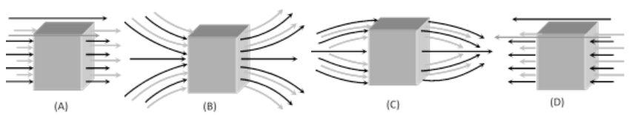

a. Fig.A b. Fig.B c. Fig C d. Fig D
16. An alternating emf is given by V = 200 sin (50$π$ t) volt. The rms value of the emf is:
a. 100$\sqrt{2}$ V b. 200$\sqrt{2}$ V c. 100 V d. 200 V
17. The peak voltage in an AC circuit is 707 V. The virtual voltage is:
a. 70.7 V b. 1000 V c. 500 V d. 707 V
18. An ac having a peak value 1.41 is used to heat a wire. A DC producing the same heating rate will be of:
a. 1.41 A b. 2.0 A c. 0.705 A d. 1.0 A
19. The rms value of potential difference V shown in the figure is:
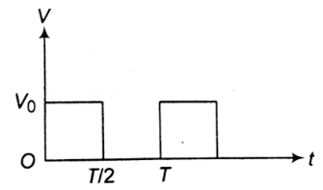
a. $\frac{V_{0}}{2}$ b. $\frac{V_{0}}{\sqrt{3}}$ c. V₀ d. $\frac{V_{0}}{\sqrt{2}}$
20. Same current flows in two separate AC circuits. The first circuit contains inductance only, while the second contains capacitance only. If the frequency of the applied voltage increases, the current:
a. increase in the first circuit, decrease in the second
b. will decrease in the first circuit, increase in the second
c. will decrease in both the cirucuits
d. will decrease in both the circuits

II. Very short-answer type questions:- 7x2=14

21. Why is an inductance more appropriate than a resistance to decrease alternating current?
22. Why is AC more dangerous than DC of the same voltage.
23. As soon as current is switched on in a high-voltage wire, the bird sitting on it flies away, why?
24. Predict the polarity of the capacitor PQ in the situation shown.
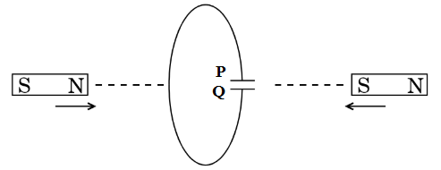
25. Interstellar space has an extremely weak magnetic field ($≈$ 10⁻¹² T). Can there be any significant consequence of such a weak field?
26. A charged particle enters a (non-uniform) magnetic field varying from point-to-point both in magnitude and direction, with a certain initial velocity. What can you say about the final velocity of the particle when it leaves the field?
27. Free electrons always keep on moving in a conductor. Even then, no magnetic force acts on them in a magnetic field unless a current is passed through it. Why?

III. Short answer type questions:- 7x3=21

28. Derive an expression for the magnetic field inside a toroid. Explain how it is different from the result obtained in case of a tightly wound long-solenoid.
29. A galvanometer has a resistance of 15 $Ω$ and the meter shows full-scale deflection for a current of 4 mA. How will you convert the meter into an ammeter of range 0 to 6 A?
OR
A galavanometer with a coil of resistance 100$Ω$ and a scale having 100 divisions has a current sensitivity of 25 $μ$A/division. How will you convert it into an ammeter of range 0 to 5 A?
30. Explain the terms magnetization, magnetizing field intensity, permeability, relative permeability and magnetic susceptibility. Write the relation between permeability and susceptibility.
31. A rectangular conducting loop of sides 8 cm and 2 cm, having a resistance of 1.6 $Ω$, is placed in a region of uniform magnetic field of magnitude 0.3 T directed normal to the loop. If the field be gradually decreased at a rate of 0.02 T s⁻¹, how much power would be dissipated by the loop as heat? From where this power does come?
OR
State Lenz’s law for determining the sense of induced current. Explain how the law is consistent with the principle of conservation of energy.
32. What are eddy currents? How are they produced? Give applications of eddy currents.
33. An alternating emf of frequency 50 Hz is applied to a circuit with a resistor of 20 $Ω$, an inductor of 100 mH and a capacitor of 30$μ$F connected in series.
i. What is the angle by which the current leads or lags the applied emf?
ii. Represent the voltage and the current in a vector diagram showing the phase angle.
34. Derive an expression for growth and decay of current in a series LR circuit.

IV. Long answer type questions:- 3x5=15

35. What do you understand with impedance? Write its unit and obtain relation for it in L-C-R circuit.
OR
In the given L-C-R series circuit fed by 220 V-50 Hz AC mains, find
i. current in the circuit, ii. value of inductor L, iii. value of capacitor C and
iv. value of C (for the same L) required to produce resonance. The voltmeter readings across R, l
and C are as shown.
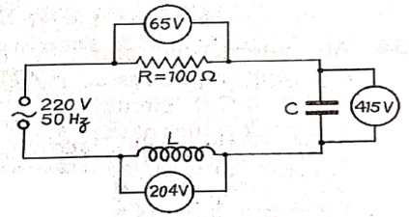
36. Using an appropriate diagrams, derive the relation for motional emf developed in a conductor of length l moving with velocity v perpendicular to uniform magnetic field B. Obtain the relation for mechanical power consumed to pull conductor in previous part of question, i.e., P = $\frac{B^{2}l^{2}v^{2}}{R}$ where R is the total resistance of the circuit.
OR
A metallic rod CD rests on a thick metallic wire PQRS with arms PQ and RS parallel to each other, at a distance l = 40 cm, as shown in figure. A uniform magnetic field B = 0.1 T acts perpendicular to the plane of this paper, pointing inwards(i.e., away from the reader). The rod is now made to slide towards right with a constant velocity v = 5.0 ms⁻¹.
i. How much emf is induced between the two ends of the rod CD?
ii. What is the direction in which the induced current flows?
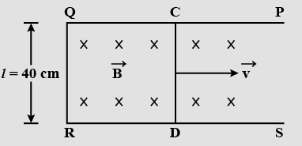

37. In the Bohr model of hydrogen atom, the electron circulates around the nucleus in a path of radius 5.1 x 10⁻¹¹ m at a frequency 6.8 x 10¹⁵ s⁻¹. Find the magnetic field set up at the centre of the orbit.
OR
Two parallel rails, distant 2.0 x 10⁻²m, are laid in north-south direction. On these rails is kept a metal cylinder of mass 4.0 x 10⁻² kg. A battery is connected to the rails with its positive terminal joined to the rail on the eastern side. The battery sends a current of 3.0 A in the cylinder. If a uniform magnetic field of 1.2 T directed upwards be there, then find out the magnitude and direction of the magnetic force imposed upon the cylinder. What would be the acceleration in the cylinder?

