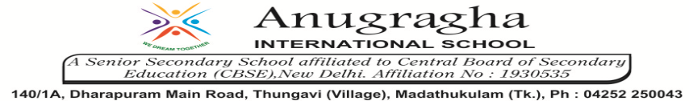

ANNUAL EXAMINATION-JAN-2020

KBQ - 02
NAME | «NAME_OF_THE_STUDENT» |  |  | AD.NO | «ADMNO»
CLASS | VI-«SECTION» |  |  | EX.NO | «EXNO»
G.D | 27.01.2020 | S.D | 31.01.2020 | SUB | SCI
TOPIC: CH:15 AIR AROUND US

Short Answer Type Questions:
1. List the activities that are possible due to the presence of air.
2. How will you show that air is dissolved in water?
3. Describe balance of oxygen in the air.
4. What is wind energy? Mention its two advantages.
5. Write a short note on atmosphere.

Long Answer Type questions:
1.How will you show that air is dissolved in water?
2.How is the level of oxygen maintained in the atmosphere?
3.Describe what air is made up of.

HOTS:
1. How do the organisms living in soil get the air they need, for respiration?
2. Why do we see the sky and air clear and clean after rainfall?
3. Why does a lump of cotton wool shrink in water?
4. Why are bubbles formed when water is poured over a lump of soil?
5. Renuka packed her flower pot with loose soil. When she watered the plant in the pot, the level of the soil went down. What could be the reason?

