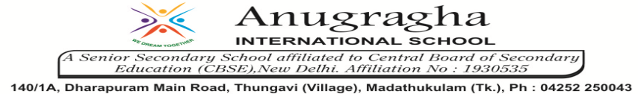

ANNUAL EXAMINATION-JAN-2020

KBQ - 02
NAME | «NAME_OF_THE_STUDENT» |  |  | AD.NO | «ADMNO»
CLASS | VII-«SECTION» |  |  | EX.NO | «EXNO»
G.D | 31.01.2020 | S.D | 03.02.2020 | SUB | SCI
TOPIC: CH:14.ELECTRIC CURRENT AND ITS EFFECTS

Short Answer Type Questions:
1. Why does a fluorescent tube not generate heat?
2.Name any two effects of electric current.
3.Write four uses of electromagnets.
4.How do the electric heater or as electric iron work?
5.What are CFLs?Why are CFLs preferred over electric bulbs?

Long Answer Type questions:
1.Describe the construction and working of an electric bell.
2.What is an electromagnet? Write its uses.
3.Write a note to describe the use of electric current to emit light.

HOTS:
1.What precautions should be taken while using electrical gadgets/appliances?
2.Five bulbs are connected in an electric circuit. Suggest a method of determining whether the bulbs are connected in series or in parallel.
3.Can you use a copper wire to make the filament of an electric bulb.
4.Why is air not filled in electric bulb?
5.Why should we not touch the lighted bulb?

