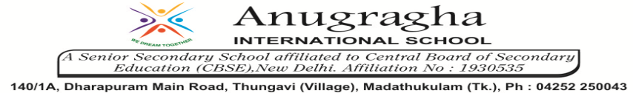

ANNUAL EXAMINATION-FEB-2020

KBQ - 05
NAME | «NAME_OF_THE_STUDENT» |  |  | AD.NO | «ADMNO»
CLASS | VII-«SECTION» |  |  | EX.NO | «EXNO»
G.D | 12.02.2020 | S.D | 15.02.2020 | SUB | SCI
TOPIC: CH:17.FOREST:OUR LIFELINE

Short Answer Type Questions:
1.What happens if there is disturbance at even a single step of a food chain?
2.Mention three uses of forests.
3.How can forests be conserved?
4.What is a food chain?
5.What is meant by the understoreys?

Long Answer Type questions:
1.Why should we worry about the conditions and issues related to forests far from us?
2.Explain how the forest act as natural absorber of rain water?
3.Explain the role of forest in maintaining the balance between oxygen and carbon dioxide in the atmosphere.

HOTS:
1.Why is it dark inside a forest?
2.If the forests are cut for construction purposes, water table goes down.Why?
3.Deforestation may lead to floods. Why?
4.We are often advised to plant more trees and not to cut the existing ones. why? What values are shown by a person who practices tree conservation?
5.Why is energy lost at every step of a food chain?
6.Why are forests called ‘green lungs’?
7.Why are trees planted alongside the roads?

