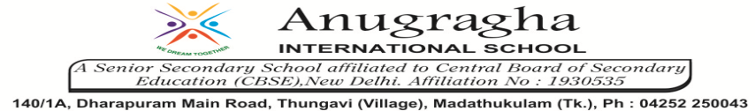

ANNUAL EXAMINATION-JAN-2020

KBQ - 01
NAME | «NAME_OF_THE_STUDENT» |  |  | AD.NO | «ADMNO»
CLASS | VII-«SECTION» |  |  | EX.NO | «EXNO»
G.D |  | S.D |  | SUB | SST
TOPIC: CH:8 MARKETS AROUND US

Short Answer Type Questions:
1.Compare and Contrast a weekly market and a shopping complex on the following:
Market | Kind of goods sold | Price of goods | Sellers | Buyers
Weekly market
Shopping complex

2.In what ways is a hawker different from a shop owner?
3.What are the unique features of a weekly market?
4.Why are weekly markets cheaper than other markets?
5.How are weekly markets advantageous?
6.How are shops in the neighbourhood useful?
7.Write a note on shopping complexes and malls.
8.What are branded and non-branded goods and where are they available?

Long Answer Type questions:
1.Explain how a chain of markets is formed. What purpose does it serve?
2.Explain the dictum of ‘markets everywhere’.

HOTS:
1.”All persons have equal rights to visit any shop in a market place.’ Do you think this is true for shops with expensive products? Explain with examples.
2.’Buying and selling can take place without going to a marketplace’. Explain this statement with the help of examples.

