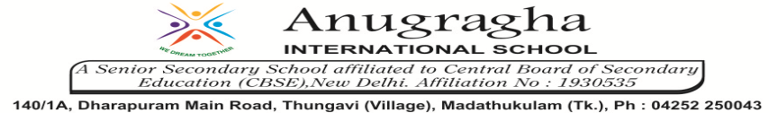

ANNUAL EXAMINATION-JAN-2020

KBQ - 02
NAME | «NAME_OF_THE_STUDENT» |  |  | AD.NO | «ADMNO»
CLASS | VI-«SECTION» |  |  | EX.NO | «EXNO»
G.D | 23.01.2020 | S.D | 27.01.2020 | SUB | SCI
TOPIC: CH:7 OUR COUNTRY-INDIA

Short Answer Type Questions:
1.Describe the locational extent of India.
2.Give the latitude and longitudinal extent of India.
3.How is India divided? What is the Indian Standard Meridian?
4.Write a note on India’s neighbours.
5.Give an account of administrative divisions in India.
6.What is Himalaya? How are they divided?
7.Which is the world’s largest delta?
8.How are coral islands formed?
9.Write a short note on Shiwalik.
10.Write a short on the islands.
11.Write a short note on east coastal plain.
12.Write a short note on Western Ghats.
Long Answer Type questions:
1.Give a brief description of the peninsular plateau of India.
2.What is the significance of the physiographic divisions in India?

