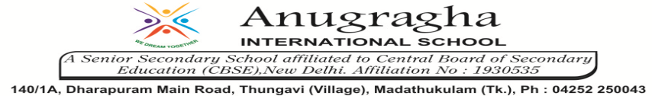

ANNUAL EXAMINATION-FEB-2020

KBQ - 06
NAME | «NAME_OF_THE_STUDENT» |  |  | AD.NO | «ADMNO»
CLASS | VII-«SECTION» |  |  | EX.NO | «EXNO»
G.D | 28.02.2020 | S.D | 03.03.2020 | SUB | SCI
TOPIC: CH:18.WASTE WATER STORY

Short Answer Type Questions:
1.What are the harmful effects of releasing untreated sewage in water bodies?
2.What is sludge? Explain, how is it treated?
3.How can we control water pollution?
4.What is portable water? Write its characteristics.
5.How is biogas formed?

Long Answer Type questions:
1.Describe various house-keeping practices for efficient of sewage system.
2.What are the different types of inorganic and organic impurities generally present in sewage?
3.Describe various steps of cleaning waste water in a waste water treatment plant.

HOTS:
1.Why should oils and fats be not released in the drain. Why?
2.Why does the speed of incoming wastewater slow down in grit and sand removal tank?
3.A man travelling in a train threw an empty packet of food on the platform. Do you think this is a proper waste disposal methods?
4.Used tea leaves, solid food remain, soft toys should not be thrown down the drain. Why?
5.Untreated human excreta is a health hazard. Explain.

