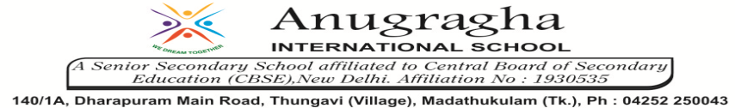

ANNUAL EXAMINATION-JAN-2020

KBQ - 01
NAME | «NAME_OF_THE_STUDENT» |  |  | AD.NO | «ADMNO»
CLASS | VIII-«SECTION» |  |  | EX.NO | «EXNO»
G.D |  | S.D |  | SUB | SST
TOPIC: CH:9. WOMEN, CASTE AND REFORM
Short Answer Type Questions:
1.How did the knowledge of ancient texts help the reforms promote new laws?
2.What were the different reasons people had for not sending girls to school?
3.Why were Chiristian missionaries attacked by many people in the country?Would some people have supported them too? If so, for what reasons?
4.Why did Phule dedicate his book Gulamgiri to the American movement to free slaves?
5.What did Ambedkar want to achieve through the temple entry movement?
6.Explain the caste system in our society.
8.Name any one reason of change in society.
9.How wass the practice of Sati banned?
10.Explain Widow Remarraige Act.
Long Answer Type questions:
1.What social ideas did the following people support?
a)Rammohan Ray
b)Dayanand Saraswathi
c)Veerasalingam Pantulu
d)Jyotirao Phule
2.How did Jyotirao, the reformer, justify criticism of caste inequality in society?
3.Give a brief description on the Non-Brahman Movement.
4.Who was Dr.B.R.Ambedkar? What was his contribution in the society?
5.Mention how women reformers helped in changing the conditions of other women?
HOTS:
1.In British period, what new opportunities opened up for people who came from caste that were regarded as ‘low’?

