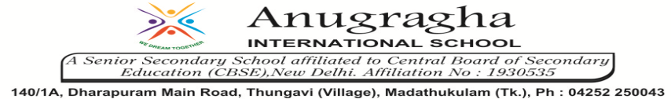

ANNUAL EXAMINATION-MAR-2020

KBQ - 07
NAME | «NAME_OF_THE_STUDENT» |  |  | AD.NO | «ADMNO»
CLASS | VI-«SECTION» |  |  | EX.NO | «EXNO»
G.D | 28.02.2020 | S.D | 02.03.2020 | SUB | SST
TOPIC: CH:11 BUILDINGS, PAINTINGS AND BOOKS
Short Answer Type Questions:
1.How is Indian literature unparalleled?
2.What does the Tamil epic Silappadhikaram deal with?
3.What did Tamil epic Manimekalai depict?
4.Give India’s achievements in the field of architecture.
5.Give India’s achievements in the field of sculpture and stone carving.
6.Give India’s achievements in metallurgy.
7.How were Hindu temples carved out?
8.Examine developments of science in ancient India.
Long Answer Type questions:
1.How are Puranas an important cultural heritage?
2.How did Sanskrit language enrich Indian literature?
3.How did Tamil language enrich South Indian literature?
4.How were bricks and stone important in Buddhist buildings?
5.How were temples and stupas built?

