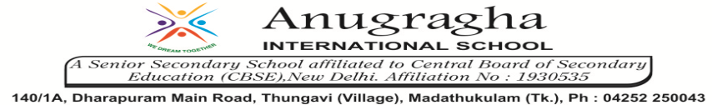

ANNUAL EXAMINATION-FEB-2020

KBQ - 03
NAME | «NAME_OF_THE_STUDENT» |  |  | AD.NO | «ADMNO»
CLASS | VIII-«SECTION» |  |  | EX.NO | «EXNO»
G.D | 03.02.2020 | S.D | 05.02.2020 | SUB | SST
TOPIC: CH:10 THE CHANGING WORLD OF VISUAL ARTS
Short Answer Type Questions:
1.Point out which of the following were brought in with British art:
a)Oil painting b) Miniature c)Life-size portrait painting d)Use of perspective e)Mural paintings
2.Why can we think of Raja Ravi Varma’s paintings as National?
3.Expain the picturesque landscape paintings.
4.Who was Johann Zoffany?
5.Write the names of two portraits painted by Johann Zoffany?
6.What do you mean by the idea of realism?
7.What does new forms of imperial art refer to?
8.What was painting history?
9.Write about the importance of imperial history paintings?
10.What happened to the court artists?
11.What were company paintings?
Long Answer Type questions:
1.Describe in your words one painting from this chapter which suggests that British were more powerful than Indians. How does the artists depict this?
2.Why did the scroll painters and potters come to Kalighat? Why did they begin to paint new themes?
3.Why do you think some artists wanted to develop national style of art?
4.Give an account of photography in India.
5.What do you know about the art of Raja Ram Verma?

